

United Nations Development Programme
Country: Botswana
PROJECT DOCUMENT

Project Title: | Promoting production and utilisation of biogas from agro-waste in South-Eastern Botswana
UNDAF Outcomes: UNDAF Outcome 4 on Environment and Climate: By 2016 the rural poor, especially women, are deriving greater benefits from the environment and natural ecosystems.

UNDP Strategic Plan Environment and Sustainable Development Primary Outcome: Growth and development are inclusive and sustainable, incorporating productive capacities that create employment and livelihoods for the poor and excluded.
Expected Country Programme Outcome(s): Improved National capacity and community participation (especially women and youth) in the management of water resources including trans-boundary management, sanitation and hygiene.
Expected CPAP Output(s): Strengthened capacity for management of water resources, pollution and sanitation for increased awareness.
Executing Entity: Ministry of Environment, Wildlife and Tourism (MEWT)

Implementing Partner: Botswana Institute for Technology, Research and Innovation (BITRI)
Brief Description:

The Botswana National Development Plan 2010-2016 accords priority to transforming agro-waste into biogas. This GEF-financed, UNDP-implemented project will assist the Government of Botswana in meeting this priority through three project components: (i) institutional strengthening and capacity development; (ii) the facilitation and establishment of biogas plants; and (iii) the setting-up of utilisation and knowledge platforms. The outcomes of the project will include the implementation of effective waste-management policies and guidelines with operational regulations; capacity to design and develop biogas projects in South-Eastern Botswana; the first best-practice public-private partnership established; reduction in greenhouse gas emissions (direct and indirect) of 1.65 million tCO₂e; and increased incomes through the use of small-scale biogas and bio-fertilizer, especially for women.

Total allocated resources: USD 19,316,300

Regular
  - GEF USD 2,632,300
  - UNDP USD 200,000

Other:
Cash contributions
  - DWMPC USD 309,000
  - BDC USD 4,600,000
  - BMC USD 3,000,000
In-kind contributions
  - MEWT USD 75,000
  - DWMPC USD 1,150,000
  - BMC USD 7,150,000
  - BITRI USD 200,000

Programme Period: 2015 – 2019

Atlas Award ID: 00098758
Project ID: 00101976
PIMS # 5299

Start date: Jan 2017
End Date Dec 2020

Management Arrangements NIM
PAC Meeting Date August 1, 2016

Agreed by (Government):
Date/Month/Year

Agreed by (Executing Entity/Implementing Partner):
Date/Month/Year

Agreed by (UNDP):
Date/Month/Year

Table of Contents
1 Situation analysis 7
1.1 Geography 7
1.2 Economy 7
1.3 Energy Situation 8
1.4 Botswana’s GHG emissions 10
1.5 Organic and Agro-Waste Production and Management 10
1.6 Legislative and Institutional Analysis 15
1.7 Biogas Sector Context 28
1.8 Gender and Energy in Botswana 29
1.9 Current Waste Management Situation 30
1.10 Barrier Analysis 32
1.11 Outcome of the situation analysis 35
1.12 Analysis 36
2 Strategy 41
2.1 Project Objectives, Outcomes, and Outputs 41
2.2 Theory of Change 41
2.3 Project Component 1 43
2.4 Project Component 2 49
2.5 Project Component 3 53
2.6 Key indicators, risks and assumptions 55
2.7 Expected Benefits, Design Principles and Strategic Considerations 57
2.8 Policy Conformity 61
2.9 Country Ownership 61
2.10 Cost-Effectiveness 61
2.11 Sustainability 62
2.12 Knowledge Management 63
3 Project Results Framework: 65
4 Total Budget and Workplan 68
4.1 Summary of funds 70
5 Management Arrangements 72
Financial and Other Procedures 74
Audit Clause 74
6 Monitoring Framework and Evaluation 75
7 Legal Context 79
8 Annexes 80
8.1 Quick scan on the feasibility for biogas in Botswana 80
8.2 Social and Environmental Screening 81
8.3 Letters of Co-Finance 88
8.4 Organisational information 97
8.5 UNDP Direct Project Services Costs 99
8.6 Letter of Endorsement 101
8.7 TORs for project staff/key consultants 104
8.8 GHG calculations 108

Tables
Table 1. BPC Electricity Tariffs, 2013 8
Table 2. Overview of potential waste streams for biogas 14
Table 3. Overview of Policies and Acts Relating to Waste Management 16
Table 4. Overview of Stakeholders 27
Table 5. Overview of the Ministries Involved in Waste Management 32
Table 6. Overview of barrier removal 35
Table 7. Financial analysis, BioSys. 39
Table 8. Proposed Timeline 43
Table 9. Overview of Outcomes 1.1 & 1.2: outputs and activities 47
Table 10. Overview of Outcome 1.3: outputs and activities 49
Table 11 Financial Analysis 52
Table 12. Overview of Component 2: outcome, outputs, activities 53
Table 13. Overview of Component 3: outcome, outputs, activities 55
Table 14. M&E workplan 78

Figures
Figure 1. BPC cost of electricity 9
Figure 2. Theory of Change 42
Figure 3 Organizational Chart 72

List of Acronyms
AD | Anaerobic Digestion
AfDB | African Development Bank
BCE | Biogas Construction Enterprise
BDC | Botswana Development Cooperation
BDS | Business Development Services
BIH | Botswana Innovation Hub
BITRI | Botswana Institute for Technology, Research and Innovation
BMC | Botswana Meat Commission
BOBS | Botswana Bureau of Standards
BOD | Biological Oxygen Demand
BOTA | Botswana Training Authority
BPC | Botswana Power Cooperation
BWG | Biogas Working Group
BWP | Botswana Pula (1 USD = 9.6 BWP as of 02/01/2015 [used] / 9.8 BWP as of 30/05/2015)
CBG | Compressed Biogas
CBO | Community-Based Organisation
CDM | Clean Development Mechanism
CHP | Combined Heat and Power
CN | Carbon : Nitrogen (ratio)
CO₂ | Carbon Dioxide
CO₂e | Carbon Dioxide Equivalent
COD | Chemical Oxygen Demand
CP | Country programme
CPAP | Country Programme Action Plan
CSO | Central Statistics Office
CSO | Civil Society Organisation
CSTR | Continuous Stirred Tank Reactor
cum / m³ | Cubic metre
DoE | Department of Energy
DWMPC | Department of Waste Management and Pollution Control
EDM | Eectricidade de Moçambique
F&C | Finance & Competence
FAO | Food and Agriculture Organisation
FIRR  GAP | Financial Internal Rate of Return  Gender Action Plan
Gg | Gigagrams
GDP | Gross Domestic Product
GEF | Global Environment Facility
GIZ | German Official Development Cooperation
GOB | Government of Botswana
HRAP | High-Rate Anaerobic Ponds
HRT | Hydraulic Retention Time
Int | International
INV | Investment
ISPAAD | Integrated Support Programme for Arable Agricultural Development
kW | Kilowatt = 1,000 watts
kWh | Kilowatt-hour
LPG | Liquefied Petroleum Gas
MDG | UN Millennium Development Goal
MFI | Micro-Finance Institution
MLG&RD | Ministry of Local Government and Rural Development
MoU | Memorandum of Understanding
MSP | Multi-Stakeholder Platform
MSW | Municipal Solid Waste
MW | Megawatt = 1,000 kW
MWe | Megawatt (electricity)
NGO | Non-Governmental Organisation
NPK | Nitrogen (N), Phosphorous (P), Potassium (K)
NPV | Net Present Value
PCIA | Partnership for Clean Indoor Air
pH | Power of Hydrogen (a measure of acidity ( ≤ 7) or alkalinity (≥ 7))
PIF | Project Identification Form
PJ | Peta Joule ( 10¹⁵ Joule)
PPG  PPA | Project Preparation Grant  Power Purchase Agreement
PPP | Public-Private Partnership
ProDoc | Project Document
RE | Renewable Energy
RET | Renewable Energy Technology
SACCO | Savings and Credit Co-operative
SAPP | Southern African Power Pool
SEK | Swedish Krone
SIDA | Swedish Development Cooperation Agency
SS | Suspended Solids
SWOT | Strength, Weakness, Opportunities, Threats Analysis
TA  TEA | Technical Assistance  Trade Effluent Agreement
TNA | Technology Needs Assessment
UNDAF | United Nations Development Assistance Framework
UNDP  UNEP  USD | United Nations Development Programme  United Nations Environment Programme  United States Dollars
WHO | World Health Organisation

Small-sized biogas digesters range from 4-300 m³ and are operated by small-scale agro-business, and small scale livestock producers, households with dairy and or beef, schools and other institutions. The estimated investment cost for small-sized biogas digesters ranges from US$ 800 (6 m³) to US$ 50,000 (300 m³).
Medium-sized biogas digesters range from 300-5,000 m³ and are operated by agro-industry in partnership with Councils and additional interested stakeholders. The estimated cost of a medium-sized digester is estimated at US$ 1.5-3.5 million (with a central estimate of $3 million), depending on the design, size and customer requirements.
Large-scale biogas digesters are over 5,000 m³ in size and are typically centralised co-digestion systems with multiple waste streams.

Situation analysis

Geography

- Botswana is a landlocked country with a mean altitude of 1,000m above sea level and an area of 582,000km². Much of the country is flat, with gentle undulations and occasional rocky outcrops. Among the features punctuating the terrain are the Okavango Delta in the north-west and the Makgadikgadi Pans in the Central District, the latter consisting mainly of calcrete and salty soils. In the east, along the north-south railway line, the more favourable climate and soils support agricultural activity and this is where 80% of the population is concentrated. The remainder of the country (66%) contains sand layers that support a vegetation of shrub and grasses, with an almost complete absence of surface water.

- Mean annual rainfall ranges from 250-650 mm. Rainfall is lowest in the south-west, gradually increasing towards the north and north-east around Maun and Kasane; the vegetation intensifies into forest in the north-east. The temperature range is wide, varying from –5°C to 43°C, with the lowest temperatures occurring in the south-west of the country, where early-morning frost occurs between June and August. The bulk of the country has soils classified as desert to semi-desert, supporting Kalahari bush savannah and grass savannah.

Economy
- Economic growth registered in 2013 was 5.8%, slowing slightly to 5.2% in 2014. Growth of 4.9% is forecast in 2015. Headline inflation fell to 3.8% in December 2014 from 4.1% the previous year, although core inflation (i.e. excluding administered prices) rose marginally from 4.7% to 4.9% over the same period. With inflation at historically low levels and well within the Bank of Botswana’s 3-6% target range, monetary policy was left unchanged during 2014, and the benchmark Bank Rate maintained at 7.5%. Key thematic areas, such as growing the economy and promoting inclusive growth, form the basis of the 2015/16 Government budget. A substantial budget surplus of BWP 7.2 billion (5.6% of GDP) was realised in 2013/14, due to the recovery of the key diamond mining sector, and the Government is committed to accumulating further surpluses in the medium-term. Similarly, driven by strong diamond exports and receipts from the Southern African Customs Union, a balance of payments surplus of P10 billion was achieved in 2014. As of the end of December 2014, foreign exchange reserves stood at P79.0 billion (US$ 8.3 billion), equivalent to 18 months’ import cover.

- Implementation of development programmes is undertaken in line with the National Development Plan (NDP). The NDP is a medium-term (typically six-year) development plan which identifies objectives, policies and accompanying Government spending programmes in the context of budget constraints arising from macroeconomic projections. The Plan is also aligned with the long-term objectives set out in the National Vision planning document and includes development benchmarks based on internationally-agreed targets such as the Millennium Development Goals. The Government has also embarked on the preparation of the National Vision Beyond 2016, to be launched in September 2016. It is for this reason that NDP 10 was extended by one year to allow for the new Vision to be aligned with NDP 11. The National Vision will provide benchmarks for long-term national development against which progress through the successive NDPs can be evaluated, as well as aligning national development with global development aspirations – i.e. with the post-2015 Sustainable Development Goals (SDGs) and development process.

Energy Situation
In 2009, Botswana’s primary energy supply was 85 PJ. Fuel imports accounted for 13% of the country’s total imports, and cost US$ 625 million. The country was only 46% energy self-sufficient during this period. A snap-shot of the fossil energy sector in Botswana developed in 2007 indicates that petrol was the most consumed energy source (33%), followed by coal and electricity (25% each), diesel (12%) and other sources of energy at about 1% each. Although the snapshot did not include fuelwood, the 1981-2003 trend showed fuelwood consumption being higher than petrol and diesel combined, and declining only slightly at the end of 2003. Consumption of petroleum products had, in 2007, exceeded 1,500 million m³ but started to decrease during the fuel price-hikes of 2008 to 800 million m³ and stabilised at just around 900 million m³.

- Electricity generation stands at 444 GWh (excluding emergency generation from diesel), with electricity use per capita being 1,528 kWh. Botswana produces 80% of its electricity needs through a state-owned entity, Botswana Power Corporation (BPC). The rest comes mainly from Eskom in South Africa, EDM (the electricity company of Mozambique) and the Southern African Power Pool (SAPP). The country’s installed generating capacity stands at 892 MW, of which 132 MW is under maintenance and is expected to return to service by the end of 2016. Peak demand is 681 MW. In late 2014, national access to electricity was 69%, and it is expected to increase to 80% by 2016.

- During the 2013 financial year, BPC incurred a 37% (P989 million) increase in the cost of supply to P3.7 billion, from P2.7 billion in the prior year. Generation, Transmission and Distribution expenses constituted almost 93% (P3.4 billion compared to P2.5 billion for March 2012) of the total operating cost. Financial losses from operations amounted to P751 million (net of the Government’s tariff subsidy of P871 million and P239.7 million support towards emergency power costs), compared with P311 million recorded in the prior year. In the table below, the latest BPC electricity tariffs are presented.

Domestic Customers | Fixed Charge |  | Energy Charge
Domestic Customers | Old Tariff | New Tariff | Old Tariff |  | New Tariff
Domestic Customers | Up to 200 kWh | More than 200 kWh | Up to 200 kWh | More than 200 kWh | Up to 200 kWh | More than 200 kWh
Domestic Customers | 19.12 | 21.98 | 0.5386 | 0.6883 | 0.5763 | 0.7571
Domestic Customers | Up to 500 kWh | More than 500 kWh | Up to 500 kWh | More than 500 kWh | Up to 500 kWh | More than 500 kWh
Small Business | 51.17 | 66.53 | 0.6166 | 0.7879 | 0.6598 | 0.8667
Medium Businesses | 51.17 | 66.53 | 0.3978 |  | 0.4376
Large Businesses | 51.17 | 66.53 | 0.3587 |  | 0.3946
Table 1. BPC Electricity Tariffs, 2013

- The cost of power generation in Botswana is higher than the tariff charged to customers, as presented in the figure below. The difference between production cost and income is covered by a Government subsidy. Below, BPC provides an example of the cost of coal generation being a minimum of BWP 1 per kWh, while the consumer pays BWP 0.43per kWh, which means the Government is required to provide a subsidy of BWP 0.57 per kWh.
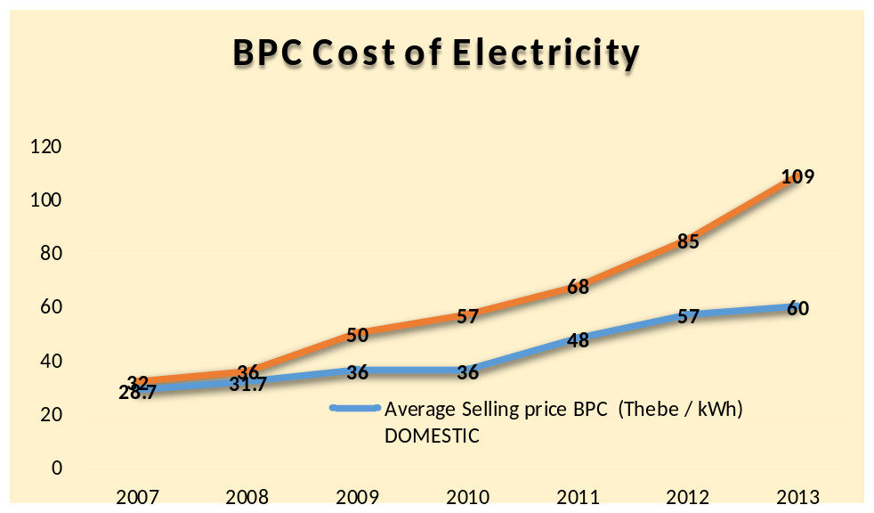
Figure 1. BPC cost of electricity

- The current renewable energy mix connected to the grid is about 1%. An ambitious target of 25% by 2030 has been set by the Government, though a Government-commissioned study on potential feed-in tariff options, undertaken in 2011, concluded that the cost of producing electricity from renewable energy is higher than that generated by coal. The Government has indicated that it will consider financial support for renewable energy – including through a feed-in tariff – ideally in a context when coal-produced electricity prices are market-based without subsidies. Investment by project developers in renewable energy technologies, including biogas, that can produce electricity at a lower cost than the derived cost-reflective tariff is being highly encouraged.

- Currently, there are 15 known biogas plants in Botswana. Two of these plants are used for research, 2 are based at wastewater treatment plants, and the rest are used for cooking and lighting at hotel and household scales. The feed stocks used are food, agro-waste and sewage slurry.

- The Draft National Energy Policy of February 2015, already approved by Cabinet and scheduled for the November 2015 Parliament sitting, outlines the following objectives that are aligned with the UNDP-implemented, GEF-financed biogas project: improving security of supply, equitable access to affordable modern energy, increasing the share of renewables, offsetting the country’s carbon footprint through renewables, ensuring effective private sector and NGO participation in the energy sector, and mainstreaming of gender, age and socio-economic issues in energy policies and programmes.

- Some of the gaps and barriers identified by a SE4ALL gap analysis for Botswana in 2014 with regard to thermal-energy applications, the power sector and modern energy for productive use are as follows:

- Lack of clear policy for energy access, renewable energy and productive use of energy.
- The need for assessment of renewable energy potential and the capacities that can be achieved, as well as the need to identify, cost and outline benefits of various technologies.
- The need to institute appropriate regulatory frameworks – for example, for technology standards and incentives to reduce costs to consumers.
- Unwillingness of Government to absorb risk to allow energy producers to supply grid, mini-grid and off-grid systems.
- Lack of monitoring and evaluation of set targets for energy access and renewable energy penetration.
- Limitations of Botswana-based technology developers, designers, installers and maintenance.

Botswana’s GHG emissions
- The Government of Botswana ratified the United Nations Framework Convention on Climate Change (UNFCCC) on 27 January 1994, and it came into force on 27 April 1994. Though Botswana is a minor emitter of greenhouse gases (GHGs), the country is negatively impacted by climate change. Water is a scarce commodity in the country and the situation will be aggravated by the impact of climate change.

- The national GHG inventory of anthropogenic emissions and removals for the year 2000 was calculated for the following five sectors: Energy; Industrial Processes; Agriculture; Land Use, Land Use Change and Forestry; and Waste. IPCC default emissions factors were applied. Botswana’s GHG emissions were estimated as 7,168.7 Gg CO₂e in 2000 and removals were 42,941 Gg CO₂e. Net emissions after accounting for removals were 35,506.8 Gg CO₂e, indicating that Botswana was a net sink in 2000. The energy sector contributed 5,537.9 Gg CO₂e of emissions and the waste sector contributed 111.3 CO₂e of emissions.

- Carbon dioxide emissions increased by 74% between 1994 and 2000, N₂O emissions increased by 100% due to increased combustion of fossil fuels (coal and transport fuel), and CH₄ emissions declined by 49%. The increase in CO₂ was attributable to the use of biomass by households for cooking: in 1994 households only contributed about 2% of CO₂ emissions, but, by 2000, households contributed 46% of CO₂ emissions.

- Although there is a Parliamentary Committee on Climate Change, a Technology Needs Assessment (TNA) conducted in 2004 found that Botswana needed to develop a comprehensive action plan to improve its medium- to long-term capacity to address climate change, and this remains true today. There are no national climate-change plans and climate change is only weakly infused in social, economic and environmental policies.

Organic and Agro-Waste Production and Management
- Abattoir agro-waste can be defined as waste or wastewater from an abattoir, which can consist of pollutants such as animal faeces, blood, fat, animal trimmings, stomach contents and urine. Proper waste treatment and methane capture of agro-waste presents opportunities, not only for reducing GHG emissions but also for addressing the country’s energy needs and limiting groundwater contamination. However, as Botswana’s National Report for the United Nations Conference on Sustainable Development (Rio+20) states, Botswana’s current “management of waste as waste is wasteful”.

- Botswana’s beef industry is a major export earner. The Energy Policy Brief – Reflecting on the Challenges of Attaining a Green Economy for Botswana states that the Botswana Meat Commission (BMC), a Government parastatal, exports close to 11,700 tonnes of frozen meat a year to Europe, worth the equivalent of approximately US$ 120 million a year. According to the Botswana Financial Statistics, beef exports by BMC were P1,002 million, equivalent to US$111 million in 2014.

- BMC’s abattoir in Lobatse (South-Eastern Botswana) is managed according to high professional standards and is regulated according to international best practices (requirements for EU exports); however, the treatment of effluents from the abattoir is unsustainably managed. An Environmental Impact Assessment (EIA) undertaken in 2009 (as well as field visits by UNDP during project preparation) confirm that polluted wastewater from the abattoir is entering the environment. BMC has two additional abattoirs, one in Maun Lobatse in the southern part of the country and another in Francistown in the north-east of the country.

- The EIA further states that: “Since all local aquifers are now polluted, Lobatse is now supplied with water from the North-South Carrier.” Any further pollution into the Woodlands aquifer will limit the recovery of this important resource. Moreover, the methane from the effluents is not captured or flared from the anaerobic ponds – thus releasing GHG emissions into the atmosphere – while the BMC Lobatse slaughter plant is exclusively reliant upon imported LPG and coal-based electricity for thermal and electric applications. Such activities continue despite the fact that the Botswana Waste Management Strategy (1998) made a series of explicit recommendations regarding the sustainable treatment of waste from the food industry.

- The Draft Energy Policy of February 2015 (which is not yet a full policy) also points specifically to the need for promoting investment in infrastructure to produce bio-energy from the by-products of agro-processing. The Policy Brief, above, indicates that abattoirs and sewage treatment plants are priority areas for intervention if the country’s Green Economy vision is to be achieved. As of September 2014, BMC slaughtered approximately 700 cattle per day. Capacity is very low during the first three months of the year (during the rainy season), then picks up during the grazing season. BMC has stand-by diesel generators and uses coal to produce steam for sanitation purposes.

- The Botswana Waste Management Strategy (1998) viewed the main environmental problem at the time as being wastes associated with the meat industry. The Botswana Meat Commission (BMC) was undertaking studies into processes to convert its wastes into valuable by-products at the time of this Strategy. Through the Waste Management Strategy, the Government planned to:

- Invite BMC to cooperate closely in demonstration projects applying its waste recycling methods to smaller abattoirs,
- Request BMC to improve the situation with respect to tannery effluents because they represented a major threat to groundwater. Appropriate technologies were deemed to be available and possible, and the Government requested BMC to develop a waste management plan.

- Fifteen years after the publication of the Waste Management Strategy, these recommendations remain unaddressed, which is testament to the need for urgent and long-overdue changes in the agro-processing sector.

- With a national cattle population of approximately 2.55 million (Agricultural Census, 2011), there is potential to produce biogas from cow dung and other animal waste in abattoirs. At the time of the Agricultural Census, there were 74,664 traditional and 659 commercial cattle holdings. According to BMC reports, the amount of dung generated per cow is about 20 kg, while the amount of wastewater generated in abattoirs per cow is between 2.3- 2.5 m³.

- A total stock of 1.9 million chickens (1.5 million broilers and 0.4 million layers) is estimated for 2014 in South-Eastern Botswana (i.e. in all seven districts of South-Eastern Botswana). Although the number of birds fluctuates, these figures mean that almost two-thirds of poultry farming in the country takes place in the South-Eastern region. This also implies that most of the methane produced from open dumping of chicken manure happens in this area. Poultry wastes pose serious environmental pollution problems through offensive odours and promotion of fly and rodent breeding. The daily manure production by a broiler and laying hen is estimated to be 0.09 kg and 0.18 kg, respectively. Applying this to the Botswana context, the broilers in the South-Eastern region produce 135 tonnes of manure daily, while the layers produce an additional 72 tonnes.

- The Gaborone wastewater treatment plant uses an activated sludge reactor with surface aerators and secondary settling tanks and maturation ponds. Effluent is regularly sampled and analysed at a modern laboratory situated at the site. Chemical Oxygen Demand (COD), Biological Oxygen Demand (BOD) and Suspended Solids (SS) are monitored, with NH₃-N and PO₄ measurement undertaken occasionally. The laboratory at the Gaborone wastewater treatment plant can be utilised to analyse the agro-waste streams for their chemical potential to generate biogas.

- District councils use diesel-powered refuse trucks to collect waste from households and agro-industry and transport it to the landfills. Each of the district councils manages a landfill, while Gaborone City Council and Kweneng District share one regional landfill, Gamodubu. The regional landfill is approximately 30 km equidistant from Gaborone and Molepolole. Other diesel-powered trucks are used for the collection and transportation of sludge from pit latrines. Non-renewable/non-biodegradable plastic linings are used in some – but not all – landfill and abattoir pits. Plastic tanks are also used, particularly in abattoirs. As there is currently no policy or activities on waste separation, some of the agro-waste from abattoirs and poultry farms is deposited in landfills already mixed with other waste.

- At the Gamodubu landfill, two diesel-powered incinerators are used for the disposal of clinical and confidential waste. There are five cells allocated for the disposal of general waste, each one lined with a geo-membrane clay liner and pipes (drainage pipes) for the collection of leachate, which is disposed of in an open sump where the water evaporates. The leachate is sampled and analysed twice a year. There are separate cells for scrap metal, tyres, garden waste and rubble. The landfill uses specialised diesel-powered machinery, including two landfill compactors, three tipper trucks to transport cover material (soil), one front-end loader, one tyre cutter for shredding tyres, a wood chipper, one bulldozer and a water bowser for dust suppression.

- District councils are increasingly interested in utilising the waste streams from schools and other educational institutions to produce biogas, as a means of replacing LPG and biomass. There are no actual data on the quantities or quality of these waste streams. Other potential sources for biogas feedstock include 12 municipal abattoirs, 30 private abattoirs and 2 Government abattoirs (operated by BMC). However, the organic waste fraction is not currently separated from other types of waste, which would be required for biogas digestion.

- The table below presents the findings of a pre-feasibility study undertaken during the project preparation (PPG) period on waste streams available at a number of agro-industrial facilities and ongoing practices with regard to waste management. The sites presented hereunder were initially proposed to provide feedstock to feed into the large-scale biogas digester as proposed by BioSys and in the PIF.

Site name | Star Poultry | Feed Master abattoir | Dikoko tsa Botswana | Goodwill Poultry
Type of business / entity | 94,000 layer chickens | - Cattle rearing: 7,000 head of cattle  - Abattoir: slaughtering 100 cattle/day and ~100 goats/day  - Layer chickens ~20,000 | Chicken abattoir, slaughtering 4,000-7,000 chickens per day | Chicken abattoir slaughtering 8,000 chickens per day
Type of waste / substrate | Chicken manure | - Cow dung/chicken manure and goat droppings heaped  - Effluent:  - Blood  - Rumen  - Fat  - Chicken manure  - Goat manure | Effluent:  - Blood  - Fat  - Rumen | Effluent:  - Blood  - Chicken fat  - Rumen
Average daily quantities | ~7.5 tones/day | ~60 tones/day | ~10 m³/ day | ~10 m³/day
Availability of water source | 60,000 litres/3-4 days | Municipality 30,000 litres/day | 110,000 litres/day | Municipality 110 liters/day
Current practice of waste treatment / disposal / management | Chicken manure: Open dumping site on location | Cow dung: Open cow dung, chicken manure and goat dropping dumping in open spaces meant to fertilize farmland but no crops actually grown on these dumping sites because of excessive manure concentrations.  Wastewater: catchment pond for effluent from abattoir.  Effluent: disposed of in distillation ponds, with agents added to the waste water and left to evaporate. | Effluent: feathers, rumen and blood disposed of at landfill on a daily basis.  Wastewater and fat: filtration system for the fat and feathers from the wastewater. After filtration, the waste water goes into a series of 4 septic ponds which distil the waste water. The wastewater is then pumped into a membrane-covered fifth pond before it is pumped into pond 6 with plants and algae absorbing the CO₂. | Effluent: feathers, rumen and blood disposed of at landfill on a daily basis.  Wastewater and fat: filtration system for the fat from the waste water. From filtration, the wastewater goes into a septic tank which is connected to the municipal sewage system.
Major issues | Open pit dumping site:  - Odor from dumping site.  - Methane build up at dumping site | - Open dumping of waste  - Methane collection site located next to Gaborone Dam: waste is seeping into water source and underground water  - Effluent disposal on site  - Land degradation arising from the dumping of wet concentrated animal waste into the environment | - Filtration system not efficient – fat still passing into the ponds  - Methane collects in the ponds  - Disposal of effluent into the landfill  - For every chicken slaughtered, ~15 liters of water is used to clean it | - Filtration system not efficient – fat still passing into the septic tank and municipal sewage system  - Methane collects in the septic tank  - Disposal of effluent into the landfill  - For every chicken slaughtered, ~15 liters of water is used to clean it
Type and quantity of fuel (diesel / gas /electricity / other)/energy use | BPC grid electricity – current bill unknown | Current electricity bill unknown | BPC grid electricity and water bill: ~Pula 120,000 /month | BPC grid electricity with diesel backup generator
Studies to address energy / environment | None carried out | None carried out | None carried out | None carried out
Table 2. Overview of potential waste streams for biogas

- From observations during project preparation, fat stains can be seen at abattoir waste pits, as well as the formation of methane gas. At locations where wastewater from poultry farms and abattoirs is dumped, there is no vegetation growth.

- The business-as-usual scenario/practices for waste treatment at abattoirs and landfills are as follows:

- The recommendations on sustainable management of agro-waste streams presented in the Botswana Waste Management Strategy (1998) have not been fulfilled. The Strategy was never implemented.
- There are no specific guidelines or standards on the sustainable utilization of biogas from agro-waste and wastewater, nor an institutional framework aimed at providing best practices in this sub-sector.
- In most cases, large-scale abattoir effluent is discharged into anaerobic evaporation ponds, many of which are in a poor state of repair or unlined. Degrading manure emits GHGs and pollutes the groundwater with nitrates.
- Effluent from improvised or slaughter slabs are often discharged into open pits or rivers.
- Other types of solid waste from abattoirs (fiscal matter and waste produced during carcass processing and offal handling) are often directed to the evaporation ponds via wastewater and are later transported to the local landfill by the district council.
- Farm waste and solid waste from small abattoirs is heaped or disposed of at landfills, with little or no utilization.
- Municipal Solid Waste (MSW) and abattoir wastewater is pumped/transported to other drainage locations or transported to landfills in diesel-powered refuse collection vehicles.
- District councils are using expensive, imported diesel to run incinerators at landfills and fuel refuse trucks. Districts in the South-Eastern region of the country (where most of the population resides and where most of the waste is generated) spend approximately US$ 2.5 million per year on inefficient waste management activities.

Due to the lack of an up-to-date waste management policy, an absence of a national energy policy or renewable energy strategy, and the lack of clear guidance on investment in renewable energy technologies as well as low levels of skills, Botswana has only a few (about 15) biogas plants; moreover, in many cases, these are non-functional. At the same time, no methane from abattoirs or landfills is being utilised. There are no dedicated investment facilitation platforms or training programmes to support the diffusion of low-carbon agro-waste technologies.

The project baseline is expected to reflect minimal, if any, biogas development without GEF support. Government, parastatal, private sector and NGO stakeholders were consulted extensively during project preparation. While interest in biogas technology is moderate to high, technical understanding of the technology is low and no stakeholders were found to have plans to invest in biogas in the baseline (i.e. without GEF support).

Legislative and Institutional Analysis
- A study was undertaken as part of the project preparation (PPG) phase to map the legislative and institutional and policy framework relating to waste management and the utilisation of biogas as a renewable energy technology. Policy documents, legislation and other relevant reports were studied. Additional information was obtained from meetings with stakeholders. Detailed information on the policy and institutional analysis is presented in the document on Promoting Production and Utilisation of Bio-methane from Agro Waste in South-Eastern Botswana.

Legislation

Instrument | Year | Objective | Potential Impact of the Act on Biogas/Bio-Methane Demonstration Plants
Environment Assessment Act | 2005  2011 | Provision of an EIA for activities that have a negative impact on the environment. | A biogas/bio-methane plant owner must invest in an EIA. This will be an additional cost in terms of time and finance required. The EIA must first be approved before the plant can be constructed. The Act does not apply to security organs such as the defense force, police, etc.
Waste Management Act  (To be reviewed as part of the Integrated Waste Management Policy) | 1999 | Management of controlled and hazardous waste. | The Act requires biogas/bio-methane plants to be included in District Council Waste Management Plans.  A Waste Recycling Plan that includes information on the type and quantity of waste that will be recycled or processed must be developed.  Registration and Licensing of Waste Carriers: private companies that transport substrates require this licence.  The Act supports information-sharing and transparency – biogas/bio-methane production information should be deposited with the Department of Waste Management and Pollution Control (DWMPC) to be included in the Public Records and the Public Register.  The Act is supportive of abattoirs and poultry farms supplying substrates to biogas/bio-methane plants.
Industrial Development Act  (Amended title: Industrial Development Regulations, 2008) | 1988  Revised 2006  Amended 2008 | Product manufacture licensing. | Any biogas plant owner is required to apply for an Industrial License. The Department of Industrial Affairs Gaborone office only accepts applications from large firms: i.e. those with annual turnovers of BWP 5 million or more. Small and medium firms can only apply to their respective councils.
Atmospheric Pollution Prevention Act | 1971 | Prevention of pollution of the atmosphere by industry. | A licence is required for any industrial process that could emit into the atmosphere. Application for a registration certificate is another process to be followed prior to constructing a biogas/bio-methane plant.
Waterworks Act | 1962 | Prevention of the misuse and pollution of water. | This Act calls for the efficient use of water at future biogas/bio-methane plants, as well as care to be taken so as not to cause any pollution to underground aquifers and other public water works. The Act contains provisions for water to be turned off if the owner of a plant offends or if there is a shortage of water in the area/country
Public Health Act | 1981 | Prevention of pollution of underground water and other pollution that could affect public health. | Protects the quality of water used by the public by controlling the disposal of polluted water.  Prohibition of ‘nuisance’ or smells which could come from, for example, garbage or manure heaps supports biogas/bio-methane production as penalties can be imposed on organic waste owners who do not comply, indirectly encouraging them to use their manure/garbage for biogas production.  In order to avoid the pollution of underground aquifers and other public water pollution, atmospheric air pollution and the spread of diseases, international biogas/bio-methane production standards must be applied and enforced at all times.
Electricity Supply Act | 1973  Amended in 2007 | Amended ‘to authorise the creation  and licensing of independent producers and suppliers of electricity…’. | The Amendment Act of 2007 allows applications for a licence to generate, supply, transmit, distribute, export or import electricity. It supports the Government’s plans to attract the private sector (i.e. independent power producers, IPPs) to contribute in the development of the country’s energy infrastructure and service delivery.  However, the lack of feed-in tariffs or any clear renewable energy guidelines represents a barrier for potential investors.
Local Government Act | 2012 |  | This Act allows councils to generate revenue through business operations. The Kgatleng District Council has already established a business arm which could be used to create a Public-Private Partnership (PPP) to establish and operate a biogas/bio-methane plant.
Table 3. Overview of Policies and Acts Relating to Waste Management

Related strategies and policies

- The Ministry of Environment, Wildlife and Tourism (MEWT) will launch a National Strategy for Sustainable Development towards the end of 2015. A concept brief regarding the approach to sustainable development and which will pave the way for the establishment of a Sustainable Development Plan process, is still in progress and will be launched in August by the Minister and will include issues pertaining to environment, economy and social services, poverty eradication, climate change, natural resources and eco-systems as well as the national institutional framework for sustainable development, among others.

- The Economic Diversification Drive (EDD) is the Government’s initiative that promotes the private sector. It is overseen by the National Economic Diversification Council. EDD’s key stakeholders are Government ministries and departments, parastatals, the private sector, civil society and labour unions. Economic diversification is to be achieved through two components: first, to leverage the Government’s purchasing power to stimulate local production and consumption by procuring from locally-based manufacturers and service providers; second, the medium-to-long term strategy aims to diversify the economy through holistic and systematic development of globally competitive enterprises that need little or no Government protection and support. Objectives of these strategies are employment creation, wealth creation, poverty eradication, industrialisation and economic development. It is expected that the EDD will accelerate diversification of the economy into sectors that will continue to grow long after minerals have run out.

Waste Management and Energy Institutions
The following institutions are currently involved / will be involved in organic waste management, related technologies such as biogas as well as accompanying research and innovation.

Ministry of Environment, Wildlife and Tourism
- The Department of Sanitation and Waste Management (DSWM) was established in April 1999 under the provisions of the Waste Management Act, 1998. The Department of Sanitation and Waste Management was later merged, in 2005, with the Department of Air Pollution Control Division from the Department of Mines to form the current Department of Waste Management and Pollution Control (DWMPC) under the Ministry of Environment, Wildlife and Tourism. DWMPC is mandated to prevent and control pollution of the environment through the formulation of waste management policies and the regulation and monitoring of the waste sector. DWMPC also registers and licenses waste carriers, waste disposal sites and waste management facilities, and monitors the collection, disposal and treatment of controlled wastes, as well as the trans-boundary movement and disposal of hazardous waste. The Department is currently working on an Integrated Waste Management Policy, with the aim of holistically addressing issues of waste management and enforcement of these policies in the country. Work on this policy started in 2014 and is expected to be concluded in 2016.

Ministry of Local Government and Rural Development (MLG&RD), and District Councils
- The Ministry of Local Government and Rural Development (formerly the Ministry of Local Government, Lands and Housing) supports Local Authorities to fulfil their legislative requirements of ensuring healthy living conditions for the public and effective waste management as required by the Public Health Act and the Waste Management Act, respectively.

- Botswana is divided into 15 administrative districts: 9 rural and 6 urban. These are administered by 15 Local Authorities (district councils, city councils or town councils). Councils operate with two types of governance structure: (1) the political leadership, which comprises councillors representing various demarcations in the district, town or city council; and (2) the local authority administration, led by a council secretary, town clerk or city mayor. The powers and duties of Local Authorities, as stated in the Waste Management Act 1999, include: preparation of waste management plans; waste recycling plans and litter plans; waste collection; ensuring the provision of waste storage receptacles; disposal of waste; serving notices for depositing litter; waste recycling; prohibition of litter and abatement of litter. The Environmental Health Department of the MLG&RD is responsible for administration of waste management projects and programmes at Local Authority level.

- Currently, district councils in the South-Eastern region of the country (where most of the population lives and most waste is generated) are spending 21 million Pula per year (approximately US$2.5 million) on waste management activities. A large portion of this budget is spent on diesel for incinerators at landfills and operating a fleet of diesel-powered refuse and waste collection trucks. MLG and the councils are working on developing more cost-effective and sustainable models of waste treatment.

- Since 2014, district councils have been mandated to invest in Public-Private Partnerships (PPPs) to enhance development. This is a new governance arrangement under the Ministry of Local Government and Rural Development and, to date, no PPPs have been established. The Kgatleng District Council is in the process of establishing a PPP with a technology provider to install and operate an incinerator for waste management. This governance arrangement opens up opportunities for agro-industry and councils to jointly develop programmes to utilise waste streams for productive use.

- The Department of Environmental Health (DEH) under MLG&RD, housed in district/town/city councils, is responsible for providing waste management services, such as waste collection and disposal, in each area of jurisdiction. Responsibility for waste management is shared between the DEH and the councils, while DWMPC provides guidance on issues relating to waste management/wastewater and air pollution matters. Both the councils and DWMPC conduct inspections of industrial facilities.

- The Department of Environmental Affairs (DEA) which falls under the Ministry of Environment, Wildlife and Tourism, was heavily involved in the development of the Environmental Impact Assessment Act (EIA Act), which was enacted by Parliament in May 2005 and revised in 2011 to form the Environmental Assessment Act (EAA). The EAA assesses the potential effects of planned developmental activities on the environment and human health, provides mitigation measures and puts in place monitoring and evaluation processes. The EAA applies to policies, programmes, projects or activities that are likely to have a significant effect on the environment. DEA is the custodian of the EAA and other environmental legislation, as well as multilateral agreements such as the UNFCCC. It is the focal point for implementation of action plans relating to Agenda 21 and, recently, the Sustainable Development Goals and Post-2015 processes. DEA is also the GEF focal point in Botswana.

Ministry of Minerals Energy and Water Resources: Energy Affairs Division and BPC
- The Energy Affairs Division (EAD) formulates national energy policy, with the aim of creating an environment in which Government, development partners and the private sector can provide affordable, environmentally-friendly and sustainable energy services in the country. EAD has a dedicated Biomass Unit that deals with all biomass energy resources, including woody and wet biomass and energy crops (excluding agricultural residues). EAD has recently completed a Draft Energy Policy (February 2015), which places emphasis on the development of the renewable energy sector, including biogas. ‘Adoption of the renewable energy feed-in tariff (REFIT) policy’ is also stated among the Draft Policy’s electricity strategies. It is envisaged that the Policy will be passed by the legislature in 2015.

- The Botswana Power Corporation (BPC) is a parastatal utility established in 1970 by an Act of Parliament. The Corporation is responsible for the generation, transmission and distribution of electricity within Botswana. The Corporation generates and distributes electricity, notably from the Morupule power station which provides approximately 20% of the country’s power requirements. BPC, with support from the Government, commenced implementation of the Rural Electrification Programme in 1975 with the objective of extending the national grid across the country over time. The programme continues to date.

- Between 2005-2014, UNDP and the Government of Botswana implemented a GEF-financed project, ‘Renewable Energy-Based Rural Electrification Programme for Botswana’. A subsidiary of BPC, BPC Lesedi (Pty) Ltd, was an outcome of this project. BPC Lesedi was a joint venture between Botswana Power Corporation and the French energy company, EDF International. BPC Lesedi was an energy services company formed for the commercial provision of basic energy services using solar photovoltaics (PV) and energy-efficient cooking appliances. A new PV-biogas mini-grid system was established in Sekhutlane Village in Southern Botswana operated by BPC Lesedi. BPC Lesedi was liquidated in 2014. This experience will be used as a guide for the development of the PPP model under this – biogas – project.

- The BPC can, in theory, enter into a power purchase agreement (PPA) if the price is considered reasonable, though the Corporation has never done so before with any company except Eskom (South Africa) and Nampower (Namibia). BPC will not reveal how much it is paying for the Eskom or Nampower power, only that the contracts ensure that the Corporation receives power in excess of 100 MW at reasonable tariffs. The tariffs are structured using the time-of-use model: peak-hour tariffs are higher, while off-peak (e.g. night-time) tariffs, when there is an abundance of power in the region, are lower.

Ministry of Infrastructure, Science and Technology (MIST)
- The Botswana Institute of Technology Research and Innovation (BITRI) is a publicly-funded research and development institution, a parastatal under the Ministry of Infrastructure, Science and Technology (MIST). BITRI was established as a limited company by guarantee (non-profit) in 2012. BITRI’s energy mandate focuses on needs-based research, and the development and adoption of energy technologies for Botswana. In addition to research and development, BITRI also offers training and consultancy on energy technologies. BITRI is currently commencing a biogas project with a partner in Ghanzi District in western Botswana. The project is funded from BITRI’s recurrent budget and is thereby supported by the Government of Botswana. BITRI was elected by stakeholders in November 2014 to be the lead national agency for the UNDP-implemented, GEF-financed biogas project.

- The Botswana Innovation Hub (BIH), under the Ministry of Infrastructure, Science and Technology, provides facilities to domestic, regional and global companies undertaking research and development activities and promoting technology-based innovation and entrepreneurship. BIH’s work is intended to stimulate downstream job creation in new manufacturing and services enterprises. BIH has partnered with Lund University and Krinova Science Park in Sweden to establish a CleanTech Centre of Expertise programme within BIH, with support from the Swedish International Development Agency (SIDA). The programme is intended to establish a hub for research and business development on clean technologies with relevance to Botswana, Swedish partners and their stakeholders. The programme promotes innovation that answers global environmental challenges such as water and air pollution, biomass and water depletion, and climate change. BIH will host training workshops and develop investment facilitation platforms for further agro-waste technology diffusion as part of the UNDP-implemented, GEF-financed biogas project.

Parastatals and Private Sector

- The Botswana Meat Commission (BMC) was established by the Government in 1967 to be solely responsible for the slaughter and marketing of all beef exports. BMC coordinates the production of beef from a national herd that grazes on rangelands covering much of the country’s 580,000 square kilometres. The facilities at BMC headquarters in Lobatse have been designed and constructed as a complete, integrated complex of abattoir, canning, tanning and waste treatment/by-products plant to handle a throughput of up to 8,000 cattle and 500 small stock per day.

- BMC currently slaughters approximately 700 cattle per day. The main waste produced is rumen and fat, while off-cuts are used to produce carcass and blood meal for sale. The BMC has signed Trade Effluent Agreements (TEAs) for wastewater treatment with relevant Local Authorities. None of the methane from the effluents emanating from the abattoir is currently being captured or flared, and there is no legal requirement to do so at present (only a recommendation from the Botswana Waste Management Strategy). The Commission has stand-by diesel generators and uses coal to produce steam for sanitation purposes. BMC is currently working on an EIA for a feedlot to be established 15 km from Lobatse. The feedlot will hold 15,000 cattle at any given time and will start operations in late-2015.

- The Botswana Development Corporation (BDC) was established in 1970 to be the country’s main agency for commercial and industrial development. The Government of Botswana owns 100% of the issued share capital of the Corporation. BDC can provide financial loans (and equity contributions in special circumstances) to qualified enterprises in Botswana for a maximum contribution of 25% of the project cost. The interest on such loans is set at competitive rates (the prime lending rate of commercial banks in Botswana is 9% as of 2015) with a payback period of 10 years and in exceptional case even longer. Minimum conditions are a bankable business plan and a power purchase agreement from BPC. The loans are repayable over a period of up to 10 years, although in exceptional circumstances a longer repayment period can be considered.

- BDC considers the UNDP-implemented, GEF-financed biogas project to be of national importance and has expressed its willingness to provide credit to bankable biogas projects. To provide a loan for the construction of a biogas plant, BDC has stipulated the following criteria:

- A commitment from the Botswana Power Cooperation (BPC) to purchase power produced by a biogas/bio-methane project.
- Maximum contribution of 25%
- The interest on the loan will be at competitive interest rates.

- On the basis of a bankable proposal, BDC is willing to invest in the construction of a biogas plant. This will demonstrate the potential of utilising waste streams to generate biogas and trigger the replication of biogas technologies throughout Botswana.

- Barclays Bank of Botswana has operated in Botswana for more than 60 years and has the largest branch network in the country. Barclays has, through Absa Bank, funded a biogas project in South Africa. Barclays Bank Botswana intends to invest in renewable energy projects and, like BDC, requires a bankable business plan and a power purchase agreement when providing a loan, whose rate is linked to the current 9% prime rate. The final interest rate will be arrived at after an assessment of the risk, security and benefits that could accrue to the bank as a result of investing in a biogas/bio-methane project. Barclays has an energy and infrastructure desk which has expressed interest in the provision of financing (loans and working capital) for biogas projects in the country.

- BioSys Botswana Pty Ltd is a limited liability company established to develop the waste-based renewable energy sub-sector in Botswana. The main objective of the company is to focus on waste as a resource for energy generation and initiate a shift from the use of imported fossil-based fuels to locally-produced waste-based renewable energies. The company has developed preliminary plans to develop the BioSys Energy Park. Based on preliminary discussions with BioSys and UNDP, Barclays has indicated that it will provide a commercial loan of up to US$2 million for a biogas plant, assuming a positive feasibility study and a successful outcome to its standard financial due diligence.

- Weltec Biopower GmbH, a German company, is a biogas plant construction company. Weltec Biopower is a partner of BioSys in the proposed development of the BioSys Energy Park and has agreed to provide a range of in-kind support (preliminary feasibility study and technical advisory support) for any future biogas project, on the assumption that it will be the chosen technology supplier for any tendered plant.

- The Organic Fertilizer Manufacturers of Botswana (OFMB) is the first large-scale organic fertilizer company in the country. OFMB has been operating since 2012. The company sells approximately 200 tonnes of organic fertilizer locally per year. OFM’s main market is South Africa, which absorbed 1,200 tonnes in 2014. The company believes that, if the local fertilizer market was as active as South Africa’s, the company would be distributing between 3-4,000 tonnes of organic fertilizer per year. Current prices for organic fertilizer produced by OFMB are P 104 for 20kg for carbonised lawn dressing, P 700 for a tonne of uncarbonised lawn dressing, and P 104 for crumbled or pelletised 10kg bags. OFMB produces fertilizer blends using the organic fertilizer as the carrier, and services include blending to a farmer’s specification. OFMB believes there is a market for organic fertilizer in Botswana. Prices for chemical fertilizer for 10kg bags (with the same blends) from known distributers are approximately BWP 270. This is more than double the cost of fertilizer produced by OFMB. This is an indication that organic fertilizer has market potential in Botswana. Using organic fertilizer also reduces the groundwater pollution arising from use of chemical fertilizers. The Government’s Integrated Support Programme for Arable Agricultural Development (ISPAAD) could be targeted as an awareness-raising platform for organic fertilizer as it is already distributing free 50 kg bags of chemical fertilizer to subsistence farmers each year.

- Production of organic fertilizer from cow dung involves composting, separation into high-quality compost, blending, pelletising, packaging and distribution. This value chain presents opportunities for job creation, as can be seen at OFMB which employs 14 labourers (equal numbers of women and men) on a permanent basis. This number rises to 28 during the peak production period. The organic fertilizer from biogas production (digestate) value chain, although shorter than that of working directly with cow dung as in the case of OFMB, has potential to improve livelihoods in areas where biogas digesters are constructed. Women and men can be employed and trained by a digester owner or an independent company to produce fertilizer from digestate. A niche market must first be established for the digester slurry (fertilizer) and the organic fertilizer packaged in such a way that it can compete with other fertilizers. It is important that retailers’ demands be met, such as durable, high-quality and bar-coded packaging for the organic fertilizer.

- The Gender and Energy Network of Botswana (GENBO) was established in Botswana in 2003, with support from ENERGIA, an international network for gender and sustainable energy, and Botswana Technology Centre (BOTEC). The Network provides gender and energy training workshops, awareness creation, and gender and energy studies such as gender audits and collection of gender-disaggregated data. GENBO undertakes the gender mainstreaming of national energy policies, programmes and institutions – for example, that of BPC and the rural electrification programme. Although GENBO became inactive with the closure of the Botswana Technology Centre in 2012 (the Network was housed at BOTEC and the Chairperson was a member of the BOTEC staff), members of the Network are still active in their various areas of expertise and continue to undertake advocacy and research in gender mainstreaming in energy. GENBO is participating in the development of the Integrated Waste Management Policy that is currently being developed by DWMPC.

- In preparation for the development of the Project Document, consultations were undertaken through a workshop and individual meetings. The first Stakeholder Workshop was held on 15 September 2014, followed by face-to-face meetings. A second stakeholder meeting was held on 28 November 2014, again followed by face-to-face meetings. A third stakeholder meeting was held on 28 May 2015 to validate the project design. The findings of the stakeholder consultations are presented in the table below.

Stakeholder | Interest in Biogas /Bio-methane | Degree of interest | Comments | Participation in project implementation | Commitment made for the PIF
Ministry of Environment, Wildlife & Tourism (MEWT) | The Department of Waste Management and Pollution Control (DWMPC) under the Ministry is mandated to prevent and control pollution of the environment through the formulation of waste management policies and the regulation and monitoring of the waste sector. DWMPC also registers and licenses waste carriers, waste disposal sites and waste management facilities, and monitors the collection, disposal and treatment of controlled wastes, as well as the trans-boundary movement and disposal of hazardous waste. The Department is currently working on an Integrated Waste Management Policy. | High |  | MEWT is the national implementing entity. | MEWT coordinates all activities to ensure there is synergy and coordination in management of resources. It is also tasked with ensuring that the country contributes and is party to international initiatives geared towards environmental conservation and management such as treaties, protocols and other Multilateral Environmental Agreements (MEAs). MEWT also coordinates implementation of other international environmental agreements housed in other ministries.
Ministry of Infrastructure Science and Technology (through BITRI) | Renewable energy technology development / adaptation / nationwide replication for improvement of lives | Very High | BITRI is a newly established research and development parastatal organisation. | As the entity with delegated daily operational responsibility for the project, BITRI will host a biogas / bio-methane project implementation unit complete with staff and associated resources.  Will coordinate policy review and alignment of policies by liaising with DWMPC, DEA, EAD and others.  Will collect information from demonstration plants as well as local communities where the demonstration plants are based (monitoring and evaluation).  The Minister of Infrastructure Science and Technology will bring the required political will and support to the project through budget approvals and regular updates to the Office of the President. | Does not appear in the PIF.
Ministry of Local Government & Rural Development  (Kgatleng District, Kweneng, South East, Southern District Councils; Lobatse and Jwaneng Town Councils; Gaborone City Councils) | Recycling of agro-waste to produce biogas for power generation as well as to replace LPG in school kitchens / institutions. | High |  | Will participate in demonstration of biogas as a replacement fuel for diesel.  Will participate in PPPs between the private sector and Government (Councils).  Will undertake a review of waste management practices with regard to landfills. | Will contribute finance for construction of biogas digesters in primary schools, particularly the Kgatleng and Lobatse Councils.
Botswana Meat Commission (BMC) | EIA undertaken for development of a feedlot | High | BMC needs to address issues associated with the large volume of manure that will be produced by 15,000 cattle that will reside at a feedlot just outside Lobatse, starting in 2015. This is in addition to dealing with waste from the existing BMC abattoirs. | Will participate in the planning for the project’s main demonstration biogas plant at the BMC premises.  Will contribute resources towards construction of the biogas plant.  Will participate in the development of the Integrated Waste Management Policy. | Willing to finance own biogas plant but will require additional financial support for construction of the digester.
DWMPC | Developing a new policy that includes organic waste management.  Establish a platform for organic waste recoveries. | High |  | Will undertake a review of the Botswana Strategy for Waste Management 1998 and the Waste Management Act 1999 to include biogas / bio-methane.  Will develop an Integrated Waste Management Policy while sourcing inputs from the UNDP-implemented, GEF-financed biogas project.  Will contribute in-kind resources towards the Integrated Waste Management Policy. | DWMPC provided with US$ 100,000 for financial year 2013 for the ongoing development of the Integrated Waste Management Policy.  DWMPC will create a platform for inclusion of biogas / bio-methane issues during development of the Policy.
Botswana Innovation Hub | Bio-methane technology diffusion. | Medium | BIH enjoys strong support from the Government. | Will host bio-methane training activities  Will develop investment facilitation platforms. | BIH has expressed interest in hosting training activities and developing investment facilitation platforms for further agro-waste technology diffusion as part of this project.
Department of Environmental Affairs (DEA) | Biogas / bio-methane data and information | High |  | DEA will review biogas demonstration plants’ EIAs.  DEA will facilitate awareness creation through two divisions: the Environmental Information Management Unit, which is responsible for online publications; and the Environmental Education and Awareness Unit, which uses print, television and radio to disseminate environmental education. | Does not appear in the PIF.
Energy Affairs Department (EAD) | Adoption of renewable energy feed-in-tariff (REFIT), and promotion of renewable energy technologies through the National Energy Policy | Medium | The Government, through EAD, commissioned a REFIT study in 2011.  EAD has developed a Draft Energy Policy, February 2015, which proposes adoption of the REFIT. The Draft Policy has been approved by Cabinet and will be tabled at the November 2015 Parliamentary sitting. | EAD will participate in a policy review (Component 1).  Will develop a RE feed-in-tariff for the benefit of biogas. | Does not appear in the PIF.
BioSys | Investment and management of a large-scale bio-methane demonstration plant. | High | BioSys has been promoting the utilisation of biogas from agro-industries and its business proposals for biogas digesters have been frequently cited in Botswana. However, other private companies have an interest in the development of the biogas sector in Botswana. In addition, the selection of a technology provider in the context of the UNDP-implemented, GEF-financed project is subject to open tender procedures as governed by the legislation of Botswana. | Invest in a biogas plant. | BioSys does not possess sufficient funds to invest in a biogas plant, or even to contribute required deposits for loans. However, the company does have land on which a centralised plant can be constructed.
Technology Provider - Weltec Biopower GmbH | Experts | High | Biogas company based in Germany with proved track record on the construction of large scale biogas digesters. | Weltec can compete with other biogas technology providers to conduct a feasibility study on the design, construction and operation of medium-scale biogas plants on a cost-recovery basis. | Weltec Biopower GmbH is a partner of BioSys in the proposed development of the BioSys Energy Park and has agreed to provide a range of in-kind support (preliminary feasibility study, and technical advisory support) for any future project, on the assumption that it is the chosen technology supplier for any tendered plant.
Financiers  (Botswana Development Corporation (BDC), Barclays, Insight Consulting) | Loans or equity for construction of biogas / bio-methane plants | High | BDC and Barclays are interested in financing renewable energy projects, driven by the growing Government interest in the renewables sector.  Insight Consulting generates income by connecting local entrepreneurs with overseas financiers, and sees potential for such partnerships in the context of biogas / bio-methane. | BDC will provide a loan or equity to private companies of up to $4.6m, at 11.7% per annum. A bankable business plan is the main requirement.  Barclays will provide loans to private companies of up to $2m, at 9% per annum. A bankable business plan is the main requirement.  Insight Consulting will connect a private company with European or American financiers for biogas plant construction. Loans of between 5-10% per annum can be arranged. | Based on preliminary discussions with BioSys and UNDP, Barclays will potentially provide a commercial loan up to US$ 2 million for a biogas plant assuming validation of positive findings of a feasibility study for a targeted site.  BDC has expressed an interest in providing finance to project sponsors of biogas and waste treatment investments. BDC has already engaged in discussions with BioSys about providing a loan for up to 25% of the total capital cost of a plant (USD 3.2 million USD), contingent on the successful completion and positive findings of a future feasibility study for a targeted site, attainment of the required approvals and licenses, and assuming other project sponsors can be brought on board to cover the remaining capital costs.  BDC has committed up to US$ 4.6 million (loan) for any bankable business plan submitted by a biogas project developer.
Table 4. Overview of Stakeholders

Biogas Sector Context
- Traditionally, cow dung is used for the construction of houses in rural Botswana and there are no cultural barriers towards the touching and handling of animal dung. Increasingly, waste such cardboard, bottles and plastics is being separated and collected (recovered) by individuals at various landfills, indicating that touching, sorting and transporting of organic waste is possible. There are women and men already working as waste recoveries in landfills in South-Eastern Botswana. An all-women group is already generating income by recovering plastics, card board and glass waste in Kweneng District.

- Waste streams for the production of biogas are available in South-Eastern Botswana. The exact quantities and locations of these waste streams, aside from poultry farms, have not been mapped by the Government. In addition, these waste streams vary in size, from small-scale farms to agro-industrial scale. There is limited information available on the quality (composition) of waste streams for biogas production. The baseline work undertaken during the project preparation phase represents the most detailed analysis of the sector conducted to date.

- The sources of waste streams are widely dispersed. For a scenario in which waste streams from various sources are transported to a centralised biogas digester, the long distances might be a potential risk factor. Distances can easily exceed 50 km and most transport routes go through the capital, which will add to the costs and create environmental risks such as spillages, odour, etc. Furthermore, waste might have to be transported across veterinary boundaries. Occasionally, the free transport of animals and waste across such boundaries is restricted due to outbreaks of foot and mouth disease. This poses a potential threat to the uninterrupted supply of substrates. In addition, with traffic congestion already a problem in and around Gaborone, further transport in this area should be avoided.

- An assessment of biogas renewable energy was carried out as part of the Botswana Biomass Energy Strategy (2009). Biogas RE Pty. Ltd. is a company involved in building domestic and institutional biogas digesters in Botswana. In 2009, it was reported that one of its most successful plants was a 10 m³ biogas plant operated by a hotel in Lobatse. This hotel was reported as having already realised a 30% saving in LPG bills. When the biogas plant was visited in September 2014 for project preparation purposes, the plant was found not to be functioning and no biogas had been produced for the past 2 years. Biogas RE Pty. Ltd. also reported that a household in Pitsane had stopped using fuelwood for cooking after installing a small bio-digester (2 m³) at the homestead. The location of this biogas plant could not be identified and therefore no up-to-date information is available on the status of this biogas plant. The company was also reported to be installing a biogas plant as a substitute for using diesel for incineration at Richmark poultry farm (400 m³) in the Tuli Block. The Energy Strategy reported that the farm would save about 150 litres of diesel per day, with extra benefits such as a reduction in blood contamination of wastewater. However, in September 2014, it was found that this biogas plant was not functioning either, as there were problems operating the biogas digesters owing to the substrate being primarily chicken manure. The biogas plant has now been abandoned. It can be concluded, therefore, that Botswana does not have a good track record on biogas and that there are no examples of successful working biogas plants.

- Precautions should be taken to overcome the differences in temperature (morning frost in June/July) during the course of the year, as well the differences between locations in Botswana. Small-scale biogas systems should be constructed underground and medium- and large-scale systems (typically constructed above-ground) should be insulated and a constant temperature maintained by using heat.

- Due to seasonality, there are differences in livestock movements in the dry (May to August) and wet seasons. The design of a biogas system should ensure a constant supply of substrate to ensure constant production of biogas. Occasional excess biogas should be flared off to avoid greenhouse gas emissions; in addition, it is not cost-effective to store excess biogas.

- In the case of medium- and large-scale biogas digesters, which typically operate with mixed substrates, it is essential to know the exact composition of the substrate. This permits the close monitoring and regulation of the carbon to nitrogen (C:N) ratio and acidity (pH) values to ensure trouble-free and sufficient gas production. Currently, there are no such analysis systems set up in Botswana.

- The underground construction of small-scale biogas systems might be problematic in some areas of Botswana due to rocky soil conditions. Other than that, there are no geotechnical limitations. There is no risk in Botswana due to erosion, earthquakes or a high water table.

- In cases where the biogas system is connected to the grid (i.e. in the case where the digester generates electricity for the grid), the power supply from the biogas system to the grid might be interrupted due to occasional electricity blackouts. This might result in loss of revenue. In the case of the biogas system being a stand-alone operation, the running of the agro-industrial facility will no longer be subject to power cuts and there will no longer be a need to maintain a back-up power system. However, every year the power supply from biogas will need to be shut down for general maintenance and, for approximately five days, a back-up system would be required.

Gender and Energy in Botswana
- In order to lift the income levels of poor families and communities, energy policies and projects must be targeted to reach those who are most in need. In many contexts, it is women who suffer the most from conditions of extreme poverty. Because of their traditional responsibilities for collecting fuel and water, women and girls would benefit the most from access to improved energy services.

- In Botswana, wood fuel, in the form of firewood, continues to be a major source (80%) of energy for rural and low-income urban communities. It is mainly used for cooking, space heating and lighting. There are opportunity costs associated with the long hours spent by women and girls collecting fuelwood. The distance travelled to collect fuelwood varies between 30-60 km and collection times can extend up to 12 hours.

- A study investigating the gender dimension of energy use in rural Botswana was conducted under the auspices of the African Energy Policy Research Network (AFREPREN) Research Programme in 2003. One of the conclusions of the study was that there was a significant share of both male-headed and female-headed households using a mix of fuels for cooking. This was often dictated by which energy fuel was available and affordable at the time. Extra money for purchasing energy fuels was not always available. Where money was not available, households resorted to collecting traditional fuels to use in cooking. Furthermore, women made decisions on which energy technologies and fuels to use for cooking – which is an important consideration as far as adoption of cleaner energy fuels/sources is concerned.

- In 2005, a Gender Audit aimed at identifying gender differences in energy/poverty policies and programmes was undertaken in Botswana, with support from ENERGIA. The findings showed that female-headed households had lower incomes than their male counterparts in both rural and urban areas. There were also more female-headed households (41%) below the poverty datum line than male-headed households (34%). Both income and poverty levels affect affordability of energy services, thus making provision of energy in the country a gender-skewed issue.

- The Audit also established that females are the individuals most involved in fuelwood collection, spending on average over 3 hours a day on the task. This adds to the drudgery and insecurity of their daily lives and deprives women of time they could have used to improve their lives, for example by undertaking income-generating activities. Moreover, women are more amenable to adopting energy-efficient technologies, especially if the technologies can help reduce their workload. The time and physical effort expended by women and girls in gathering fuel and carrying water limits their ability to engage in educational and income-generating activities. Much of women’s time is taken up with difficult and time-consuming chores related to producing and processing food without mechanical or electrical equipment and to cooking without clean-burning fuels and energy efficient appliances. One of the recommendations of the Gender Audit was to mainstream gender into the country’s energy policy and programmes of energy-related organisations in order to achieve gender equality.

- The Biomass Energy Study (2007) conducted in Botswana found that fuelwood has become increasingly scarce and often requires a means of transport to bring it long distances. Its scarcity has led to buyers paying a high purchase cost: for instance, a van-load of fuelwood now costs approximately BWP 200 in Gaborone.

- Findings from the studies above point to a significant gender dimension with regard to energy use in rural households. The inability to address this critical issue during the planning, implementation and monitoring of an energy programme can lead to the programme being unable to achieve some of its objectives. It is therefore imperative that gender is mainstreamed in the GEF-financed biogas project. This will entail gender training for project stakeholders, gender analysis of the biogas project prior to its implementation in order to establish the biogas requirements of both women and men, and development of gender indicators to be used during implementation, monitoring and evaluation.

- In order to achieve gender equity in the Botswana project, project activities with specific gender equality outputs outlined below will be undertaken:

- Development of gender goals and indicators.
- Equal participation in decision-making roles: e.g. in the Councils’ project management teams.
- Similar numbers of women and men will be trained in biodigester construction, maintenance and repair.
- Marketing of biodigesters to agro-businesses – at least 40% women will be engaged in the promotion of the small-scale biodigesters.
- Women biogas masons and entrepreneurs established – 40% of the agro-business biodigesters will be reserved for women entrepreneurs and women’s groups.
- Women’s groups will be encouraged take up biogas work.
- Gender training will be conducted for the project management team at BITRI. Gender parity will be sought in the employment of project staff (50% women and 50% men, to the extent possible).

Current Waste Management Situation
- Town councils and district councils (under the Ministry of Local Government and Rural Development – MLG&RD) own and operate landfills and municipal solid-waste collection trucks. The Department of Waste Management and Pollution Control (DWMPC) is responsible for the development of standards for all types of waste handling and disposal. DWMPC issues waste-handling permits and is responsible for enforcing adherence to the standards. There are no specific guidelines or standards on the utilisation of biogas from agro-waste and wastewater, nor an institutional framework aimed at providing best practices in this sub-sector. According to the Waste Management Policy, all private sector entities emitting significant amounts of waste (including agro-waste) are supposed to sign trade effluent agreements with DWMPC and compliance is supposed to be monitored. DWMPC is now working on developing a National Waste Policy, as well as a National Waste Management Plan.

- District councils are using 117,000 litres of imported diesel to operate incinerators at landfills. In the case of the previously mentioned Botswana Meat Commission (BMC) abattoir in Lobatse, BMC is paying P 25,000 per day (approximately US$ 3,000/day) to Lobatse Town Council to dispose of (via pumping) the treated waste water; the district councils in the region, in turn, spend almost P 21 million (US$ 2.5 million) per year on waste management activities, much of which is spent on diesel fuel for their fleet of trucks.

- The private sector’s role in waste management remains largely unexploited. Several companies have proposed plans to expand their operations beyond refuse collection. Municipal and district council waste streams are separated to some extent but organic waste (feedstock for biogas) is not. Opportunities for proper waste separation and cost recovery are handicapped by institutional limitations and a lack of knowledge of available alternatives. An additional obstacle is that there is limited payment towards waste collection, making it unattractive for a private company to establish a business case. For instance, the Kgatleng District Council waste collection charges for residential and industrial premises cost approximately US$ 12 and US$ 20 per annum, respectively. Charges vary greatly between the councils: for example, South East District Council’s prices for residential and industrial premises are US$ 12 and US$ 360 per annum, respectively.

- From a regulatory perspective, the challenge facing the nascent biogas sector is that numerous licences, permits and inspections from a range of ministries are required prior to and during operation and construction of biogas plants. Obtaining these licences and permits, some of which appear to be overlapping and redundant, would take considerable effort and might lead to conflict between organisations: licensing authorities might disagree on certain issues. As there is no substantial track record of biogas technology in Botswana, it cannot be expected that all authorities are familiar with the technology – hence stakeholders’ demands during project preparation for alignment, information dissemination and capacity development.

- The process to undertake an EIA, and acquire both the Industrial and Product Manufacturer licences, can take up to one year. This is the experience of the private sector involved in biodiesel production in the country. In addition to the EIA and licences, a biogas project developer could be required to obtain or produce other documents, such as the Waste Management Facility licence (issued to recycling facilities), Waste Management Plans, a Waste Recycling Plan, a Waste Carrier licence (transporting waste), and biogas/bio-methane production documentation.

Ministry | License /Documentation
Ministry of Environment, Wildlife and Tourism | - Environmental Impact Assessment (EIA)
Ministry of Local Government and Rural Development | - Waste carrier license
Ministry of Trade and Industry | - Industrial license  - Product Manufacturer license
Ministry of Minerals Energy and Water Resources | - Power Purchase Agreement (in the case of selling power to BPC grid)
Table 5. Overview of the Ministries Involved in Waste Management

- Bearing in mind the above institutional and legislative barriers:

- It is necessary that a conducive environment is created by the Government in order to attract and enhance investment from the private sector towards the development of the biogas sector in Botswana.

- The first biogas plants will play an important role in paving the way for follow-up investments in biogas by the private sector.

- Councils have already been issued with some of the needed permits in other contexts – for example, as waste carriers. Therefore, if councils were to be involved in initial biogas projects, simplified permitting processes could be followed.
- The councils, as custodians of local authority development plans and budgets, are also in a strong position to obtain the remaining required licenses from other Government departments for the successful operation of biogas plants.

Barrier Analysis
- The emission of greenhouse gases produced by the environmentally unsustainable disposal of agro-waste products combined with the use of imported fossil fuels is identified as a key problem. Due to the abundance of livestock manure, agricultural/animal waste and other forms of biomass, there is, in principle, very good potential for the increased use of biogas in Botswana. Livestock waste presents an important potential source of renewable energy. Key barriers identified that need to be addressed to allow for a truly transformative development of the biogas sector include the following:

- There are no suitable demonstration projects for technology penetration since the current use of biogas in Botswana is limited to small-scale applications and there is no institutional biogas plant operating at either an abattoir or a landfill.

- There is insufficient knowledge among various stakeholders (Government, private companies, farmers, communities, women, consumers) about the benefits of biogas and the available technologies. In addition, there is, across the board, a very low level of knowledge among stakeholders about the major benefits of biogas technologies, including: the production of green energy – both electricity and heat; the substitution of bio-methane for LPG; biogas’s considerable environmental advantages (lower methane, CO₂ and nitrous oxide emissions); the protection of subsoil water – improved nitrogen exploitation reduces leaching and thus protects the drinking water; reduced spending on artificial fertiliser due to the use of bio-fertilizer; and the associated local benefits of green jobs and employment arising from the operation and maintenance of biogas plants.

- Private-sector companies seeking Public-Private Partnerships (PPPs) in the waste sector have been discouraged by bureaucratic hurdles and an inability to obtain concessional rights or secure contracts for the use of waste substrates originating from public-owned assets such as landfills and abattoirs. Similarly, there is an overlap of roles and mandates between national and local stakeholders governing the sector, which makes it difficult for investors to know with whom they should be negotiating. For example, several companies have sought a concessional agreement to sustainably treat and utilise effluents from BMC’s abattoirs, but this has been obstructed as a result of the lack of a framework for PPPs in the sector and (mis)understandings about who should share the costs and benefits of such a scheme (as well as concerns about technical viability).

- There is a lack of specific guidelines or policies on biogas resources and the absence of an appropriate legal and regulatory framework for the utilisation of biogas from agro-waste and waste water. There is a need for standardised waste management methods, detailed guidelines for different kinds of waste (including agro-waste), and defined policies and legislation. The Botswana Waste Management Strategy (1998) only made recommendations in this regard but did not provide specific guidelines. At present, there is no specific legal and regulatory framework for the utilisation of biogas from agro-waste and wastewater, nor an institutional framework aimed at providing best practices in this sub-sector. The Draft Energy Policy of July 2014 sees potential in biogas for households, schools and farms. However, the national Energy Policy has been in formulation since early 2000. This Policy cannot be relied on to support the development of a biogas sector in Botswana as it is unlikely to be published or implemented on time. Nonetheless, in theory, the latest Draft of February 2015 is scheduled for final adoption in the latter part of 2015.

- There is poor infrastructure maintenance and weak monitoring and enforcement of waste treatment regulations. Most abattoirs discharge into municipal sewers, have their own waste disposal or have waste disposed of by the relevant district councils. Under the Waste Management Act, licences must be issued for the operation of sewerage and wastewater facilities. Holders of these licences are to comply with the relevant pollution conditions. Excessive polluters are charged the equivalent of US$ 110, plus US$ 54 per day, if the offence continues. As the fines levied are relatively low, the business-as-usual scenario is that abattoirs, for example, have little incentive to address unsustainable practices and shift to more sustainable waste treatment platforms. There is a need to empower the appropriate authorities to better perform their regulatory mandates and improve consistency between laws, regulations, institutions and practical day-to-day waste management. These include DEA (EIAs), councils and DWMPC. The framework within which they operate is unclear, with hazy demarcation of institutional responsibilities.

- Banks and financial institutions in Botswana (including the Botswana Development Corporation) have insufficient capacity to assess the technical risks and benefits of investing in biogas technologies. Town and district councils are interested in providing finance but are handicapped by their unfamiliarity with the chosen technologies and associated business models, as well as the lack of clarity on institutional roles and PPP frameworks. At present, there is no framework for systematic cooperation between actors, which would help facilitate financing in clean technology investments across the country and maintain a database of projects.

- Lack of a level playing field: the Botswana Power Cooperation supplies electricity at BWP 0.43/kWh and is subsidised. For a biogas digester to produce electricity on cost-recovery terms, a minimum price of BWP/1.4 kWh is required. To stimulate investment in biogas technology, a level playing field has to be created.

- The lack of enforcement regulations and inadequate institutional organisation: it is not clear who is responsible for monitoring and enforcement, and too many offices are involved in licensing and industry inspections. Clear and transparent guidelines and procedures need to be in place and communicated to all parties involved. In addition, the focus on the implementation of waste management is through enforcement, and no attractive and effective incentives for the private sector have been identified to stimulate voluntary compliance with waste management policies. Offering low rates for the disposal of waste at a landfill does not necessarily address the root problem. Issues related to waste management are merely transferred from one owner to another and from location A to location B.

- Lack of dialogue and joint responsibility between Government, private sector and civil society: there are no institutionalised structures in place to allow stakeholders to take on joint responsibility for waste management and the promotion of biogas technology. Without support across the board at the national, district and village level, the successful implementation of waste management policies is likely to be unsuccessful. Furthermore, the general public are not fully aware of the environmental and health hazards related to uncontrolled waste management.

- Currently there is one successful Public-Private Partnership (PPP) in Botswana, namely the Debswana/Botswana Government PPP (a 50:50 diamond mining joint venture). The success of Debswana is apparent in the sustained profitability of the company while, at the same time, providing the Government with a major source of revenue to fund public spending programmes (development expenditure in particular). In other words, the Government has been successful in accruing the portion of Debswana profits that constitute “economic rent” without resorting to cruder forms of expropriation that could have deterred private sector investment and the ensuing benefits in terms of productive efficiency and innovation. Specific success factors of this model are:

- The agreement (and successive renewals) of the formula, through which diamond revenues from Debswana are shared between the two partners (over and above its 50% stake, the Government also receives taxes and royalties). Neither party has been tempted to renege on the agreement, while the mines have benefited from continuing investment programmes to expand their capacity and prolong their economic viability.
- The agreement to transfer the main De Beers sales operations (commencing mid-2012) from London to Gaborone as a means of supporting the development of downstream diamond industries in Botswana.

- The main options to remove or reduce the impact of these barriers are presented in the table below (the Outcomes referred to relate to the UNDP-implemented, GEF-financed biogas project):

Barriers | Reduction or Removal of Barrier | Outputs
Emissions of greenhouse gases | Create an enabling environment for the use of agro-industry waste streams in the generation of biogas. (Outcome 1.2 & 1.2) | Emission reductions (direct and indirect) of 1.9 million tCO_{2e.}
No suitable demonstration of well-functioning biogas technology. | Facilitate the construction of small-, medium- and large-scale biogas digesters.  (Outcome2) | 1,000 small-scale and 3 medium-scale biogas digesters constructed; design and planning for a large-scale biogas digester.
Insufficient knowledge among all stakeholders on waste management and biogas technology. | Capacity development for waste management and biogas technology. (Output 1.5) | Stakeholders have adequate knowledge to formulate and have input on the development of waste-management policies and biogas technology. Knowledge and skills to construct and operate biogas digesters exists.
Lack of enabling environment for private-sector companies and Public-Private Partnerships (PPPs) in the waste sector. | Facilitate the establishment of PPPs for waste management and biogas utilisation. (Outcome 3) | Biogas digesters constructed through partnership between private sector and councils.
Lack of specific guidelines or policies on biogas resources and absence of an appropriate legal and regulatory framework for the utilisation of biogas from agro-waste and wastewater. | Support multi-stakeholder platforms to address regulatory issues related to waste management and biogas.  (Outcome 1.11) | Conducive enabling environment in place with broad consensus of stakeholders. Stakeholders responsible for implementation and monitoring.
Poor infrastructure maintenance and weak monitoring and enforcement capacity of waste treatment regulations.
Insufficient capacity to assess the technical risks and benefits of investing in biogas technologies. | Capacity development of key council staff, private sector and financial institutions on biogas technology. (Outcome 1.8) | Stakeholders have the capacity to develop and assess business plans relating to biogas technology.
Lack of a level playing field within the energy sector. | Support the Ministry of Minerals Energy and Water Resources in developing detailed sectoral strategies with detailed action plans and resources.  Create equivalent (non-preferential) conditions for investment in conventional and renewable energy technologies. (Outcome 1.10) | Detailed strategies that outline the roles played by all key stakeholders exist.  Equal subsidy for all energy technologies or suitable REFIT in place.
The lack of enforcement regulations and inadequate institutional arrangements. | Strengthen the departments of environment within the Ministries of Wildlife, Environment & Tourism and the Ministry for Local Government by removal of grey areas related to enforcement.  Clarify the enforcement roles of DWMPC and the Department of Environmental Health within MLG and the councils.  Establish follow-up procedures for corrective measures stipulated in EIAs. (Outcome 1.5 &1.7) | Existence of clear roles and responsibilities within DEA, councils and DWMPC regarding enforcement of waste-management regulations.  Corrective measures outlined in EIAs are implemented.
Lack of dialogue and joint responsibility between stakeholders, Government, private sector and civil society. | Support multi-stakeholder (Government, private sector, civil society) platforms to encourage to take on joint responsibility for addressing issues related to waste management and biogas. (Outcome 3.1) | Projects designed and developed by stakeholders with all stakeholders involved.
Public’s inability to realise economic potential of organic waste. | Create awareness on potential income activities that can be undertaken within the organic waste subsector. (Outcome2.1) | Women, men and the youth generate income from organic waste.
Table 6. Overview of barrier removal

Outcome of the situation analysis
- Due to the change in the interest and commitment of district and town councils, the realisation of a large-scale biogas to bio-methane installation, as presented in the PIF under project Component 2, might not be feasible at the moment. The financial analysis undertaken during project preparation indicates that such an installation is not viable under the current policy and financial conditions. The proposed project by BioSys is beyond the scope of the PIF. The BioSys energy park requires, in addition to biogas/bio-methane, infrastructure development (road, water, connection to the grid), water harvesting, bio-char production, production of Napier grass, etc. These individual projects are all intertwined and, if one of these components fails, the entire production of biogas will be jeopardised.

- Investors are expected to make a financial commitment towards the construction of the first large-scale biogas plant. It is observed that there is insufficient awareness and knowledge about the opportunities and constraints of biogas among stakeholders to make such a commitment. The successful realisation of a biogas plant is subject to many different factors and, for each proposed site, these factors need to be studied and assessed. Only based on the outcome of in-depth feasibility studies can it be expected that stakeholders will make a final decision to invest or not. It is therefore recommended that a revised strategy, presented in the next chapter, is implemented.

As a result of stakeholder consultation and collection of baseline information, it is evident that there is a need to adjust the project design as presented in the PIF. The councils are now interested in committing financial resources towards the construction of small- and medium-sized biogas digesters and establishing PPPs within their districts.

- Based on the situation analysis and outcome of the stakeholder consultation, the strategy as presented in the next section differs from the initial outline of the project presented in the PIF. This has a particular impact on Component 2.

Analysis
- To ensure a lifespan of at least 15 years, a high standard of design, construction, operation and maintenance of a biogas digester unit is required.

- Typically, a standard biogas burner uses biogas to provide heat. Its application is at the household level, where the biogas is used for cooking; in small-scale businesses, where biogas is used for heating water (small-scale dairy farmers, small-scale abattoirs); and in schools that use biogas for cooking. In the case of medium- and large-scale systems, biogas can be used directly for heating water or for other heat requirements in the production process. According to the pre-feasibility study undertaken for GEF project preparation, biogas can also be used directly to heat chicken runs (only in the winter), replacing grid electricity. Biogas from the biogas plant can also be upgraded to bio-methane and used for cooking purposes in the by-products and canning plants at Senn Foods.

- Biogas can be utilised directly to operate a Combined Heat and Power (CHP) unit. The electricity can be fed directly into the grid or used in the production process. The advantage of using CHP is that biogas can be used without upgrading to bio-methane, electricity and heat are generated, and CHP technology is widely available and relatively easy to operate. The heat generated by the CHP can be used for heat inside the biogas digester.

- Using biogas to upgrade to bio-methane requires considerable investment. Preliminary analysis indicates that converting vehicles to run on biogas instead of diesel would be an expensive option at present. Farms also provide very limited opportunities for using biogas as a fuel, as operations requiring the use of vehicles are fairly limited. As for BMC, it was identified that biogas from the plant can also be upgraded and used for cooking purposes of the by-products (e.g. corned beef) and canning plants. BMC Lobatse had an incentive scheme for its employees in which LPG gas was given to them for free. Upgraded biogas can also be used as a vehicle fuel, although, as the study established, converting vehicles is expensive. However, BMC Lobatse could run an experimental programme in which they convert the vehicles that they use around the company premises to run on bio-methane, with the lessons-learned from the experiment being collected to inform similar projects that may be implemented in future.

- The assumed investment cost for a compressed biogas (CBG) filling station and Refuse Truck Refurbishing (10 vehicles) are estimated at US$ 1.47 million in Botswana. This is an investment of an estimated US$147,000 per vehicle. Assuming the running diesel cost of a vehicle is BWP 10/km, the investment pays off when the refuse truck travels more than 135,240 km. Another option is to gradually replace the fleet of refuse trucks at the end of their economic lifespans with high-range vehicles that run on CBG and diesel. The Government, through the Ministry of Agriculture’s extension system, creates awareness on best ploughing practices, as well as distributing chemical fertiliser together with seeds at the start of each ploughing season. The bio-fertiliser produced from biogas production could be used to replace the chemical fertiliser currently in use. In this case, the bio-fertiliser would particularly benefit women as they are disproportionately involved in subsistence farming. Botswana has 404,706 landowners, of whom 186,699 (46%) are women – the highest proportion of women landowners in the region.

- BioSys has developed a business plan for the BioSys Energy Park, based around the construction of a proposed 7 MW agro-waste to bio-methane production facility. The business plan analyses various revenue streams from biogas, including Compressed Biogas (CBG) for cooking, CBG for vehicle fuel, the sale of bio-fertiliser and gas for electricity production. The project’s technology partner is Weltec Biopower GmbH, one of Germany’s top ten suppliers of anaerobic technology, which has already made contributions to the UNDP-implemented, GEF-financed project by costing potential plant specifications and is prepared to provide technical advisory support and training of plant operators both in Germany and at a future plant site. BioSys has held preliminary financing discussions with a variety of Botswana-based investors, including BDC and Barclays.

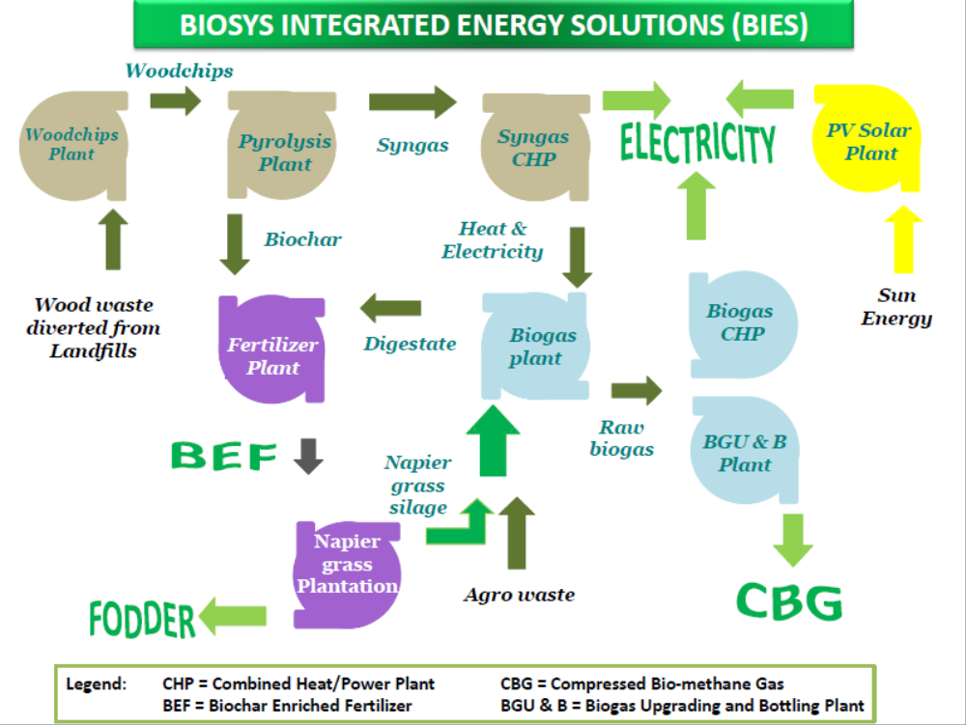

- Guided by the outcome of the pre-feasibility study, observations and findings of the UNDP project design team, the outcome of stakeholder consultations, information provided by Weltec and general information on biogas, a financial analysis has been prepared on the feasibility of the proposed biogas /bio-methane digester by BioSys. The assumptions are that revenues can be generated through the generation of electricity using a Combined Heat and Power (CHP) unit, use of direct heat and income from the sales of bio-fertilizer. Expenditures include cost for feedstock, operational cost for the borehole/water supply, transport cost, 7% own power use, personnel cost, depreciation, maintenance and operation cost (10% of investment cost), renewable and repairs, taxes, interest on investment.

- The current BPC rate for power supply for large-scale companies is used: BWP 0.43/kWh. Revenues can be generated through the utilisation of heat and sales of bio-fertilizer. Conservative figures are used for these revenues. It is assumed that the total amount of the investment consists of a loan at 11.7% interest per annum and a repayment period of 10 years.

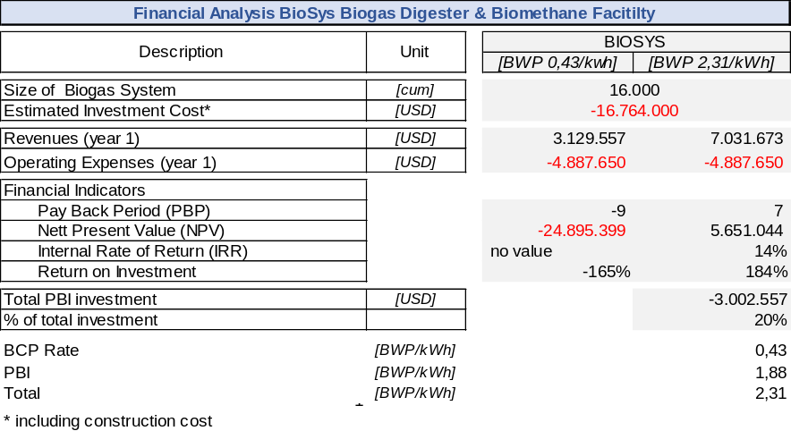
Table 7. Financial analysis, BioSys.

- With a rate of BWP 0.43/kWh as the benchmark for the feed-in tariff to the grid or replacement of power supplied by BPC, it is observed that the proposed biogas technology is not financially attractive: it would entail a negative NPV and a negative return on investment. To arrive at an IRR of approximately 14%, as is assumed in the PIF, a rate of BWP 2.31/kWh is required: i.e. an additional payment of BWP 1.88/kWh, on top of BPC’s standard tariff, would be required.

- According to a study carried out in Sweden, the additional cost for upgrading biogas to bio-methane can range between BWP 0.08 and 0.16 per kWh. This excludes the investment cost for technology to upgrade biogas to biomethane – for example, the cost of a water scrubber, the cost of a 200 Bar compressor, special CBG bottles, etc. – and, further, assumes that the existing distribution chain for LPG can be used at no additional cost. Information from technology suppliers indicates that the cost of upgrading from biogas to bio-methane is approximately US$ 1.2 million for an installation with a capacity of 200 m³ biogas per hour. Based on these cost estimates, it is clear that additional subsidies would be required to make an upgrade to bio-methane financially attractive. Moreover, these additional costs should be considered in the context of clear feedback from Botswana financial stakeholders, such as Barclays Bank, that biogas projects must be bankable in order to be considered for financing.

- To make investment in medium- and large-scale biogas technology attractive, a number of options can be considered.
- An additional payment per kWh to top-up the current rate paid by BPC to power generators. This can be a performance-based incentive. The exact amount needed to top up the current BPC rate of BWP 0.43/kWh is not yet known as there are no IPPs in Botswana. Initial calculations indicate that the power generated with biogas is at least BWP 1.4/kWh. This would mean a top-up of BWP 0.97/kWh. Power generated with a diesel operated generator is BWP 3/kWh, making biogas a financially attractive option in comparison.
- A reduced interest rate, an extended loan repayment period (more than 10 years) or the provision of a grant. These options were assessed and the grant provision for the performance-based incentive (PBI) (in the form of a price for each kWh produced) was determined to be the best approach as it is explicitly linked to ongoing energy generation (i.e. successful operation of the digesters). The reduced interest rate and extended loan tenor approaches will also be explored in conjunction with local commercial banks, but these are less amenable to direct GEF support at this point in time.
- A reduced investment cost (cheaper biogas technology). However, this might affect the quality and lifespan of the biogas system.
- Increased production of biogas through additional feeding of maize, grass, etc. A higher biogas yield results in additional electricity output (kWh). This is a technical option that could be considered in a situation whereby there is abundance of maize or grass but is not being considered by the project due to shortages of these commodities in relation to their primary economic use in Botswana, feeding livestock.
- Enforcement of the Waste Management Policy, whereby industries and polluters are penalised if they do not comply with the Policy. Investing in green technologies will thereby become financially attractive compared with the alternative of payment of fines for non-compliance. Industry might consider developing an agreement for voluntary compliance with the Waste Management Policy. It should be noted that this is an option that is not yet in place in Botswana but can be introduced during the development of the Integrated Waste Management Policy.
- Tax revenues are allocated for the promotion and investment of green technologies.
- Mobilisation of carbon credits.

Strategy

Project Objectives, Outcomes, and Outputs
- The objective of the project is to facilitate low-carbon investments and public-private partnerships in the production and utilization of biogas from agro-waste in the districts of South-eastern Botswana.

- The UNDP-implemented, GEF-financed project will build on the work done to date in Botswana with regard to waste management. It will facilitate the most practical and affordable biogas technology that can meet the operational conditions in Botswana and address the most critical waste issues and energy demands. The project will build on the work done by DWMPC, the Department of Energy and other relevant institutions. It will facilitate low-carbon investments and public-private partnerships in the production and utilisation of biogas that will result in improved waste-management practices and provide access to secure and sustainable biogas energy for agro-industry, institutions, residences and council services. The project has four strategic elements:

- Creating an enabling environment that supports the market development of agro-waste management and biogas technology, stimulating investments in biogas technology and increasing uptake of such technologies through new policies, tools and financial incentives.
- Institutional and private-sector strengthening and capacity development for biogas technology development and servicing, and improved agro-waste management and regulation through awareness-raising, training and dissemination sessions.
- Facilitation and establishment of biogas installations: these include small, medium and utility-scale biogas plants in South-Eastern Botswana.
- Facilitation and establishment of appropriate utilisation and knowledge platforms.

- These four elements are expected to work in synergy, organising and enhancing the baseline project so as to promote global environmental benefits (enhanced climate change mitigation) and make the transition from loosely-connected concepts to biogas sector development and targeted investments.

The underlying theory of change that drives the project is described below.

Theory of Change
- The latent market potential for biogas in Botswana is considerable. The project takes a facilitation and demonstration approach to introducing biogas technology from agro-waste. Through this approach, the four-year project is designed to achieve a well-functioning enabling environment whereby waste-management policies and regulations are implemented and enforced, demonstration biogas plants constructed and operational, and investment in biogas technology demonstrably increased.

- The theory of change illustrated below has been designed based on the challenges related to environmental pollution and waste management in Botswana. The project is designed to facilitate capacity development and learning. It incorporates a feedback loop to ensure that results on approaches and activities are collected and fed into an annual review by key stakeholders. This will enable analysis and adaptation of the model and ensure activities remain aligned with the achievement of results.

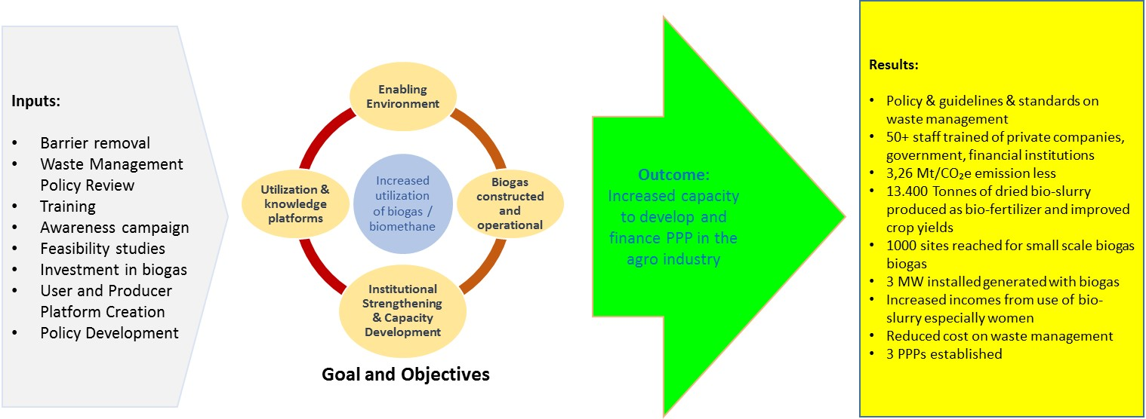
Figure 2. Theory of Change

- Removal of identified barriers to the use of biogas technology will also provide the private sector with the necessary incentive to improve its services and set up new businesses for the sale of biogas technology. This will benefit (rural) customers in Botswana in that they will have access to environmentally clean energy technologies.

- The project seeks to facilitate the installation of at least 1,000 small-scale biogas plants, the construction and commissioning of three 1 MW capacity medium-scale biogas plants, a ready-to-implement proposal for a utility-scale bio-methane installation, and the basis for sustainable market growth by:

- Establishing an enabling policy and institutional and regulatory framework to provide the basis for sustainable market growth of biogas applications and for attracting adequate financing for the required investments.

- Supporting the design and formulation of small-scale biogas plants that can be easily replicable, with small (agro) business, schools, households and livestock-rearing farms the main beneficiaries.

- Supporting the design, construction and operation of Botswana’s first three medium-scale agro-industry biogas plants of approximately 1 MW each as demonstrations in order to enhance general awareness of biogas, capacity development and further knowledge development by the end of the project.

- As a result of these combined efforts, stakeholders will be sufficiently informed and enabled to design and develop a commercial, large-scale, centralised utility biogas installation owned by multiple shareholders, utilising multiple waste streams and with an option to upgrade from biogas to bio-methane.

- Institutional strengthening and enhancing the capacity of the Government, private sector and community to utilise waste.

- Facilitating the establishment of biogas operation and knowledge platforms in at least two districts and one town council to support the development of the biogas market.

- The proposed timeline is presented in the table below. Over time, the enabling environment will be developed, as well as the capacity to deal with biogas/bio-methane, thus allowing for incremental development of the waste-management/biogas sector in terms of technology and operational complexity.

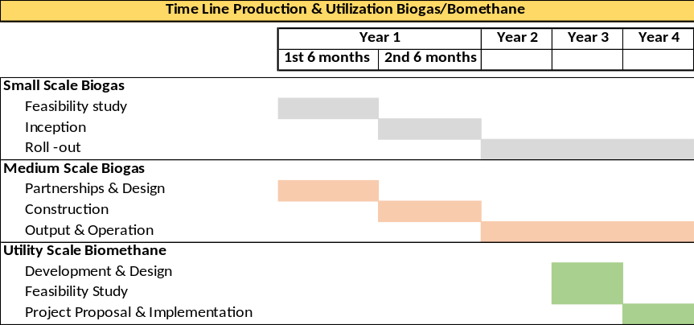
Table 8. Proposed Timeline

Project Component 1
Institutional strengthening and capacity building for biogas investment and improved agro-waste management and regulation

Outcome 1.1: Increased capacity of Government, the private sector and stakeholders to develop, finance and implement PPPs in the agro-waste sector.
- For this outcome, the project will encourage institutional strengthening and capacity building to promote improved agro-waste management and regulation for centralized and decentralised, grid- and non-grid-connected power generation, with a particular focus on the application of biogas installations. Under the umbrella of the process for developing an updated National Waste Policy and a National Waste Management Plan, guidelines and standards will be developed for low-carbon solutions and the utilisation of biogas technologies for (agro) solid and liquid waste.

- A framework agreement for public-private partnerships in the waste sector will be developed and disseminated. The project will support this process through the establishment of a multi-stakeholder platform specifically set up for this purpose. The members of this multi-stakeholder platform will identify and implement the appropriate actions to make PPPs in the biogas sector a reality. The outcome of this multi-stakeholder platform will be communicated by the same participants to relevant parties and, where required, specific training will be offered.

- The project will support the required background analysis, consultations, awareness-raising and capacity-building of the key stakeholders in order to finalise the drafting of the guidelines for waste management, standards for biogas technology and PPP framework. It will build on the experiences and lessons-learned in other countries and will benefit from the results of a number of international projects that have been undertaken in other countries. Topics will include legal, regulatory and institutional barriers to successful development of a biogas sector utilising agro-waste.

- Through workshops, seminars and networking meetings, relevant stakeholders will be informed and put in a position to develop and formulate the guidelines on waste management, standards for biogas technology and PPP framework on waste management and biogas technology. When required, the project will bring in relevant human resources to deliver on selected issues.

- The UNIDO-implemented, GEF-financed project, ‘Promoting organic waste-to-energy and other low-carbon technologies in small and medium and micro-scale enterprises (SMMEs): accelerating biogas market development’ (PMIS 5704) was CEO-endorsed in January 2016. The UNIDO and UNDP project development teams have been in close contact throughout their respective project preparation periods.

- Under Component 1 (‘Capacity building and technology system’) of the UNIDO project, UNIDO plans to hold a regional training workshop in conjunction with the SADC Centre for Renewable Energy and Energy Efficiency (SACREEE) in Namibia to enhance the capacity of market actors to assess and characterize waste streams, to understand biogas technology options and to realize investment projects. The two GEF-financed projects have agreed that the Botswana UNDP-GEF project will assist in the design and funding of this workshop. A second joint regional workshop will focus on standardized training of biogas technicians; this will, in turn, inform (and be informed by) a collaborative effort to develop a longer-term SADC-recognized training programme for technicians. In the absence of such a programme, the region – including Botswana – will be served by variable-quality technicians poorly-equipped to catalyze the sector, and who may actually serve to undermine investors’ confidence and sector credibility.

- With a total human population of just over 2.1 million people and a cattle population of 2.22 million (Statistics Botswana, 2012), the volume of cow dung and waste products produced annually (3 kg dung/LSU/day) in Botswana is significant and remains an under-utilised source of potential biogas. During the project preparation phase, preliminary information was collected to calculate the market potential for biogas technology. There is, however, a need for detailed market information on the full potential of biogas from agro-waste and a market feasibility study is, therefore, required that assess in detail the potential for small-, medium- and utility-scale biogas. A database will be developed and, through the Department of Waste Management and Pollution Control (DWMPC), the management of waste streams will be mapped and monitored. Through this monitoring system, a green certification system will be introduced. Companies, institutions, agro-industry and others with satisfactory waste management systems in place can be awarded performance-based incentives. The precise details of these performance-based incentives will be determined during the implementation phase and they might not necessarily be financial incentives. Accordingly, the capacity of DWMPC will be developed and support provided to manage the expansion of activities and responsibilities.

- Draft amendments will be made to the existing laws and regulations and new regulations introduced to ensure adequate quality control in the construction of biogas technology and provision of services.

- Biogas can be utilised to generate electricity and can be used in an off-grid modality or as a grid-connected power supply. As the latter is of particular interest to investors (to guarantee a timely return on investment), the current proposal for the REFIT (Renewable Energy Feed-in Tariff) will be reviewed and where possible modified to suit the needs of the biogas sector by providing sufficient top-op on the existing power rate.

Outcome 1.2: Increased capacity of Government authorities to monitor and assess the effectiveness of incentives, ensure quality and enforce guidelines and standards related to waste management in the agro-industrial sector.
- A baseline study is the first step in a good planning, monitoring and evaluation system. At the beginning of the project, a baseline study will gather key information on the proposed sites for biogas digesters, with potential waste streams for biogas at district/town/city council level providing the base for monitoring and evaluation so that judgements can be made later about (the contribution to) the quantity and quality of development results achieved by the intervention. The baseline study will also include a comprehensive supply-chain and demand-side analysis.

- The project will support the Department of Waste Management and Pollution Control (DWMPC), town councils and city councils in improving the monitoring and enforcement of Trade Effluent Agreements (TEAs) between agro-industrial firms and local authorities. Stakeholders will, as soon the Integrated Waste Management Policy has been formulated, determine their modalities to improve the monitoring and enforcement in conjunction with the Ministry of Local Government and Rural Development.

- For medium-scale biogas digesters, a fee per kWh produced will be paid for a pre-determined period depending on the total investment, operational cost and other factors influencing the financial analysis. This will serve to accelerate the return on investment and ensure continuous output. If a project fails to generate power, it will be at the expense of the investor(s). Provision of performance-based incentives will be an important marketing tool. They will be linked to pre-defined quality standards (only quality-certified projects will qualify for incentives) and will support private sector investment in biogas technology and its construction. The construction of medium-scale biogas plants will be financed by private-sector partners, commercial banks and Government partners (BMC or BDC).

- The Government of Botswana is in the process of introducing a renewable energy feed-in tariff (the REFIT) after many years of preparations. It is not yet clear when, precisely, the REFIT will be fully operational. The performance-based incentive support from the GEF-financed project can therefore be considered as a bridging arrangement. After the project implementation period (i.e. after 4 years), the REFIT will certainly be operational and can take over as a de facto performance-based payment.

- BPC is gradually increasing the tariffs of the electricity sold to consumers. This development will close the gap between the cost for production of power and the sale of power, suggesting that power supply will in the near future be at commercial rates and a level playing field will be created. BPC can, in theory, enter into a power purchase agreement (PPA) if the price is considered reasonable. The GEF-funded performance-based payment will no longer be required one year after the project period, assuming a rate of BWP 0.77/kWh (2015) and an annual increment of 14% for each year of the GEF project: i.e. from 2016 to 2019. For the performance-based payment, total funding of USD 635,000 is required. This represents 24% of the total GEF budget.

- Biogas is a new technology and the performance-based payments can be considered a stimulus measure towards the development of the sector. Through these payments, the project will maintain control over the quality of the proposed biogas technology, appropriateness of design and service delivery by technology providers. Further, with a performance-based payment system in place, it will easier to bring in investors to support biogas market development in the country. By the end of the project, local investors such as BDC will have gained sufficient capacity and confidence to support biogas technologies in the commercial sector.

- To ensure that competitively-priced biogas technology is of good quality and related after-sales services are effective and lead to customer satisfaction and market growth, a credible and effectively enforced quality-control scheme is required. Through the participation of stakeholders, including regulators, system designers, constructors, equipment vendors, potential manufacturers, system installers and repair and maintenance specialists in the South-Eastern region, quality and operational standards will be developed, and will be augmented with training materials and manuals, workshops and ‘on-the-job’ training.

- The project will facilitate training of key stakeholders, including the public authorities responsible for implementing the waste management policy and biogas programme and local service providers, such as installers, to meet the minimum quality requirements. For this, the project will cooperate closely with local universities and professional and vocational schools to ensure that, for instance, there will be a sufficient number of trained and certified biogas technicians available in the market.

- A certification scheme will be developed, which will be managed by the Botswana Training Authority (BOTA) and the Botswana Bureau of Standards (BOBS). The scheme will verify that adequately trained and skilled biogas installers are hired and that the biogas hardware supplied for installation projects comes with (inter)nationally recognised quality certificates and has adequate warranties. In the case of faults, the installers will be responsible for providing service under warranty and for communicating with equipment manufacturers throughout the warranty period of the installation.

- Masons, both women and men, and construction companies will be trained in technical aspects of biogas installation and operation (construction, maintenance and repair), and also on promotion (how to attract new clients), plant sizing and selection, user outreach (how to explain operation and maintenance tasks to the user, including trouble-shooting and minor repairs) and handling user feedback. A typical new mason’s training will be divided into two parts and will include 14 days’ training at a training institute, plus on-the-job training in the form of constructing a biogas digester under close supervision (supervised training).

- A suitable training institute will be identified in South-Eastern Botswana for facilitating training on biogas technology. The staff of this institution will undergo a tailor-made training programme and will be authorised to conduct training on biogas. The institute shall be authorised to accredit certified biogas technicians.

- Individual masons and construction companies will be responsible for the construction of 1,000 small-scale biogas digesters in Botswana, the provision of user training, after-sales service and guarantees.

- The international biogas companies that are identified, through a tendering process, to construct the first medium-scale biogas digesters in Botswana will be responsible for training the staff of the institute offering biogas training and the staff of the company identified for the day-to-day operation of the biogas installation. The training institute will, in turn, train staff of town councils, district councils, agro-industry and the private sector. The initial training will be offered at a reduced rate and will gradually be offered on a full cost-recovery basis. The international companies will be asked to prepare a capacity development plan as part of the overall tender for the construction of medium-scale biogas plants.

Outcome 1.1 & 1.2 | Outputs | Activities
Increased capacity of Government, private sector and community stakeholders to develop, finance and implement PPPs in the agro-waste sector.  Increased capacity of Government authorities to properly monitor and enforce waste management regulations in the agro-industrial sector. | - Specific guidelines and standards on low-carbon alternatives and utilisation technologies for agro-waste and wastewater developed and disseminated to all relevant stakeholders in the sector.  - Framework agreement for public-private partnerships (PPPs) in the waste sector adopted and disseminated.  - Training conducted for all relevant stakeholders on the new guidelines and PPP framework agreement (1.1. and 1.2)  - Updated regulations developed and adopted for the successful monitoring of effluent flows and by-product waste in all abattoirs in the country, including launch of a “green certification” waste-management award for industry actors.  - Support provided to the Department of Waste Management and Pollution Control (DWMPC) and District Council authorities to improve monitoring and enforcement of Trade Effluent Agreements between industries and local authorities.  - Review of enforcement practices and support towards enforcement of pollution prevention laws, mainstreamed into relevant organisations’ activities: e.g. Councils or DWMPC.  - Corrective EIA measures implemented. | 1.1.1 Establishment of a multi-stakeholder platform (MSP) to define guidelines and standards (national level); regular stakeholder meetings.  1.1.2 Organise short workshops with sector experts to introduce new approaches and technologies.  1.1.3 Study tours in Botswana and to an African country that has been successful in developing the biogas sector.  1.1.4 Key stakeholders facilitate MSP at district level.  1.2.1 Workshop and follow-up meetings to identify framework agreement.  1.2.2 Share experience with PPPs in other countries; experts will be invited to present latest developments/practices on waste management  1.3.1 A training institute is identified and contracted to facilitate training and capacity development.  1.3.2 Development of training materials  1.4.1 Establishment of MSP for regulations and monitoring.  1.4.2 Identification of an institution to develop the green certification protocol to be adopted by sector stakeholders.  1.4.3 Annual event organised to promote green companies.  1.5.1 Support to ongoing initiatives by DWMPC to organise MSP meetings, workshops, study tour, visits by experts, training.  1.6.1 External assessment and results shared with stakeholders.  1.6.2 Adjustment of current practices and information published and disseminated.  1.7.1 DWMPV and Councils to monitor the implementation of EIA through project visits.
Table 9. Overview of Outcomes 1.1 & 1.2: outputs and activities

Outcome 1.3: Autonomous support systems in place for the replication and scale-up of agro-waste technologies post-project
- Although interested and willing, the financial sector in Botswana has not yet fully recognised the full potential of biogas technology as an investment opportunity. The absence of such recognition and support from financial institutions is a barrier to potential investors when they need capital to install biogas digesters. Biogas technology has high initial capital requirements. For that reason, financial measures will be put in place to overcome this barrier.

- A mechanism needs to be established to make reasonable finance available for small-, medium- and large-scale biogas digesters. Preferably, this finance should be channelled through existing, regulated banking institutions. One of the options for promoting low-carbon investments can be through establishing a platform or joint venture with potential investors, financial institutions, town councils, city councils and the private sector. This options to promote low-carbon investments will be explored in detail during the implementation of the project.

- The project will support awareness-raising on waste management and the application of biogas technology. DWMPC will play an important role to: (i) promote biogas technology; (ii) represent the interests of the supply-side in further policy dialogue; and (iii) become a knowledge-management and eventual training centre for issues associated with further promotion of the biogas sector in Botswana.

- Stakeholders, including financial institutions, council and municipality staff and the private sector, will be trained in best practice in assessing and financing agro-waste projects, with a particular focus on biogas. Initial capacity development will be supported by the GEF project. Vocational-training centres will integrate a module on waste management and biogas into their existing curricula. It is expected that these courses will, initially be supported by the GEF and, over time, be offered at cost-recovery rates.

- At the national level, Government institutions, NGOs, the private sector, the mass media, microfinance institutions, community-based organisations such as cooperatives and others will be mobilised in order to create general awareness on waste management and the promotion of biogas. Coordination of promotional activities will be the responsibility of a Biogas Working Group (BWG). Stakeholders will jointly implement activities including: development of a detailed plan of action to disseminate information on biogas; the printing/distribution of different written information materials; organisation of orientation training to the institutions and agro-industry on the benefits of biogas; establishment of networks with organisations working in the biogas sector and dissemination of biogas information through these networks; participation in exhibitions and national school competitions; council-level promotional campaigns and biogas-awareness workshops; use of (social) media and mobile-phone messages.

- As part of the project’s awareness-raising, study tours will be arranged to relevant countries – such as South Africa – with agro-waste biogas projects. In addition, visits will be arranged to industry events, such as trade shows. The objective is to create a group within Botswana that is well connected to the international waste management and biogas industry and is well aware of market developments, so that this group can exploit these developments for the benefit of Botswana.

Outcome 1.3 | Outputs | Activities
Autonomous support systems in place for replication and scale-up of agro-waste technologies post-project | - Financial institutions trained on best practices in assessing and financing agro-waste projects through BITRI.  - Dedicated investment facilitation platform on low-carbon waste-utilisation technologies established at BITRI, and operational with independent budget.  - Level playing field created for all energy providers and REFIT in place. | 1.8.1 Capacity developed to provide training for financial institutions and other relevant stakeholders.  1.8.2 Study tours/knowledge exchange facilitated between project stakeholders and other agro-waste-to-energy projects in the region, including those supported by GEF.  1.9.1 BITRI will organise consultation meetings to identify options for the setting up of an investment-facilitation platform or similar structure.  1.10.1 Provide technical and financial support towards development and implementation of REFIT by engaging expert to share experiences from other countries.
Table 10. Overview of Outcome 1.3: outputs and activities

Project Component 2
Facilitation and establishment of the first biogas plants in Botswana.

- Due to the outcome of the pre-feasibility study, extensive stakeholder consultations and observations by the project preparation consultants, there is a deviation from the original proposal, as described in the PIF, to establish a large-scale bio-methane installation. The main considerations are:

  - This large-scale biogas installation (16,000 m³) would require continuous feedstock of approximately 300 tonnes per day, including chopped wheat bran and maize to ensure that sufficient biogas is generated for upgrading to bio-methane. Using this type of feedstock is considered inappropriate as food security is an issue in Botswana.
  - In addition, multiple waste streams are proposed for operating the biogas installation. Currently, these waste streams can be collected for free. However, an initial risk analysis indicates that this situation might change over time and owners of waste streams might start charging in the near-future as waste becomes a valuable commodity. This will jeopardise the functioning of the biogas installation, with a high risk that the cost of its operation might exceed income. Such high risk is likely to deter potential investors.
  - Upgrading from biogas to bio-methane can only be economically viable on a larger scale. In addition, biogas technology in Botswana does not have a robust track record and there will be insufficient capacity at the beginning of the project to run this high-end technology. On the other hand, capacity can be developed over time within the time-frame of this project to a sufficient level. It is therefore proposed that the development of such high-end technology is postponed until the third or fourth year of the project. By that time, sufficient capacity will have been created in Botswana so that stakeholders can make a well-informed decision on how best to invest in bio-methane technology.
  - The proposed technology is centralised and requires waste streams from all the councils of South-Eastern Botswana. A pre-condition is that councils invest jointly in such an approach. Councils have indicated they prefer to pursue smaller-scale approaches within their jurisdictional boundaries.

Outcome 2.1: Increased investment in biogas technologies and low-carbon practices in the agro-waste, small-scale farming and institutional (e.g. schools) sectors.
- A three-pronged approach will address Outcome 2.1. Small- and medium-scale biogas digesters will be constructed and continuous operation will be ensured. In addition, these biogas digesters will demonstrate that, with (private) investment, biogas technology is applicable in the Botswanan context and is commercially viable. As a result of these demonstration plants, relevant capacity will be developed on design, construction, operation, investment and regulatory aspects.

- A programme will be developed and implemented to promote small-scale biogas digesters. Through the promotion of small-scale biogas digesters utilising waste streams from small-scale agro-business, the livestock-rearing industry, institutions and rural households, fossil fuels will be replaced by renewable energy, unsustainable utilisation of wood will be reduced, and high-value organic fertilizer from the bio-slurry will be utilised.

- For the construction of small-scale biogas digesters, the fixed dome biogas design will be used and will be constructed by a (local) mason or a local construction company. The size of these small-scale biogas digesters will vary from 4-300 m³. Biogas will be used directly for cooking, lighting or electricity generation.

- The project will commision a feasibility/market study, including a detailed outline of a programme to promote small-scale biogas digesters in South-Eastern Botswana. The feasibility study will be conducted in the first year of project implementation. The actual roll-out period of the small-scale biogas programme will be three years. At the end of the three years, 1,000 small-scale biogas digesters will have been constructed.

- Potential users of the small-scale biogas digesters are expected to invest in the installation of the technology. This own-investment is justified as the financial benefits of biogas technology are such that the expected payback period is less then three years and a personal contribution will ensure ownership; the broader benefit for the project is that user investment will help to ensure that the biogas digesters are properly operated and maintained. The expected investment cost ranges from US$ 800 (6 m³) to US$ 50,000 (300 m³). To overcome these upfront investment costs, the project will facilitate the availability of credit through established financial institutions such as Barclays Bank of Botswana. Financial institutions will use their own funds for making credit for biogas available; the project will assist to design this financial product, create awareness of the benefits of biogas and assist with financial analysis. In addition to the commercial credit, the project will make USD 50 available for each small-scale biogas digester as a completion incentive for construction of quality biogas digesters. The project will also provide support towards the training, marketing, M&E, quality management, project coordination and utilisation of bio-slurry.

- At three locations in South-Eastern Botswana, a public-private partnership between agro-industry (and financiers) and the council will be established with the aim of constructing a biogas system utilising locally-available waste streams. Depending on the size of the waste streams, a medium-sized biogas digester of approximately 300-5,000 m³ will be constructed, with an average expected feedstock input of 100 tonnes per day. The biogas generated will be used for generating electricity using Combined Heat and Power (CHP). Per project site, it is estimated that 1 MWe will be installed. Electricity will either be used on- or off-grid, depending on the context, with at least one of the 3 locations grid-connected so that the GEF project can build up stakeholders’ expertise (including Botswana Power’s) in this important sub-sector. Excess heat will be utilised for production processes in the agro-industrial firm. Additional income will be generated from the sale of bio-fertilizer. To reach farmers in Botswana, bio-fertilizer will be packaged and presented in small quantities (10-50kg bags), allowing for easy transportation and distribution.

- The proposed technology will be provided by international biogas companies with a proven track record. Various technology options are available: lagoon biogas digesters, High Rate Anaerobic Ponds (HRAPs), Continuous Stirred Tank Reactor (CSTRs) and plug flow, each with its own characteristics and suitability for the Botswanan context. These technologies change rapidly and improve continuously with increased efficiency. To ensure that the most efficient and effective technologies are installed, the final selection of the technology for each site will be determined during the implementation of the project. For each site, a number of companies will be shortlisted and invited to conduct a feasibility study on a cost-recovery basis. Based on these feasibility studies, three companies will be invited to participate in a tendering process.

- To ensure continued digester operation for at least fifteen years, the project will place emphasis on the selection of high-quality, durable biogas technology. Construction materials will be resistant to the corrosive biogas environment, and designs will guarantee the utmost safety to prevent any negative environmental impact or risk to operators and the population.

- For the small-scale biogas programme, one Environmental Impact Assessment (EIA) will be performed; the three medium-sized biogas systems will be subject to an EIA each. The cost of these EIAs will be covered by co-finance contributions.

- Digestate: Medium-scale digesters: After digestion, the digestate will be separated into a wet fraction and a dry fraction. The wet fraction will be stored or used directly to fertilize feedlots or other plantations close to the biogas facility. The dry fraction will be dried using the excess heat of the CHP. The dried digestate will be sold to an organic fertilizer company or pelletized at the biogas facility itself. The organic fertilizer pellets can then be easily transported throughout Botswana.

- Small-scale digsters: The digestate will be collected in compost pits and mixed with organic materials. From time to time, the mixture will be tilted. When composting is completed it can be removed from the pit and transported to nearby farmers and applied as organic fertilizer. The risk of pathogen contamination in food grown using bio-slurry is less than that using fresh farm yard manure, the current predominant standard practice. Nonetheless, simple-to-use guidance materials will be provided to small- and medium-scale digester owners, advising them on how to safely use digestate.

- A private company, Organic Fertilizer Manufacturers Botswana, currently applies South African standards for bio-fertilizer in order to be able to export bio-fertilizer. The project will adopt these standards as an interim measure and thereafter stakeholders will agree on quality standards and appropriate utilisation of biogas digestate. Monitoring and certification will be done by the Ministry of Agriculture as part of ongoing agricultural support activities. Under the Integrated Support Programme for Arable Agriculture Development (ISPAAD), the Ministry provides farmers with fertilizers and also provides, through district demonstration officers, guidance to the farmers (commercial and subsistence) on the use of fertilizers. An inventory on the annual use of fertilizers is also maintained. The Ministry is also currently certifying performance standards for horticultural activities, agricultural engineering and sorghum production. The GEF project will use this existing Ministry architecture for regulating fertilizer use.

- Small-scale biogas digesters in Kenya, for example, constructed under the national biogas programme have been financially analysed and show that biogas is a worthwhile investment for small-scale biogas farmers as presented in the table below. It must be noted that the intangible benefits (income) of small-scale biogas digesters are not included in the financial calculation. When monetised, the financial analysis would improve.

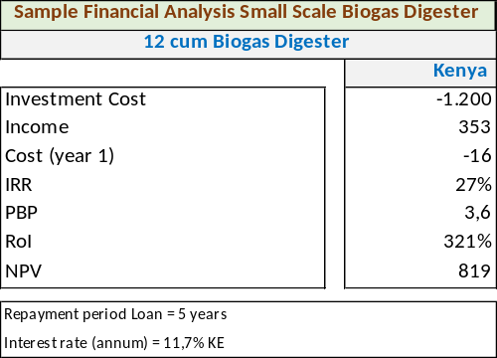
Table 11 Financial Analysis

- The financial viability of the business model for the medium-scale biogas plants is based on an assessment of the cash flows from revenue-based sales of various products produced by the plant (biogas, pelletised organic fertilizer, heat, electricity provision). A further driver for investing in small- and medium-scale biogas technologies will be the enforcement of the newly-drafted Waste Management Policy and Guidelines, which will be supported by the GEF-financed project. An additional driver will be the GEF-supported nationwide awareness campaign and green certification programme. Agro-industry will be able to utilise the green certification as a marketing tool.

- As part of the capacity-building component of the project, a training programme that attracts both women and men to the biogas sector will be developed, providing both academic and vocational training and certification to create a cadre of competent waste-management/biogas professionals. The training will cover all aspects, from initial design to operation and maintenance. The training will be carried out through national and regional networks of universities and teaching and training centres.

- To develop widespread awareness of waste management and the opportunities to utilise biogas for energy production and bio-fertilizer, awareness and knowledge materials will be developed that specifically target existing and new market entrants and highlight the emerging market opportunities for biogas. A series of stakeholder workshops will be held in conjunction with the councils and investment bodies (such as BDC).

Outcome 2 | Outputs | Activities
Increased investment in clean-energy  technologies and low-carbon practices in the agro-waste sector. | - Sensitisation campaign conducted with district councils, stakeholder and community groups in targeted biogas plant sites | 2.1.1 A series of meetings is organised to provide information on the pros and cons of biogas, as well as opportunities for employment and agriculture and energy use.
 | - Feasibility study undertaken for small-scale biogas digester component.  - Business plan developed for the three potential medium-scale biogas sites near agro-industrial plants with potential off-take uses analysed.  - Feasibility study undertaken on centralised large-scale biogas plant with bio-methane upgrade.  - Environmental impact assessment of selected biogas sites completed.  - Tender launched for operator of the medium-sized biogas plant.  - Legal establishment of biogas operators based on public-private partnerships and concessional agreements with chosen agro-industrial partners (including guaranteed supply of substrate and purchase agreement for supply of biogas).  - Technology agreement signed on North-South or South-South cooperation with selected international biogas equipment providers.  - Construction and commissioning of biogas plants. | 2.2.1 Consultants (international and local) identified to perform market study.  2.2.2 Programme modality identified and agreed upon by stakeholders.  2.3.1 Technology providers will be invited to submit proposals to develop business plan (3 per site). The most suitable proposal will be selected by PPPs to undertake a complete feasibility study.  2.3.2 Consultants (international and local) identified and contracted to develop business plan at the three sites.  2.3.3 Detailed business plan developed and assessed on technical and financial feasibility.  2.4.1 Consultants or technology providers identified to perform feasibility study.  2.5.1 EIAs conducted in line with Government policy.  2.6.1 Technology providers for each of the 3 sites are selected as per Government tender procedures.  2.7.1 The project will support the establishment of PPPs and bring in resource persons when required.  2.7.2 Prepare and develop sample contracts and incorporate best practices from similar projects.  2.8.1 The project to facilitate the signing of these agreements and support negotiations where required.  2.9.1 PPPs, with support of the project office, to facilitate and monitor construction of biogas plants, ensure commissioning and operation.
Table 12. Overview of Component 2: outcome, outputs, activities

Project Component 3
Facilitation and establishment of appropriate biogas utilisation platforms in at least two districts of South-Eastern Botswana

Outcome 3.1: Increased investment in less GHG-intensive energy systems using biogas
- Component 2 is dedicated to the design, development and construction of biogas digesters, whereas Component 3 focuses on the operation and maintenance aspects to ensure that biogas is utilised as intended with the aim of safeguarding the reputation of biogas technology and thereby stimulating replication of biogas technology to the market segment not covered under this project. Under Component 3, the feasibility will be assessed for a centralised, large-scale biogas digester whereby multiple feedstock can be utilised and at least two Councils enter into a partnership.

- To coordinate the implementation and monitor the performance of the small-scale biogas programme, a steering committee with be established with delegates from the participating councils in South-Eastern Botswana. The steering committee at the Council Level will delegate day-to-day management and coordination of the programme to a dedicated programme office in each council (Programme Manager, Biogas Engineer, biogas technicians).

- The partnership that has been established between council, investor, supplier and operator under Component 2 for the investment in, and construction of, medium-scale biogas plants (3x) will also include detailed arrangements on issues related to the day-to-day operation and monitoring of the plants, a constant and reliable supply of feedstock, maintenance, repair, (financial) management and utilisation of biogas. Staff members of the partners will be trained on biogas technologies.

- To assess the performance of the constructed biogas plants, a monitoring scheme will be developed and put in place to track fuel savings (from the switch to biogas) and GHG emission reductions.

- For the realisation of a utility-scale bio-methane facility, a detailed feasibility study will be conducted to confirm the financial and operational viability of upgrading from biogas to bio-methane. The utilisation of bio-methane is proposed for a vehicular fuel-switch programme and/or replacement of LPG. The study can be conducted with the support of international companies with a proven track record on biogas refuelling stations and truck-refurbishment schemes. Based on the outcome of the feasibility study and analysis by stakeholders, selected biogas utilisation technologies will be identified, constructed and commissioned, capacity developed and performance will be monitored. This process will be (partially) supported by GEF funds.

- In the third or fourth year of the project period, the design, planning, partnerships and investments will be in place for at least one utility-scale biogas installation in South-Eastern Botswana, utilising multiple waste streams (more than 10) from agro-industry, using Compressed Biogas (CBG) as a possible replacement for diesel and LPG.

Outcome 3 | Outputs | Activities
Increased investment in less GHG-intensive energy systems using biogas. | - Partnership established between biogas plant operators and selected district councils for supply and purchase of biogas from the plants.  - District council staff trained on the biogas-utilisation technologies selected for investment, including operations and maintenance.  - Monitoring scheme in place to track fuel savings (from switch to biogas) and GHG-emission reductions. | 3.1.1 Facilitate meetings with operators, councils and other stakeholders.  3.1.2 Technical and financial advice on utilisation of biogas within the partnership.  3.2.1 Identify training institute to conduct training in biogas.  3.2.2 Facilitate training of trainers at the training institute.  3.2.2 Develop gender-sensitive training materials to be used to train male and female masons.  3.3.1 Design and develop monitoring system with stakeholders.  3.3.2 Exposure and introduction of proven approaches to monitor GHG-emissions; development of a database to monitor performance on actual GHG emission reduction.
 | - Feasibility study conducted to analyse the financial viability and best operational options for use of biogas/bio-methane produced by a large-scale biogas digester as an alternative fuel in district council waste operations.  - Based on outcome from feasibility study, selected biogas-utilisation technologies identified.  - By end of project, at least two (2) district councils in South-Eastern Botswana have developed plans to utilise biogas technologies in their waste operations.  - Contracts signed on performance-based incentive, monitored and made available to biogas owners. | 3.4.1 Identify and contract consultant/technology providers to conduct feasibility study.  3.4.2 BITRI and project office to ensure quality of feasibility study and its relevance to local context through screening of proposals.  3.5.1 Select technology providers to propose biogas technology for the large-scale biogas digester.  3.5.2 Facilitate financing for the biogas plant (construction, operation, maintenance).  3.5.3 Forge partnerships between at least two Councils, agro-waste industries and investors and technology providers.  3.6.1 Project design and development completed and ready for financing and construction (following a similar approach as for the medium-scale biogas digesters).  3.7 Biogas owners receive a performance-based incentive based on actual output in kWh or equivalent
Table 13. Overview of Component 3: outcome, outputs, activities

Key indicators, risks and assumptions

- In accordance with the GEF’s Focal Area Objective #3 to “Promote Investment in Renewable Energy Technologies” of the GEF-5 Climate Change Strategy, the key success indicators of the project are:

- A favourable policy and regulatory environment is created for renewable energy investments: extent to which RE policies and regulations are adopted and enforced.

- Investment in renewable energy technologies is increased: volume of investment mobilised.

- GHG emissions avoided: tonnes of CO₂ equivalent.

Project-specific outcomes will include:
- An enabling environment is created whereby barriers are removed and comprehensive policies and regulations on waste management are developed, adopted and enforced;
- Biogas digesters are constructed to demonstrate the feasibility of their application throughout Botswana.
- Biogas is full-time operational: >95% of small-scale digesters function daily, medium-scale biogas installations operate 360 days a year with a maximum of 5 days lay-off for maintenance.
- 1,000 small-scale biogas digesters and three medium-scale biogas plants are constructed and operate according to specifications.
- Training is undertaken to create capacity to design and develop a utility-scale biogas/bio-methane facility.
- Government policies, regulations and financial incentives are established to promote investment in systems for waste management, with a particular focus on biogas technology.
- Human capacity developed in Government, the private and financial sectors, academia and local communities to support the biogas sector in Botswana.

- Construction and operation of a biogas plant comes with a number of safety issues, potential risks and hazards for humans, animals and the environment. Biogas plants pose the risk of explosion, fire, injury from mechanical and electrical operations, skin burns from hot surfaces, noise, asphyxiation and poisoning. Under certain conditions, biogas in combination with air can form an explosive gas mixture. The risk of fire and explosion is particularly high close to digesters and gas reservoirs. If biogas is inhaled in sufficiently high concentrations, it can result in poisoning or asphyxiation symptoms and even death. The presence of hydrogen sulphide in non-desulphurised biogas can be extremely toxic, even in low concentrations. A plant can also be struck by lightning if not properly constructed.

- Waste of animal and human origin, used as digester feedstock, contain various pathogenic bacteria, parasites and viruses. Pathogenic species that are regularly present in animal manures, slurries and household waste are bacteria (e.g. Salmonellae, Enterobacter, Clostridiae, Listeria), parasites (e.g. Ascaris, Trichostrangylidae, Coccidae), viruses and fungi. Co-digestion of abattoir and fish-processing wastes, sewage sludge and bio-waste increases the diversity of pathogens. After the digestion period, the bio-slurry is very likely to be land-spread and could enter the animal and human food chains. Utilisation of digestate as fertiliser means application on the fields of several individual farms, with the risk of spreading pathogens from one farm to another.

- Proper precautions and safety measures to avoid these risks and hazardous situations, and ensure a safe operation of the proposed biogas plants, will be undertaken. Potential dangers that could result from operation of biogas plants will be marked with visible warnings on the respective parts of the plant and operating personnel will be trained accordingly.

- Veterinary safety measures will be undertaken in order to prevent new routes of pathogen and disease transmission between animals, humans and the environment. The lifetime of pathogens depends on the origin of liquid manure. Salmonellae, for instance, survive longest in cattle slurry, but pig slurry, on the other hand, contains more infectious organisms due to higher livestock density and the presence of pathogens in the feed. Effective control of pathogens will be implemented through applying sanitary measures: livestock health control, feedstock control, separate pre-sanitation of specific feedstock categories, controlled sanitation, and verification of pathogen reduction.

- The EIA to be undertaken for the small-, medium- and large-scale biogas digesters must indicate how important safety issues will be fulfilled, and stipulate clear preventive and damage control measures as a condition for obtaining the construction permit from the Department of Industrial Affairs. In addition to hygienic and veterinary considerations, the EIA will also address safety, avoidance of air-polluting emissions, prevention of ground and surface water leakages, avoidance of pollutant release during waste disposal, and flooding safety.

- Training of biogas plant construction and operating personnel will be aligned with the Government’s occupational health and safety regulations, which are already available in easy-to-use booklet form. The biogas training to be supported by the UNDP-implemented, GEF-financed project will, therefore, include a specific module on health and safety in the workplace. This module will be delivered by staff from the Division of Occupational Health and Safety in the Ministry of Labour and Social Security. Furthermore, the trainees will be assessed against the Botswana Training Authority’s (BOTA’s) Occupational Health Standard. This Standard will assess the trainees’ ability to comply with set health and safety requirements. The Workers Compensation Act will be followed should any unfortunate incidents occur to personnel at the biogas plant. The Act provides for compensation of workers for injuries suffered or occupational diseases contracted in the course of employment, or for death resulting from the workplace.

Expected Benefits, Design Principles and Strategic Considerations

- The calculated greenhouse gas (GHG) reduction benefits of the project are:

  - Direct GHG emission reductions arising from the use of biogas digesters supported by project funding.
  - Indirect GHG reductions as a result of improved waste-management practices. Untreated waste streams emit methane into the atmosphere.

- The direct CO₂ emission reductions attributed to the project are estimated as 901,836 tCO₂e over the 15/20-year lifespans of biogas digesters. The total (direct and top-down indirect) emission reductions are estimated as 1.88 million tCO₂e, resulting in a GEF cost of USD 1.40/tonne CO_{2e} avoided.

- The associated national and local benefits include reduced local pollution from agro-waste streams, reduced burning of fossil fuels and increased national revenue through the reduction of imported fossil fuels. One thousand small- and 3 medium-scale biogas digesters will process 132 tones of agro-waste per day (292,000 tones per year). This translates into the availability of approximately 29,200 tonne of organic bio-fertilizer with an estimated market value of US$ 5.5 million. A comparable quantity of imported chemical fertilizer would have a market value of US$63 million in Botswana.

- The project will also create jobs at several levels. Biogas technicians and installers are needed to install, operate, maintain and trouble-shoot biogas systems. These are expected to be mid-level women and men technicians with basic mechanical/civil engineering/building backgrounds. They will receive training as part of the project. Job creation is also expected in the biogas supply chain. Certain components can be readily manufactured locally, such as biogas appliances, stoves, steel or concrete structures, as well as other components. Fuelwood for cooking will be replaced by biogas in some households, largely benefiting women and girls.
Risk Analysis

Risk | Level of Risk | Mitigation Action
The technologies proposed – while proven in other countries – are unfamiliar in Botswana and technical capacities in this area are limited.  Technical failures, either due to equipment failure or poor installation, poor operational management, maintenance can lead to loss of trust on the performance of biogas technology. | Moderate | The project intends to utilise proven, feasible and affordable biogas technologies and duplicate solutions that have been successfully introduced in countries with developed biogas sectors.  Through extensive training programmes, sufficient capacity will be developed to ensure guaranteed operation of biogas digesters.
The agro-waste industry in Botswana is slow to adopt new technologies to address waste management from agro-waste. The sector requires incentives or enforcement to attract investors in waste management / biogas technologies.  The investment cost for construction and operating biogas installations are high. The cost of generating electricity from biogas is higher than the cost of electricity supplied by Botswana Power Corporation for large-scale business (0.43 BWP/kWh). | High | The GEF project will support the development of the Integrated Waste Management Policy with clear and transparent guidelines, with inputs from the agro-industry and reinforcement of the policy whereby multiple stakeholders take on responsibility for addressing waste management. The project will support the development and introduction of financial incentives, including the REFIT, with the aim of reducing the financial risks for investors and ensuring bankable projects. Further, the project will advocate for the development of a level playing field whereby Independent Power Producers can supply through the grid in commercial conditions.
There is limited capacity in Botswana relating to biogas technology and to managing biogas systems. There is, therefore, inadequate and/or non-capacitated human resources to successfully implement the project and support the mainstreaming of its results. | Low | Through the GEF-supported training programme, workshops, multi-stakeholder platforms and study tours, sufficient capacity will be created to ensure sound operation of biogas digesters. Stakeholders will be well informed to decide on the most suitable financial and technical option to invest in biogas technology in Botswana.
Lack of adequate and reliable market data to facilitate the monitoring of project impacts and planning of further policy measures. | Low | Baseline data will be collected on the available waste streams for generating biogas, energy consumption of agro-industries and existing waste management practices at the start of the project and monitoring systems will be developed and implemented by relevant institutions. The approach of the project is that stakeholders have a shared responsibility for monitoring.
There is a risk of the Government introducing alternative or subsidised fuels, thus making biogas-based systems less viable and less attractive as an alternative. | Low | The Government, via the Economic Diversification Drive, now enforces the policy of using the Government’s buying power to support locally-produced goods and reduce the country’s reliance on imports. This extends to the energy sector, where indigenous sources of energy are being prioritised over energy imports. Also, the Government is implementing a programme of phased electricity tariff increases, thereby making biogas a more attractive alternative to grid-supplied electricity.
PPPs are not yet widely established in Botswana and therefore the establishment of PPPs by this project could face protracted, bureaucratic challenges. Moreover, the success of the project depends on the successful signing of a concessional agreement between the biogas operator and the provider of the substrate for use in the plant. | Moderate | The Government is strongly committed to increased private sector participation in the waste sector. Since 2014, district councils have been mandated to invest in PPPs to enhance development. This is a new governance arrangement under the Ministry of Local Government and Rural Development. Engagement with all Government and private sector stakeholders has indicated a strong willingness to partner together provided that project investments make economic and social sense for all concerned parties. The strengthening of enforcement and monitoring under Component 1 will further incentivise waste producers such as BMC to seek solutions to waste management in partnership with Councils.
DWMPC’s capacity to fulfil its regulatory function depends not only on capacity-building but also on a more clearly defined mandate and a source of recurring revenue for enforcement activities. The development of improved regulations for monitoring of effluent flows and by-product waste in all abattoirs in the country will not be effective unless DWMPC and the Councils have the capacity to actually apply them in practice. | Moderate | DWMPC is in the process of developing an Integrated Policy on Waste Management and the GEF-financed project will support this initiative through the facilitation of stakeholder consultations and platforms. UNDP has already closely reviewed many of these issues in the context of its support to DWMPC under the ‘Municipal Recycling Guidelines for Botswana Municipalities’ project. The lessons-learned and experiences from that project have informed the design of the activities under this project.
Water use requirements in the agro-waste processing sub-sector are extremely high, and scarcity of water in the future might oblige the agro-waste processing sector to scale-back production, thus producing less effluent to be treated and utilised in any biogas plant. | Moderate/High | Although not the primary focus of this project, the project will do everything possible to advocate for a strategic approach towards water and wastewater management at abattoirs in accordance with the principles of water conservation, waste minimisation and progressive waste treatment philosophies. Water use licences and trade effluent permits should make provision for conditions that will encourage abattoirs to incrementally progress towards improved waste water quality. The guidelines developed under Output 1.1 will cover best practices on minimisation of waste generation at source (including maximising the recovery of useful materials) and curb the practice of washing solids to drain (which transfers waste solids to the liquid medium). BITRI will be encouraged to promote research into cleaner technology and recovery of higher-value products from the waste stream. At present, no abattoir in Botswana operates on a closed water circuit. The reason for this is that wastewater streams generated by abattoirs contain high levels of pollutants and it is generally prohibitively costly to treat to a water quality standard which is fit for recycling or re-use (especially in view of the high intake water quality required). Nonetheless, as part of the feasibility studies for the biogas plant, a variety of water minimisation and treatment/re-use technologies will be costed and analysed, and the principles of water conservation and waste minimisation will be factored into all project activities.
Botswana is prone to drought and reduced rainfall patterns, which can result in major losses to its livestock population from drought-induced mortality and absence of healthy rangelands – which, in turn, can mean significantly reduced cattle stocks available for agro-processing facilities. The cattle population of Botswana fell by 32% between 1962 and 1966 due to such a drought. Between 1981-84, the national herd is estimated to have decreased by 20% to 2.4 million head, following 3 years of drought. | Moderate | This is a major external risk to the project which will be mitigated in the context of a variety of other activities and initiatives the Government is undertaking as part of its National Strategy on Sustainable Development (NSSD). Research indicates that a reduction in rainfall and grazing quality may best be addressed not through increases in grazing area (as the land is finite) but through improved systems of land and herd management. Such improvements in herd and range management are needed as cattle farming operates at sub-optimal levels wherein (i) recruitment rates rise and (ii) mortality rates fall but with no commensurate increases in off-take.  In the context of this project, this issue will be considered as part of the feasibility studies for the medium-scale biogas digesters, which will use conservative assumptions regarding the minimum amount of waste effluent feedstock that will be needed to operate on a commercial basis and the risk of an interruption in supply because of drought-related factors.
The time for approval by Parliament of the Integrated Waste Management Policy is lengthy and hence implementation of the policy is delayed. | High | An approach and detailed work plan with DWMPC, Councils and other stakeholders will be agreed upon that will support the function of the multi-stakeholder platforms. Key stakeholders, notably Councils, can use these platforms to express the importance of having the Policy in place as there is pressure to address environmental issues from the local population.
Botswana’s large coal resource base threatens the deployment of renewable energy; this is also evidenced by the current ongoing expansion of the Morupule Thermal Power Station. Various initiatives on clean coal technologies are also being pursued. | Moderate | The current renewable energy mix is about 1% and the Government has set an official target of 25% by 2030, as communicated to the UNFCCC. It can be expected that the Government will adhere to commitments that have been made at the international level. There are, in addition, opportunities for renewable energy technology deployment in Botswana in the context of increasing electricity tariffs, which have risen from BWP 0.47 to 0.98 BWP in less than 3 years. As these tariff increases continue and as soon as the REFIT is introduced, this will offer improved financial viability to RE projects in Botswana.
Construction and operation of a biogas plant comes with a number of safety issues, potential risks and hazards for humans, animals and the environment. | Moderate | Proper precautions and safety measures to avoid the related risks and hazardous situations, and ensure a safe operation of the proposed biogas plants, will be undertaken. Training of biogas plant construction and operating personnel will be aligned with the Government’s occupational health and safety regulations. The biogas training will include a specific module on health and safety in the workplace.

Policy Conformity
- The project contributes to GEF Climate Change Focal Area Objective #3, to “Promote Investment in Renewable Energy Technologies”, recognising that renewable energy plays an indispensable role not only in combating global climate change but also in addressing energy access, energy security environmental pollution and sustainable development.

- The project will link primarily to the Integrated Policy on Waste Management currently being developed by the Department of Waste Management and Pollution Control. The project is also aligned with the draft National Energy Policy, also being developed. The utilisation of waste streams from agro-industrial firms and development of biogas technology will directly contribute to the National Strategy for Sustainable Development (NSSD). The National Policy on Climate Change is being developed, and the project’s biogas knowledge will be shared with the Policy’s developers. Finally, the REFIT is being introduced by the Government and will open up opportunities for investment in renewable energy technologies, including biogas. The project will support the development of the REFIT and aim to secure relevant and financial attractive tariffs for power produced by IPPs with the aim of making investment in biogas technology commercial viable and competitive with power produced by coal.

- The project will play a critical role in creating a biogas market and to respond to the demand for low-carbon solutions. The project will promote waste-management and uptake of biogas technology in Botswana, by providing capacity development, creating and enabling environment, supporting PPPs and the construction of commercial-based biogas installations in Botswana.

Country Ownership
- According to the Instrument for the Establishment of the Restructured Global Environment Facility, Botswana qualifies for GEF financing on the following grounds:

- It has ratified the UN Framework Convention on Climate Change; and
- It receives development assistance from UNDP’s core resources.

- The project fits within the programme of work that UNDP Botswana is undertaking as part of the implementation of the Government of Botswana – United Nations Development Assistance Framework (UNDAF) and the implementation of its Programme Operational Plan (POP). The project specifically contributes to UNDAF Outcome 4 on Environment and Climate (“By 2016 the rural poor, especially women, are deriving greater benefits from the environment and natural ecosystems”) and UNDP Country Programme Output 4.3 on Enhanced National Capacity for Climate Change Adaptation and Mitigation. It also contributes to the work of the Economic Diversification and Poverty Reduction (EDPR) Unit of UNDP Botswana.

- The GEF Operational Focal Point for Botswana, Mr. Mpofu, endorsed the project with a letter signed on 16 June 2015.

Cost-Effectiveness
- The GEF financing for Outcome 1 will consist of grants for technical assistance, which will support the further development of policies, regulations, baseline studies and technical requirements for waste management and biogas technology to support the waste management and biogas / bio-methane sector in Botswana. Together, these initiatives are expected to foster an environment for attracting investments for privately-owned thermal and electric (off-grid and grid-connected) biogas systems, direct use and utilisation of bio-fertilizer, and for facilitating effective monitoring, quality control and dissemination of the results of the RE investments made.

- In addition, the activities of Outcome 2 create an overall environment for the development of biogas technology. The deployment of GEF funds is cost-effective as this type of sector development is extremely difficult in Botswana. Numerous barriers have to be removed if a conducive environment is to be created, and there is a need for stakeholders from within the Botswana Government, private sector, financial sector, civil society and the general public to coordinate within the framework of the GEF-financed project to successfully implement the Integrated Waste Management Policy and construct, manage and operate biogas technology.

- The GEF support related to Outcome 2 will support the construction of 1,000 small-scale biogas digesters that will handle waste streams produced by small-scale agro-industrial firms and households. In addition, support will be rendered for the construction of 3 medium-scale biogas digesters (1 MW each) at large agro businesses such as the Botswana Meat Commission. The benefits will include secure and independent power supply at competitive cost, and reduced CO₂ emissions at a reasonable cost to the GEF of GEF USD 1.39/tCO₂e.

- The GEF funding will help support the optimal design and operation of these plants, resulting in the highest efficiency achievable and, therefore, the greatest reduction in greenhouse gas emissions. In the absence of GEF support, it is likely that the construction of biogas plants will be considerably delayed and, when constructed, it is likely that the plants would suffer sub-optimal performance. Therefore, the relatively small GEF funding will catalyse a relatively large deployment of biogas technology and effective utilisation of that capacity, resulting in a very cost-effective reduction of greenhouse gas emissions.

- In sum, the activities of the UNDP-implemented, GEF-financed project will combine to mobilise considerable co-financing (USD 16,709,000) and enable future investments that would be very difficult to achieve through a less comprehensive intervention. The project builds on ambitious but sub-optimal baseline initiatives, augmenting them with GEF funds to provide enabling support and expertise and thereby making the use of GEF funds highly cost-effective.

Sustainability
- Botswana’s National Report for the United Nations Conference on Sustainable Development (Rio+20) states that “Management of waste as waste is wasteful”. The National Development Plan of 2010–2016 places increased emphasis (compared to previous plans) on sustainable utilisation of renewable energy (primarily solar and biogas) to respond to the country’s abundance of solar resources and agro-waste by-products. The Energy Policy Brief – Reflecting on the Challenges of Attaining a Green Economy for Botswana indicates that meat abattoirs and sewage-treatment plants are priority areas for intervention in order to achieve the country’s vision for a Green Economy. The Draft Energy Policy of 2012 also specifically points to the need for Government strategies that promote investments in infrastructure to produce bio-energy from the by-products of agro-processing.

- Biogas applications are proven in providing lasting, relatively cheap and environmentally sound and green eco-solutions to organic waste management and low-carbon energy in developing economies. The potential for scaling-up biogas technology is evident; this project only focuses on one part of the country but, given the availability of agro-waste in Botswana, there is the potential to extend the technologies to many other parts of the country. Biogas technology is applicable to other agro-processing industries and has potential for utilisation in households, schools, the livestock industry, meat-processing plants, landfills and wastewater-treatment plants around the country.

- The city of Gaborone alone generates 100 kg of waste per person per annum, amounting to 85 tonnes per day for the entire city. This waste is currently completely unutilised and, furthermore, actively contributes to atmospheric and water pollution. Waste generation in Botswana is estimated to be increasing at a rate of 7% per annum and so the potential substrates for use in biogas technologies will increase in the coming years. Experience has proven that “seeing is believing” and the actual demonstration of these technologies will have a powerful effect in inducing further investment in the waste-management/biogas sector.

- It should also be noted that Component 3 is only intended to cover two councils initially; however, there are four other councils interested in replicating the project. The success of this project can have a major impact on Botswana’s waste sector since more than 50% of Botswana’s population lives in the geographical jurisdictions of these 7 councils and more than 50% of the country’s poultry and intensive beef-farming waste is generated in this area. The project offers a combination of both “sticks” (improved monitoring and enforcement) and “carrots” (financial incentives, facilitation and training for technology dissemination and showcasing of low-carbon commercial business models) to foster the long-term development of the sector. As noted earlier, the absence of updated regulations and punitive measures for non-compliance – combined with a lack of knowledge of the available low-carbon alternatives – perpetuates a business-as-usual scenario in the waste sector whereby entities such as abattoirs have little incentive to address unsustainable practices and shift to more sustainable waste-treatment platforms.

Knowledge Management
- The project will, throughout its four-year lifetime, gather, analyse, document and disseminate data on waste-management and biogas technology. Studies and baseline surveys will be conducted at the initial phase of the project to inform the project and at the end to evaluate the impacts of the intervention. These studies will be specific to waste management and the energy sector and are in addition to the final evaluation for the overall project. These studies will include a household-energy survey, a study on willingness to pay, a survey on energy for public institutions, and a study on energy for productive use, in particular in the agricultural sector. These studies will be undertaken in cooperation with the Energy Affairs Division, universities, educational establishments, branch/sector organisations and individual renewable-energy experts. Data will be disaggregated by gender as much as possible. These findings will be presented at (inter)national platforms on renewable energy and shared with (inter)national organisations promoting waste management and biogas technology. A final study will be completed at the end of the project to evaluate the impacts that the energy interventions have had on overall quality of life, focusing specifically on improved business and level of service delivery.

- Regular knowledge-network meetings will be held with stakeholders directly linked to the project and with organisations and institutions that have similar experience. This is with the aim of facilitating general learning, increasing awareness, networking, and enhancing the debate on specific policy topics. Topics will be identified during the course of implementation of the project by stakeholders and will certainly include: waste management, institutional and legal frameworks, biogas, public sanitation, cooking for school feeding, business development, quality management, and maintenance of biogas systems.

- The project will facilitate cooperation between Government institutions, organisations, individuals and entrepreneurs who will work towards a shared understanding of the waste and energy situation in South-Eastern Botswana. During the course of the project, this stakeholder platform will mature and assume more responsibilities related to the development of the biogas sector. In addition, the stakeholder platform will increasingly take on responsibility for collective action towards the sound implementation of the project. This will lead to the establishment of a well-functioning network promoting the waste-management agenda in South-Eastern Botswana and will subsequently lead to accelerated up-scaling of the proposed technologies and management system. Eventually, stakeholders will engage in promoting the biogas and bio-methane concepts across the entire country.

- At the end of project implementation, a conference will be held and will serve as a launch event for an advocacy research report that will be developed, drawing on the results from the final impact study. The advocacy research report will target relevant policy-makers and will highlight interventions under the project with a particularly high impact and cost-effectiveness for possible up-scaling. The conference and launch of the report will serve to further influence national strategies on waste management and energy in order to promote biogas as a source of renewable energy.

Project Results Framework:

This project will contribute to achieving the following Country Programme Outcome (CPO) as defined in CPAP or CPD: The project specifically contributes to CPO: Improved national capacity and community participation (especially women and youth) in the management of water resources including trans-boundary management, sanitation and hygiene; CPAP: Strengthened capacity for management of water resources, pollution and sanitation for increased awareness; and UNDAF Outcome 4, Environment and Climate Change: By 2016, the rural poor, especially women, are deriving greater benefits from the environment and natural ecosystems.
Country Programme Outcome Indicators: UNDP Country Programme Output 4.3 on Enhanced National Capacity for Climate Change Adaptation and Mitigation.
Primary applicable Key Environment and Sustainable Development Key Result Area:
1. Mainstreaming environment and energy
Applicable GEF Strategic Objective and Programme: GEF-5 FA Objective # 3 (CCM-3): “Promote Investment in Renewable Energy Technologies”
 | Indicator | Baseline | Targets  End of Project | Source of verification | Risks and Assumptions
Project Objective  To facilitate low-carbon investments and public-private partnerships in the production and utilisation of bio-methane from agro-waste in the districts of South-Eastern Botswana. | Amount of reduced CO₂ emissions as a result of investments facilitated by the project.  Project beneficiaries  Energy generation using biogas  Number of new development partnerships with funding for improved sustainable energy solutions | 0  0  0  0 | Installations in place and operating to achieve direct and indirect reductions of 1.9 million tonnes CO₂.  Minimum of 3 medium-scale agro-industries installed and operational; 1,000 small-scale agro-businesses utilising agro-waste streams for biogas digestion; at least 2 District Councils utilising organic waste for biogas digestion. At least 2 companies constructing biogas digesters and 75 masons trained and employed.  350,000 MWh  3 Public-Private Partnerships in place to facilitate biogas investment. | Project monitoring reports and final evaluation.  Project monitoring reports and final evaluation.  Project monitoring reports and final evaluation. Performance-based payments to medium-scale digester operators.  As applicable, post-project market monitoring and evaluations. | It is assumed that the DWMPC will formulate an updated Waste Management Policy that includes CO₂ reduction.  The project’s barrier removal strategy can be successfully implemented. The Government maintains the commitments it has stated in Parliament and in Botswana’s INDC.  Sustained O&M of digester units to ensure ongoing usage.  It is assumed that Councils will pursue their legal ability and stated interest in entering into PPPs.
Outcome 1  Increased capacity of Government, private sector and community stakeholders to develop, finance and implement PPPs in the agro-waste sector.  Increased capacity of Government authorities to properly monitor and enforce waste management regulations in the agro-industrial sector.  Autonomous support systems in place for replication and scale-up of agro-waste technologies post-project. | Extent to which policies and regulations for waste management in the agro-sector are adopted and enforced.  Number of beneficiaries (owners/users of biogas). | Poor infrastructure maintenance and weak monitoring and enforcement capacity of waste treatment regulations.  Lack of specific guidelines or policies on biogas resources and absence of an appropriate legal and regulatory framework on the utilisation of biogas from agro-waste and wastewater.  Insufficient capacity of relevant financial institutions and stakeholders (including banks) to assess the technical risks and benefits of investing in biogas technologies. | Specific guidelines on low-carbon alternatives and utilisation technologies for agro-waste and wastewater developed and disseminated.  Framework agreement for at least 3 public-private partnerships (PPPs) in the waste sector and biogas related in place and implemented.  Up-to-date regulations developed and adopted for the successful monitoring of effluent flows.  Financial institutions invest in at least 3 biogas plants. | Official Government  publications.  Project final evaluation.  Post-project monitoring, as applicable. | The proposed legal and regulatory improvements pass swiftly through the Government approval process.  Adequate demand for, and competitively priced financing products able to provide, long-term financing. Banks’ requirements for securities within clients’ limits.
Outcome 2  Increased investment in clean-energy technologies and low-carbon practices in the agro-waste sector. | Number of biogas digesters constructed and in use.  Total capacity (in m³) of installed biogas digesters constructed and energy generated. | 0 | One thousand (1,000) small-scale biogas digesters constructed and operational.  Three medium-sized biogas digesters constructed and operational.  Finalised proposal to construct a centralised biogas digester of an estimated 15,000 m³ or larger with facility to upgrade to bio-methane and utilisation.  At least 3,000 m³ biogas per annum and 3 MW of electricity installed. | Project monitoring reports and final evaluation.
Outcome 3  Increased investment in less GHG-intensive energy systems using biogas. | Total investment (US$) in biogas technology. | 0 | At least three financial institutions have incorporated the financing of biogas technology in their national portfolios. | Annual reports. | The investment in biogas technology is no longer deemed bankable; focus on other technologies for waste management.

Total Budget and Workplan

Award ID: | 00089547 | Project ID(s): | 00095702
Award Title: | Promoting production and utilisation of bio-methane from agro-waste in South-Eastern Botswana
Business Unit: | BWA 10
Project Title: | Promoting production and utilisation of bio-methane from agro-waste in South-Eastern Botswana
PIMS no. | 5299
Executing Agency/ Implementing Partner | Ministry of Environment, Wildlife and Tourism/  Botswana Institute for Technology, Research and Innovation (BITRI)

GEF Outcome/Atlas Activity | Responsible Party/ | Fund ID | Donor Name | Atlas Budgetary | ATLAS Budget Description | Amount Year 1 (USD) | Amount Year 2 (USD) | Amount Year 3 (USD) | Amount Year 4 (USD) | Total (USD) | See Budget Note:
GEF Outcome/Atlas Activity | Implementing Agent | Fund ID | Donor Name | Account Code
OUTCOME 1: | BITRI | 62000 | GEF TF | 71200 | International Consultants | 45,000 | 25,000 | 14,000 | 10,000 | 94,000 | 1
 |  |  |  | 71300 | Local Consultants | 15,000 | 10,000 | 5,000 | 2,000 | 32,000 | 2
 |  |  |  | 71400 | Contractual services- Individuals | 72,000 | 72,000 | 72,000 | 72,000 | 288,000 | 3
 |  |  |  | 71600 | Travel | 14,000 | 8,000 | 3,000 | 1,000 | 26,000 | 4
 |  |  |  | 75700 | Training, Workshops & Conferences | 5,400 | 5,400 | 3,900 | 3,900 | 18,600 | 5
 |  |  |  |  | sub-total GEF | 151,400 | 120,400 | 97,900 | 88,900 | 458,600
OUTCOME 1: |  |  |  |  | Total Outcome 1 | 151,400 | 120,400 | 97,900 | 88,900 | 458,600
OUTCOME 2: | BITRI | 62000 | GEF TF | 71200 | International Consultants | 65,000 | 60,000 | 10,000 | 20,000 | 155,000 | 6
 |  |  |  | 71300 | Local Consultants | 20,000 | 15,000 | 2,000 | - | 37,000 | 7
 |  |  |  | 71600 | Travel | 14,000 | 8,000 | 3,000 | 1,000 | 26,000 | 8
 |  |  |  | 72100 | Contractual services | 70,000 | 70,000 | 70,000 | 70,000 | 280,000 | 9
 |  |  |  | 75700 | Training, Workshops & Conferences | 10,000 | 10,000 | 10,000 | 10,000 | 40,000 | 10
 |  |  |  | 75700 | Training, Workshops & Conferences | 122,250 | 157,250 | 167,250 | 157,250 | 604,000 | 11
 |  |  |  |  | sub-total GEF | 301,250 | 320,250 | 262,250 | 258,250 | 1,142,000
OUTCOME 2: | BITRI |  |  |  | Total Outcome 2 | 301,250 | 320,250 | 262,250 | 258,250 | 1,142,000
OUTCOME 3: | BITRI |  |  | 71200 | International Consultants | 8,000 | 24,000 | 16,000 | 4,000 | 52,000 | 13
OUTCOME 3: | BITRI | 62000 | GEF TF | 71300 | Local Consultants | 4,500 | 13,500 | 9,000 | 2,700 | 29,700 | 14
 |  |  |  | 71600 | Travel | 7,000 | 3,000 | 1,000 | 1,000 | 12,000 | 15
 |  |  |  | 71400 | Contractual services- Individuals | 35,000 | 35,000 | 35,000 | 35,000 | 140,000 | 16
 |  |  |  | 72300 | Materials & Goods | 160,000 | 160,000 | 160,000 | 155,000 | 635,000 | 12
 |  |  |  | 72500 | Supplies | 2,000 | 2,000 | 2,000 | 2,000 | 8,000 | 17
 |  |  |  | 75700 | Training, Workshops & Conferences | 10,000 | 10,000 | 7,500 | 7,500 | 35,000 | 18
 |  |  |  |  | sub-total GEF | 226,500 | 247,500 | 230,500 | 207,200 | 911,700
OUTCOME 3: | BITRI |  |  |  | Total Outcome 3 | 226,500 | 247,500 | 230,500 | 207,200 | 911,700
Project Management Unit | BITRI | 62000 | GEF TF | 71400 | Contractual services- Individuals | 7,500 | 7,500 | 7,500 | 7,500 | 30,000 | 19
 |  |  |  | 71600 | Travel | 6,000 | 6,000 | 6,000 | 6,000 | 24,000 | 20
 |  |  |  | 72500 | Supplies | 6,880 | 6,880 | 6,880 | 6,880 | 27,520 | 21
 |  |  |  | 72800 | Information Technology Equipment | 10,000 | - | - | - | 10,000 | 22
 |  |  |  |  | sub-total | 30,380 | 20,380 | 20,380 | 20,380 | 91,520
Project Management Unit | UNDP | 62000 | GEF TF | 74598 | Direct project Cost | 7,120 | 7,120 | 7,120 | 7,120 | 28,480 | 23
 |  |  |  |  | sub-total | 7,120 | 7,120 | 7,120 | 7,120 | 28,480
Project Management Unit | UNDP | 04000 | UNDP | 71400 | Contractual Services – Individual | 50,000 | 50,000 | 50,000 | 50,000 | 200,000 | 24
Project Management Unit |  |  |  |  | Total Management | 37,500 | 27,500 | 27,500 | 27,500 | 120,000
 | SUB-TOTAL GEF |  |  |  |  | 716,650 | 715,650 | 618,150 | 581,850 | 2,632,300
 | SUB-TOTAL UNDP TRAC |  |  |  |  | 50,000 | 50,000 | 50,000 | 50,000 | 200,000
 | PROJECT TOTAL |  |  |  |  | 766,650 | 765,650 | 668,150 | 631,850 | 2,832,300

Summary of funds

 | Amount (USD) | Amount (USD) | Amount (USD) | Amount (USD) | Total (USD)
 | Year 1 | Year 2 | Year 3 | Year 4 | Total (USD)
GEF | 716,650 | 715,650 | 618,150 | 581,850 | 2,632,300
UNDP | 50,000 | 50,000 | 50,000 | 50,000 | 200,000
Botswana Innovation Technology & Research Institute | 50,000 | 50,000 | 50,000 | 50,000 | 200,000
Department of Waste Management and Pollution Control (DWMPC) | 364,750 | 364,750 | 364,750 | 364,750 | 1,459,000
Botswana Development Cooperation | 1,150,000 | 1,150,000 | 1,150,000 | 1,150,000 | 4,600,000
Botswana Meat Commission | 50,000 | 5,400,000 | 2,350,000 | 2,350,000 | 10,150,000
Ministry of Environment, Wildlife and Tourism (MEWT) | 18,750 | 18,750 | 18,750 | 18,750 | 75,000
TOTAL | 2,400,150 | 7,749,150 | 4,601,650 | 4,565,350 | 19,316,300

Budget Notes
No. | Note
1 | One waste management expert, one MSP & PPP expert, one standard expert to assist BITRI in setting up consultation processes and develop capacity (45 days @ USD 800/day)
2 | Local consultants for individual contracts and to support the international consultants @450/day
3 | Core project team consisting of the project manager, project engineer, administrative assistant time allocation to Outcome 1.
4 | Travel costs of international and local consultants; - Int @ USD 230/day & local @USD 50/day
5 | Regular multi stakeholder meetings combined with workshops with international consultants (50 meeting over 4 years @ USD 372/meeting)
6 | International consultants for detailed feasibility studies on small-scale biogas component, medium and large scale biogas digesters: one biogas expert, one standard expert to assist BITRI in setting up consultation processes and develop capacity (45 days @ USD 800/day)
7 | Local consultants for individual contracts and to support the international consultants @450/day
8 | Travel costs of international and local consultants; -Int @ USD 230 p/day & local @USD 50/day
9 | Core project team consisting of the project manager, project engineer, administrative assistant time allocation to Outcome 2.
10 | Regular multi stakeholder meetings combined with workshops with international consultants
11 | Capacity development on awareness and promotion of biogas technology, construction of biogas through vocational and academic level training, quality assurance and private sector development. (52 workshops over 4 years @ USD 300/wsp)
12 | Financing set aside for each kWh produced by medium-scale biogas digesters. The exact amount per kWh is subject to the actual investment cost and rate payable by BPC for power produced by the IPP. The proposed PPPs will be a joint venture between a private company (e.g. BMC), a District Council, a financial institution (e.g. BDC) and possibly an NGO or CBO.
13 | One MSP & PPP expert to assist BITRI in setting up consultation processes and develop capacity (5- 30 days @ USD 800/day)
14 | Local consultants for individual contracts and to support the international consultants (5- 30 days @ USD 450/day)
15 | Travel costs of international and local consultants; -Int @ USD 230 p/day & local @USD 50/day
16 | Core project team consisting of the project manager, project engineer, administrative assistant time allocation to Outcome 3.
17 | Power, water etc. to keep the office running
18 | Training for Councils and private sector on PPP and function of MSPs, regular stakeholder meetings
19 | Core project team consisting of the project manager, project engineer, administrative assistant to project management including M&E costs
20 | Travel costs of international and local consultants; -Int @ USD 230/day & local @USD 50/day
21 | Power, water etc. to keep the office running
22 | Software, computers and IT tools for the project team
23 | The cost of UNDP direct support costs to the project relating to procurement and finance support. Refer to the DPSC agreement in Annex 8.4 for more details.
24 | Project personnel costs

Management Arrangements

Project Manager
(BITRI)

Project Board
Senior Beneficiary: Ministry of Environment, Wildlife & Tourism
Permanent Secretary
Chair of the Project Steering Committee (PSC)

Minsitry of Enviromen

Senior Supplier:
UNDP
Project Assurance
UNDP

Project Biogas Engineer
Project Technician
Programme Assistant

Project Organization Structure

Technical Reference Group (chaired by BITRI & stakeholders)

Figure 3 Organizational Chart
- Implementation of the project will be coordinated by the Ministry of Environment, Wildlife and Tourism as represented by the Botswana Institute for Technology, Research and Innovation (BITRI). BITRI, in close cooperation with the Department of Waste Management and Pollution Control, will take operational responsibility for the project’s implementation, and the timely and verifiable attainment of project objectives and outcomes. The Ministry of Environment, Wildlife and Tourism will nominate a high-level official as a UNDP Focal Point, who will provide Government oversight and guidance on the project’s implementation. The MEWT and UNDP Focal Point will not be paid from the project funds but will, rather, represent a Government in-kind contribution to the project.
- The Project Manager (BIRTI) will be accountable for the disbursement of funds and the achievement of the project goals, according to the approved work plan. Working closely with BITRI, the UNDP Country Office will be responsible for: (i) providing financial and audit services to the project; (ii) recruitment of project staff and contracting of consultants and service providers; (iii) overseeing financial expenditures against project budgets approved by the Project Steering Committee; (iv) appointment of independent financial auditors and evaluators; and (v) ensuring that all activities, including procurement and financial services, are carried out in strict compliance with UNDP-GEF procedures. A Programme Associate (BITRI staff member) will be assigned with responsibility for the day-to-day management and control of project finances. BITRI will ensure Mid-Term Reviews and Terminal Evaluations, and will ensure that they are thorough and completely independent. In the context of this specific UNDP-implemented, GEF-financed project, the UNDP-GEF Regional Technical Advisor will provide an additional layer of oversight, and will participate in regular project-team calls to monitor progress and advice on project implementation.
- A Project Steering Committee (PSC) will be established at the inception of the project to monitor its progress, to guide its implementation and to support the project in achieving its listed outputs and outcomes. It will be chaired by Ministry of Environment, Wildlife & Tourism and co-chaired by the United Nations Development Programme, and will include the Focal Point from the Ministry of Local Government and Rural Development, a member from the Ministry of Minerals, Energy and Water Resources (MMEWR), a representatives from BITRI, the financial and private sector. Other members can be invited at the discretion of the PSC on an as-needed basis, while ensuring that the PSC remains sufficiently lean to be operationally effective. The final list of PSC members will be completed at the outset of project operations and presented in the Inception Report by taking into account the envisaged role of different parties in the PSC. The Project Manager serving as the Secretariat will be responsible for compiling a summary report of the discussions and conclusions of each PSC meeting.
- The Project Steering Committee is responsible for making executive decisions for the project and providing guidance as required by the Project Manager. The PSC shall receive the reports and make recommendations as well as approving the work-plans and budgets. It also ensures that required resources are committed and arbitrates on any conflicts within the project or negotiates a solution to any problems with external bodies. Based on the approved Annual Work Plan, the Project Steering Committee will also consider and approve the quarterly plans (if applicable) and also approve any essential deviations from the original plans. The Project Steering Committee decisions will be made in accordance with standards that shall ensure management for development results, best value for money, fairness, integrity, transparency and effective international competition. In case consensus cannot be reached within the PSC, the final decision shall rest with UNDP.
- The day-to-day management of the project will be carried out by a Project Management Unit (PMU) housed at BITRI and under the overall guidance of the Project Steering Committee. The Project Manager (PM) will report to BITRI, UNDP and the PSC. The Terms of Reference of the Project Manager are presented in the Annexes. The project personnel will be selected on a competitive basis in accordance with the relevant UNDP rules and procedures and in consultation with the UNDP-GEF Regional Technical Advisor. Gender balance will be observed as much as possible. Procurement of specified services, as detailed in an annex to this Project Document, will be undertaken by UNDP on behalf of the national executing partner.
- The PM will produce Annual Work and Budget Plans (AWPs & ABPs) to be approved by the PSC at the beginning of each year. These plans will provide the basis for allocating resources to planned activities. Once the PSC approves the Annual Work Plan, it will be sent to the UNDP Regional Technical Advisor at the UNDP Regional Centre in Addis Ababa for revision and approval. Once the Annual Work Plan and Budget is approved by the Regional Centre, it will be sent to the UNDP-GEF Unit in New York for final approval and release of the funding. The PM will further produce quarterly operational reports and Annual Progress Reports (APRs) to the PSC, or any other reports at the request of the PSC. As in the case of the Annual Work Plans, these reports are sent for approval and clearance to the UNDP Regional Centre in Addis Ababa. These reports will summarise the progress made by the project versus the expected results, explain any significant variances, detail the necessary adjustments and be the main reporting mechanism for monitoring project activities.
- The Project Manager will be supported by international and national experts taking the lead in the implementation of specific technical-assistance components of the project. Contacts with experts and institutions in other countries that have already gained experience in developing and implementing renewable energy policies and financial support mechanisms are also to be established. Recruitment of all specialist services for the project will be done by the PSC, in consultation with UNDP and the Government.
- For successfully reaching the objective and outcomes of the project, it is essential that the progress of different project components will be closely monitored both by the key local stakeholders and authorities as well as by the project’s international experts, starting with the finalization of the detailed, component-specific work plans and implementation arrangements and continuing through the project’s implementation phase. The purpose of this is to facilitate early identification of possible risks to the successful completion of the project together with adaptive management and early corrective action, when needed.
- In order to accord proper acknowledgement to GEF for providing funding, a GEF logo should appear on all relevant project publications, including any hardware purchased with GEF funds. Any citation or publications regarding projects funded by GEF should also accord proper acknowledgement to GEF in accordance with the respective GEF guidelines.
- The international experiences and lessons learned from catalysing local renewable energy development have been taken into account in the design of this new project. The applicable parts of the information collected and the work and contacts initiated during the previous projects will be fully utilised, thereby not losing or duplicating the work already done. The activities of the other donors and the foreseen synergies and opportunities for co-operation have been discussed in further detail in chapter 1 of this Project Document. During implementation, proper care will be taken to have adequate communication and co-ordination mechanisms in place to ensure that areas of common interest can be addressed in a cost-efficient way.

- The project has a major focus on women, therefore gender mainstreaming will be applied at all levels of project implementation, monitoring and evaluation.

Financial and Other Procedures
- The financial arrangements and procedures for the project are governed by the UNDP rules and regulations for National Implementation Modality (NIM). All procurement and financial transactions will be governed by applicable UNDP regulations under NIM.

Audit Clause
- The project audits will be conducted according to UNDP Financial Regulations and Rules and applicable Audit policies.

Monitoring Framework and Evaluation

The project will be monitored through the following M&E activities. The M&E budget is provided in the table below.

Project start:
- A Project Inception Workshop will be held within the first 2 months of project start with those with assigned roles in the project organisational structure, the UNDP Country Office and, where appropriate/feasible, regional technical policy and programme advisers, as well as other stakeholders. The Inception Workshop is crucial to building ownership for the project results and to plan the first year’s annual work plan.

The Inception Workshop should address a number of key issues, including:

- Assist all partners to fully understand and take ownership of the project. Detail the roles, support services and complementary responsibilities of UNDP CO and RCU staff vis-à-vis the project team. Discuss the roles, functions and responsibilities within the project’s decision-making structures, including reporting and communication lines, and conflict-resolution mechanisms. The Terms of Reference for project staff will be discussed again as needed.
- Based on the project results framework and the relevant GEF Tracking Tool if appropriate, finalize the first annual work plan. Review and agree on the indicators, targets and their means of verification, and re-check assumptions and risks.
- Provide a detailed overview of reporting, monitoring and evaluation (M&E) requirements. The Monitoring and Evaluation work plan and budget should be agreed and scheduled.
- Discuss financial reporting procedures and obligations, and arrangements for the annual audit.
- Plan and schedule Project Steering Committee meetings. Roles and responsibilities of all project organization structures should be clarified and meetings planned. The first Project Steering Committee meeting should be held within the first 12 months following the inception workshop.
- An Inception Workshop report is a key reference document and must be prepared and shared with participants to formalize various agreements and plans decided during the meeting.

Quarterly:
- Progress made shall be monitored in the UNDP Enhanced Results Based Management Platform.

- Based on the initial risk analysis submitted, the risk log shall be regularly updated in ATLAS. Risks become critical when the impact and probability are high. Note that, for UNDP-GEF projects, all financial risks associated with financial instruments such as revolving funds, micro-finance schemes, or capitalization of Energy Supply Companies (ESCOs) are automatically classified as critical on the basis of their innovative nature (high impact and uncertainty due to no previous experience justifies classification as critical).

- Based on the information recorded in ATLAS, a Project Progress Report (PPR) can be generated in the Executive Snapshot.

- Other ATLAS logs can be used to monitor issues, lessons learned, etc. The use of these functions is a key indicator in the UNDP Executive Balanced Scorecard.

Annually:
- Annual Project Review/Project Implementation Reports (APR/PIRs): This key report is prepared to monitor progress made since project start and in particular for the previous reporting period (30 June to 1 July). The APR/PIR combines both UNDP and SOF (e.g. GEF) reporting requirements. The APR/PIR includes, but is not limited to, reporting on the following:
- Progress made toward project objective and project outcomes – each with indicators, baseline data and end-of-project targets (cumulative).
- Project outputs delivered per project outcome (annual).
- Lessons learned/good practice.
- AWP and other expenditure reports
- Risk and adaptive management
- ATLAS QPR
- Portfolio-level indicators (i.e. GEF focal area tracking tools) are used by most focal areas on an annual basis as well.

Periodic monitoring through site visits:
- The UNDP Country Office will conduct visits to project sites based on the agreed schedule in the project’s Inception Report/Annual Work Plan to assess project progress at first-hand. Other members of the Project Steering Committee may also join these visits. A Field Visit Report/BTOR will be prepared by the CO and will be circulated no less than one month after the visit to the project team and Project Steering Committee members.

Mid-term of project cycle:
- The project will undergo an independent Mid-Term Review at the mid-point of project implementation (approximately October 2017). The Mid-Term Review will determine progress being made toward the achievement of outcomes and will identify course correction if needed. It will focus on the effectiveness, efficiency and timeliness of project implementation; will highlight issues requiring decisions and actions; and will present initial lessons learned about project design, implementation and management. Findings of this review will be incorporated as recommendations for enhanced implementation during the final half of the project’s term. The organization, terms of reference and timing of the Mid-Term Review will be decided after consultation between the parties to the project document. The Terms of Reference for this Mid-Term Review will be prepared by the UNDP CO based on guidance from the Regional Coordinating Unit.

- The GEF Climate Change Mitigation Tracking Tool will also be completed during the Mid-Term Review cycle.

End of project:
- An independent Terminal Evaluation will take place three months prior to the final Project Steering Committee meeting and will be undertaken in accordance with UNDP and SOF (GEF) guidance. The final evaluation will focus on the delivery of the project’s results as initially planned (and as corrected after the Mid-Term Review, if any such correction took place). The final evaluation will look at the impact and sustainability of results, including the contribution to capacity development and the achievement of global environmental benefits/goals. The Terms of Reference for this evaluation will be prepared by the UNDP CO based on guidance from the Regional Coordinating Unit.

- The Terminal Evaluation will also provide recommendations for follow-up activities and requires a management response which should be uploaded to PIMS and to the UNDP Evaluation Office Evaluation Resource Center (ERC).

- The GEF Climate Change Mitigation Tracking Tool will also be completed during the Terminal Evaluation.
- During the last three months, the project team will prepare the Project Terminal Report. This comprehensive report will summarise the results achieved (objectives, outcomes, outputs), lessons-learned, problems met and areas where results may not have been achieved. It will also lay out recommendations for any further steps that may need to be taken to ensure sustainability and replicability of the project’s results.

Learning and knowledge sharing:
- Results from the project will be disseminated within and beyond the project intervention zone through existing information-sharing networks and forums.

- The project will identify and participate, as relevant and appropriate, in scientific, policy-based and/or any other networks which may be of benefit to project implementation through lessons-learned. The project will identify, analyse and share lessons learned that might be beneficial in the design and implementation of similar future projects.

- Finally, there will be a two-way flow of information between this project and other projects of a similar focus.

Communications and visibility requirements:
- Full compliance is required with UNDP’s Branding Guidelines. These can be accessed at: http://intra.undp.org/coa/branding.shtml, and specific guidelines on UNDP logo use can be accessed at: http://intra.undp.org/branding/useOfLogo.html.

- Amongst other things, these guidelines describe when and how the UNDP logo needs to be used, as well as how the logos of donors to UNDP projects need to be used. For the avoidance of any doubt, when logo use is required, the UNDP logo needs to be used alongside the GEF logo.

- The GEF logo can be accessed at: http://www.thegef.org/gef/GEF_logo.

- The UNDP logo can be accessed at http://intra.undp.org/coa/branding.shtml.

- Full compliance is also required with the GEF’s Communication and Visibility Guidelines (the “GEF Guidelines”).

- The GEF Guidelines can be accessed at: http://www.thegef.org/gef/sites/thegef.org/files/documents/C.40.08_Branding_the_GEF%20final_0.pdf.

- Amongst other things, the GEF Guidelines describe when and how the GEF logo needs to be used in project publications, vehicles, supplies and other project equipment. The GEF Guidelines also describe other GEF promotional requirements regarding press releases, press conferences, press visits, visits by Government officials, productions and other promotional items.

- Where other agencies and project partners have provided support through co-financing, their branding policies and requirements should be similarly applied.

M&E workplan and budget

Type of M&E activity | Responsible Parties | Budget US$  Excluding project-team staff time | Time Frame
Inception Workshop and Report | Project manager supported by an International Expert, MEWT, BITRI  UNDP CO, UNDP GEF | Indicative cost: 10,000 | Within first two months of project start-up
Measurement of Means of Verification of project results. | Project manager will oversee the hiring of specific studies and institutions, and delegate responsibilities to relevant team members | Indicative costs: 15,000 | Start, mid- and end of project (during evaluation cycle) and annually when required.
Measurement of Means of Verification for Project Progress on output and implementation | Oversight by project manager  Project team | Indicative costs: 15,000 | Annually prior to ARR/PIR and to the definition of annual work plans
ARR/PIR | Project manager and team MEWT,  BITRI, UNDP CO, UNDP RTA | None | Annually
Periodic status/ progress reports | Project manager and team | None | Quarterly
Mid-Term Review | Project manager and team, MEWT, BITRI, UNDP CO, UNDP RCU  External consultants (i.e. evaluation team) | Indicative cost: 35,000 | At the mid-point of project implementation.
Terminal Evaluation | Project manager and team, BITRI,  UNDP CO, UNDP RCU  External Consultants (i.e. evaluation team) | Indicative cost: 35,000 | At least three months before the end of project implementation
Project Terminal Report | Project manager and team  UNDP CO  Local consultant | 15,000 | At least three months before the end of the project
Financial Audits | UNDP CO  Project manager and team | Indicative cost per year: 3,000 | Yearly
Visits to field sites | UNDP CO  UNDP RCU (as appropriate)  Government representatives | For GEF-supported projects, paid from IA fees and operational budget | Yearly
TOTAL indicative COST  Excluding project-team staff time and UNDP staff and travel expenses |  | US$122,000  (+/- 5% of total budget)
Table 14. M&E workplan

Legal Context
- This document, together with the Country Programme Action Plan (CPAP) signed by the Government of Botswana and UNDP which is incorporated by reference, constitute together a Project Document as referred to in the Standard Basic Assistance Agreement (SBAA) and all CPAP provisions apply to this document.

- Consistent with Article III of the Standard Basic Assistance Agreement, the responsibility for the safety and security of the implementing partner and its personnel and property, and of UNDP’s property in the implementing partner’s custody, rests with the implementing partner.

- The implementing partner shall:
- Put in place an appropriate security plan and maintain the security plan, taking into account the security situation in the country where the project is being carried;
- Assume all risks and liabilities related to the implementing partner’s security, and the full implementation of the security plan.

- UNDP reserves the right to verify whether such a plan is in place, and to suggest modifications to the plan when necessary. Failure to maintain and implement an appropriate security plan as required hereunder shall be deemed a breach of this agreement.

- The implementing partner agrees to undertake all reasonable efforts to ensure that none of the UNDP funds received pursuant to the Project Document are used to provide support to individuals or entities associated with terrorism and that the recipients of any amounts provided by UNDP hereunder do not appear on the list maintained by the Security Council Committee established pursuant to resolution 1267 (1999). The list can be accessed via: http://www.un.org/Docs/sc/committees/1267/1267ListEng.htm.

- This provision must be included in all sub-contracts or sub-agreements entered into under this Project Document.

Annexes

Quick scan on the feasibility for biogas in Botswana
In the table below a summarised overview is presented on the current status of biogas technology in Botswana. The red colour indicates that the conditions are not favourable or are in place but not yet compliant. Green indicates a favourable situation.

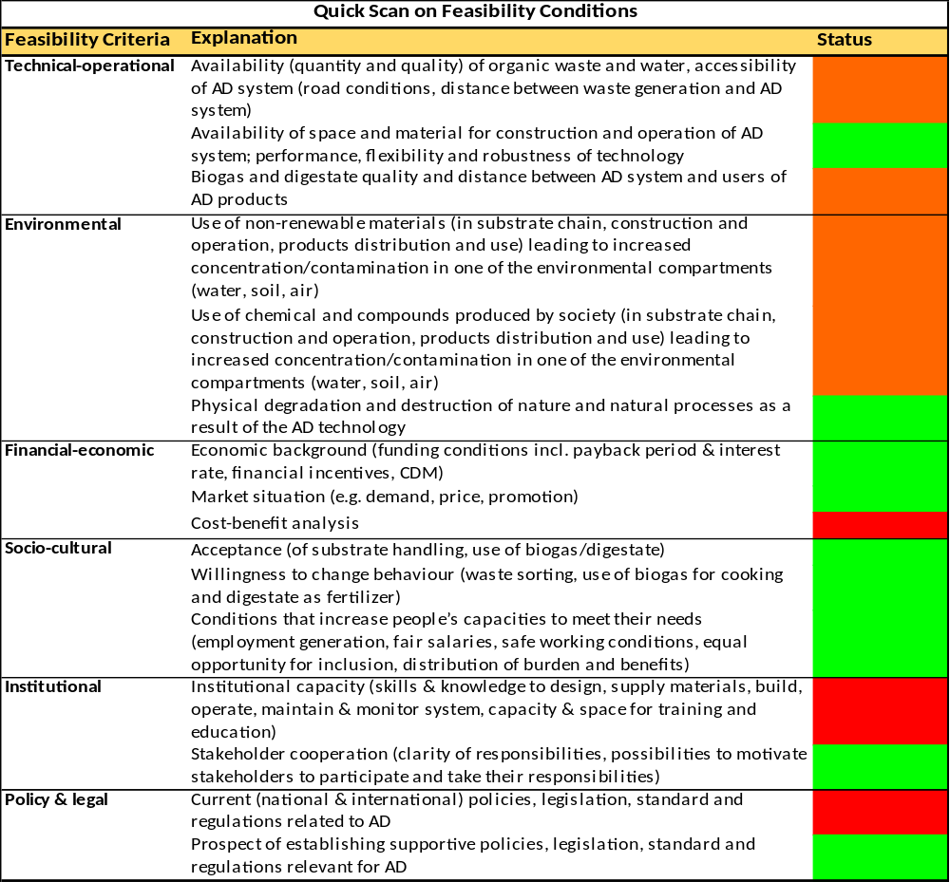

Social and Environmental Screening

The completed template, which constitutes the Social and Environmental Screening Report, must be included as an annex to the Project Document. Please refer to the Social and Environmental Screening Procedure for guidance on how to answer the 6 questions.]
Project Information
Project Information
- Project Title | Promoting production and utilisation of bio-methane from agro-waste in South-Eastern Botswana
- Project Number | PIMS 5299
- Location (Global/Region/Country) | Botswana
Part A. Integrating Overarching Principles to Strengthen Social and Environmental Sustainability
QUESTION 1: How Does the Project Integrate the Overarching Principles in order to Strengthen Social and Environmental Sustainability?
Briefly describe in the space below how the Project mainstreams the human-rights based approach

The outcome of the project is reduced greenhouse gas emissions through improved waste management. The project will directly benefit communities that are currently affected by pollution from waste streams, in particular from agro-industries. Where applicable, local communities (both women and men) will participate and contribute to the development of biogas technology in their local areas. Members of local communities will be capacitated and will benefit from the project through creation of employment opportunities during the construction of biogas digesters, as well as employment resulting from operations and maintenance of the digesters. The project is being implemented within the governance framework of the Government of Botswana and, as such, provides opportunities to raise concerns and/or grievances caused by the project to communities or individuals.
Briefly describe in the space below how the Project is likely to improve gender equality and women’s empowerment
The staff of stakeholder organisations (Government institutions, local councils, private companies, financial sector) will be enabled to strengthen their gender commitment through training, gender consciousness and commitment to the promotion of gender equality in waste management and active participation in the planned multi-stakeholder process to formulate waste management policies and guidelines. Different groups will be identified in the affected communities, and will be invited to participate in a process to analyse the distinguishing factors that maintain their relatively disadvantaged position. In consultation with these groups, jointly developed approaches will be identified for new opportunities for women in waste management. Typically, the use of small-scale biogas digesters can provide the following benefits for women: Biogas digesters can reduce their expenditures on fuelwood and other traditional cooking fuels; use of biogas plants reduces the time and labour of women and girls in collecting fuelwood and other biomass fuels, freeing them for economically productive activities; construction and installation of biogas plants creates employment and additional income; additional income opportunities include selling bio-slurry residues for fertilizer, selling more agricultural produce due to fertilizer availability, and using biogas for activities such as commercial cooking; use of bio-slurry on fields improves agricultural production and food availability.
Briefly describe in the space below how the Project mainstreams environmental sustainability
The project aims to utilise existing waste streams from primarily agro-industries for the generation of biogas. The biogas will be used for heating and/or electricity production. The throughput (digestate) of the biogas digesters will be prepared as a commercial sellable organic fertilizer. The project will support the creation of an enabling environment that will stimulate improved waste management and utilisation of biogas beyond the project period. The project will reduce GHG emissions. Additional environmental benefits of the project include reduced nitrate run-off, reduced reliance on unsustainable biomass for energy and reduction of diesel use for back-up power, reduction of coal-generated electricity, etc. It is compulsory that a full-fledged EIA will be conducted for each medium-scale biogas digester. One EIA will be undertaken to cover all the 1,000 small-scale biogas digesters.
Part B. Identifying and Managing Social and Environmental Risks
QUESTION 2: What are the Potential Social and Environmental Risks?  Note: Describe briefly potential social and environmental risks identified in Attachment 1 – Risk Screening Checklist (based on any “Yes” responses). | QUESTION 3: What is the level of significance of the potential social and environmental risks?  Note: Respond to Questions 4 and 5 below before proceeding to Question 6 |  |  |  | QUESTION 6: What social and environmental assessment and management measures have been conducted and/or are required to address potential risks (for Risks with Moderate and High Significance)?
Risk Description | Impact and Probability (1-5) | Significance  (Low, Moderate, High) | Comments |  | Description of assessment and management measures as reflected in the Project design. If ESIA or SESA is required note that the assessment should consider all potential impacts and risks.
Risks related to operation or decommissioning pose potential safety risks to local communities. | I = 4  P = 2 | Moderate | Due to low quality design, poor construction and poor operational management there is a small risk of explosion of biogas. |  | Low-cost (and hence riskier) biogas technologies are not supported by the project; high quality of design and construction will be ensured; and staff will be well trained on operational management.
Risk to community health and safety due to the transport of waste. | I = 2  P = 1 | Moderate | Similar to above. Due to transport accidents with organic waste. |  | The impact of a road accidents with organic waste is of a temporary nature and, if addressed and cleaned-up in a timely fashion, should not pose a permanent threat to the population or environment. The operator of the biogas digesters will use well-serviced vehicles, staff will be well informed and trained to avoid health and safety hazards, and clean-up facilities will be in place.
Risk to the release of pollutants to the environment due to routine or non-routine circumstances with the potential for adverse local impact. | I = 2  P = 4 | Moderate | Due to low-quality design, poor construction and poor operational management, there is a risks of greenhouse gas (methane) being emitted in the atmosphere and sludge being released in open waters. |  | Low-cost (and hence riskier) biogas technologies are not supported by the project; high quality of design and construction will be ensured; and staff will be well trained on operational management through training course on health and safety.
Risks: fire, mechanical dangers, lightning protection, thermal safety, noise emissions protection, asphyxiation, poisoning prevention, hygienic and veterinary safety, prevention of ground and surface water leakages, avoidance of pollutants release during waste disposal, flooding safety. | I = 4  P = 3 | Moderate | These are typical risk issues that are associated with the construction and operation of biogas digesters. |  | Construction and operation of a biogas plant is related to a number of important safety issues, potential risks and hazards for humans, animals and the environment. Taking proper precautions and adopting safety measures have the aim of avoiding any risks and hazardous situations, and contribute to ensuring a safe operation of the plant. Fulfilment of important safety issues and stipulating clear preventive and damage control measures will be a condition for obtaining the biogas plant construction permit. Local councils will be trained on biogas technology and responsible for issuing building permits on the condition that health and safety standards are met. These standards are defined as part of creating an enabling environment for the development of biogas technology. Construction and operation personnel will be trained on safety measures.
 | QUESTION 4: What is the overall Project risk categorization?
 | Select one (see SESP for guidance) |  |  |  |  | Comments
 | Low Risk |  |  | ☐
 | Moderate Risk |  |  | X |  | The project has the potential for adverse social and environmental risks and impacts. These are known and have been identified with certainty, and can be addressed through application of high-quality construction, applied safety standards, capacity development, best practice, mitigation measures and stakeholder engagement during project implementation.
 | High Risk |  |  | ☐
 | QUESTION 5: Based on the identified risks and risk categorization, what requirements of the SES are relevant?
 | Check all that apply |  |  |  |  | Comments
 | Principle 1: Human Rights |  |  | ☐
 | Principle 2: Gender Equality and Women’s Empowerment |  |  | ☐
 | 1. Biodiversity Conservation and Natural Resource Management |  |  | ☐
 | 2. Climate Change Mitigation and Adaptation |  |  | X
 | 3. Community Health, Safety and Working Conditions |  |  | X
 | 4. Cultural Heritage |  |  | ☐
 | 5. Displacement and Resettlement |  |  | ☐
 | 6. Indigenous Peoples |  |  | ☐
 | 7. Pollution Prevention and Resource Efficiency |  |  | X

Final Sign Off
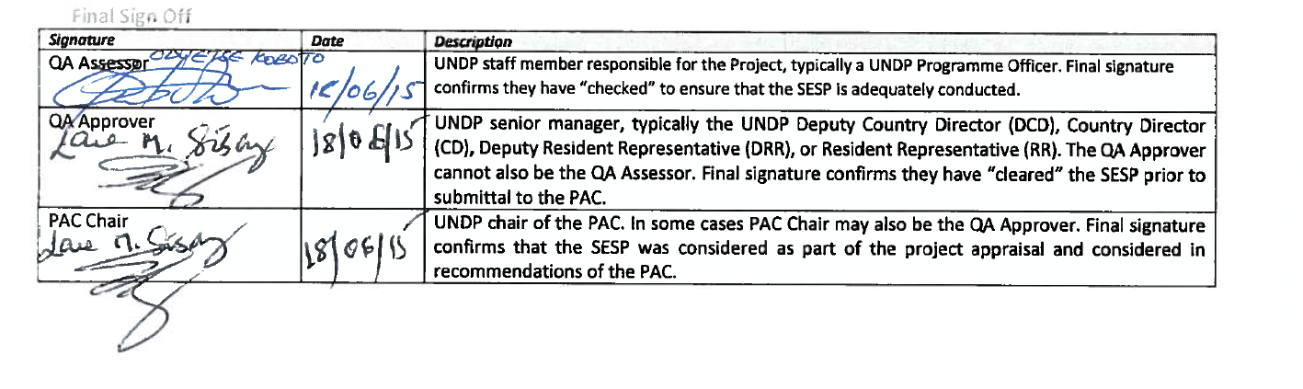
SESP Attachment 1. Social and Environmental Risk Screening Checklist
Checklist Potential Social and Environmental Risks
Principles 1: Human Rights | Answer  (Yes/No)
1. Could the Project lead to adverse impacts on enjoyment of the human rights (civil, political, economic, social or cultural) of the affected population and particularly of marginalized groups? | No
2. Is there a likelihood that the Project would have inequitable or discriminatory adverse impacts on affected populations, particularly people living in poverty or marginalized or excluded individuals or groups? | No
3. Could the Project potentially restrict availability, quality of and access to resources or basic services, in particular to marginalized individuals or groups? | No
4. Is there a likelihood that the Project would exclude any potentially affected stakeholders, in particular marginalized groups, from fully participating in decisions that may affect them? | No
5. Are there measures or mechanisms in place to respond to local community grievances? | Yes
6. Is there a risk that duty-bearers do not have the capacity to meet their obligations in the Project? | No
7. Is there a risk that rights-holders do not have the capacity to claim their rights? | No
8. Have local communities or individuals, given the opportunity, raised human rights concerns regarding the Project during the stakeholder engagement process? | No
9. Is there a risk that the Project would exacerbate conflicts among and/or the risk of violence to project-affected communities and individuals? | No
Principle 2: Gender Equality and Women’s Empowerment
1. Is there a likelihood that the proposed Project would have adverse impacts on gender equality and/or the situation of women and girls? | No
2. Would the Project potentially reproduce discriminations against women based on gender, especially regarding participation in design and implementation or access to opportunities and benefits? | No
3. Have women’s groups/leaders raised gender equality concerns regarding the Project during the stakeholder engagement process and has this been included in the overall Project proposal and in the risk assessment? | No
3. Would the Project potentially limit women’s ability to use, develop and protect natural resources, taking into account different roles and positions of women and men in accessing environmental goods and services?  For example, activities that could lead to natural resources degradation or depletion in communities who depend on these resources for their livelihoods and well being | No
Principle 3: Environmental Sustainability: Screening questions regarding environmental risks are encompassed by the specific Standard-related questions below
Standard 1: Biodiversity Conservation and Sustainable Natural Resource Management
1.1 Would the Project potentially cause adverse impacts to habitats (e.g. modified, natural, and critical habitats) and/or ecosystems and ecosystem services?  For example, through habitat loss, conversion or degradation, fragmentation, hydrological changes | No
1.2 Are any Project activities proposed within or adjacent to critical habitats and/or environmentally sensitive areas, including legally protected areas (e.g. nature reserve, national park), areas proposed for protection, or recognised as such by authoritative sources and/or indigenous peoples or local communities? | No
1.3 Does the Project involve changes to the use of lands and resources that may have adverse impacts on habitats, ecosystems, and/or livelihoods? (Note: if restrictions and/or limitations of access to lands would apply, refer to Standard 5) | No
1.4 Would Project activities pose risks to endangered species? | No
1.5 Would the Project pose a risk of introducing invasive alien species? | No
1.6 Does the Project involve harvesting of natural forests, plantation development, or reforestation? | No
1.7 Does the Project involve the production and/or harvesting of fish populations or other aquatic species? | No
1.8 Does the Project involve significant extraction, diversion or containment of surface or ground water?  For example, construction of dams, reservoirs, river basin developments, groundwater extraction | No
1.9 Does the Project involve utilization of genetic resources? (e.g. collection and/or harvesting, commercial development) | No
1.10 Would the Project generate potential adverse transboundary or global environmental concerns? | No
1.11 Would the Project result in secondary or consequential development activities which could lead to adverse social and environmental effects, or would it generate cumulative impacts with other known existing or planned activities in the area?  For example, a new road through forested lands will generate direct environmental and social impacts (e.g. felling of trees, earthworks, potential relocation of inhabitants). The new road may also facilitate encroachment on lands by illegal settlers or generate unplanned commercial development along the route, potentially in sensitive areas. These are indirect, secondary, or induced impacts that need to be considered. Also, if similar developments in the same forested area are planned, then cumulative impacts of multiple activities (even if not part of the same Project) need to be considered. | No
Standard 2: Climate Change Mitigation and Adaptation
2.1 Will the proposed Project result in significant greenhouse gas emissions or may exacerbate climate change? | No
2.2 Would the potential outcomes of the Project be sensitive or vulnerable to potential impacts of climate change? | No
2.3 Is the proposed Project likely to directly or indirectly increase social and environmental vulnerability to climate change now or in the future (also known as maladaptive practices)?  For example, changes to land use planning may encourage further development of floodplains, potentially increasing the population’s vulnerability to climate change, specifically flooding | No
Standard 3: Community Health, Safety and Working Conditions
3.1 Would elements of Project construction, operation, or decommissioning pose potential safety risks to local communities? | Yes
3.2 Would the Project pose potential risks to community health and safety due to the transport, storage, and use and/or disposal of hazardous or dangerous materials (e.g. explosives, fuel and other chemicals during construction and operation)? | Yes
3.3 Does the Project involve large-scale infrastructure development (e.g. dams, roads, buildings)? | No
3.4 Would failure of structural elements of the Project pose risks to communities? (e.g. collapse of buildings or infrastructure) | No
3.5 Would the proposed Project be susceptible to or lead to increased vulnerability to earthquakes, subsidence, landslides, erosion, flooding or extreme climatic conditions? | No
3.6 Would the Project result in potential increased health risks (e.g. from water-borne or other vector-borne diseases or communicable infections such as HIV/AIDS)? | No
3.7 Does the Project pose potential risks and vulnerabilities related to occupational health and safety due to physical, chemical, biological, and radiological hazards during Project construction, operation, or decommissioning? | No
3.8 Does the Project involve support for employment or livelihoods that may fail to comply with national and international labor standards (i.e. principles and standards of ILO fundamental conventions)? | No
3.9 Does the Project engage security personnel that may pose a potential risk to health and safety of communities and/or individuals (e.g. due to a lack of adequate training or accountability)? | No
Standard 4: Cultural Heritage
4.1 Will the proposed Project result in interventions that would potentially adversely impact sites, structures, or objects with historical, cultural, artistic, traditional or religious values or intangible forms of culture (e.g. knowledge, innovations, practices)? (Note: Projects intended to protect and conserve Cultural Heritage may also have inadvertent adverse impacts) | No
4.2 Does the Project propose utilizing tangible and/or intangible forms of cultural heritage for commercial or other purposes? | No
Standard 5: Displacement and Resettlement
5.1 Would the Project potentially involve temporary or permanent and full or partial physical displacement? | No
5.2 Would the Project possibly result in economic displacement (e.g. loss of assets or access to resources due to land acquisition or access restrictions – even in the absence of physical relocation)? | No
5.3 Is there a risk that the Project would lead to forced evictions? | No
5.4 Would the proposed Project possibly affect land tenure arrangements and/or community based property rights/customary rights to land, territories and/or resources? | No
Standard 6: Indigenous Peoples
6.1 Are indigenous peoples present in the Project area (including Project area of influence)? | No
6.2 Is it likely that the Project or portions of the Project will be located on lands and territories claimed by indigenous peoples? | No
6.3 Would the proposed Project potentially affect the rights, lands and territories of indigenous peoples (regardless of whether Indigenous Peoples possess the legal titles to such areas)? | No
6.4 Has there been an absence of culturally appropriate consultations carried out with the objective of achieving FPIC on matters that may affect the rights and interests, lands, resources, territories and traditional livelihoods of the indigenous peoples concerned? | No
6.4 Does the proposed Project involve the utilization and/or commercial development of natural resources on lands and territories claimed by indigenous peoples? | No
6.5 Is there a potential for forced eviction or the whole or partial physical or economic displacement of indigenous peoples, including through access restrictions to lands, territories, and resources? | No
6.6 Would the Project adversely affect the development priorities of indigenous peoples as defined by them? | No
6.7 Would the Project potentially affect the traditional livelihoods, physical and cultural survival of indigenous peoples? | No
6.8 Would the Project potentially affect the Cultural Heritage of indigenous peoples, including through the commercialization or use of their traditional knowledge and practices? | No
Standard 7: Pollution Prevention and Resource Efficiency
7.1 Would the Project potentially result in the release of pollutants to the environment due to routine or non-routine circumstances with the potential for adverse local, regional, and/or trans boundary impacts? | Yes
7.2 Would the proposed Project potentially result in the generation of waste (both hazardous and non-hazardous)? | No
7.3 Will the proposed Project potentially involve the manufacture, trade, release, and/or use of hazardous chemicals and/or materials? Does the Project propose use of chemicals or materials subject to international bans or phase-outs?  For example, DDT, PCBs and other chemicals listed in international conventions such as the Stockholm Conventions on Persistent Organic Pollutants or the Montreal Protocol | No
7.4 Will the proposed Project involve the application of pesticides that may have a negative effect on the environment or human health? | No
7.5 Does the Project include activities that require significant consumption of raw materials, energy, and/or water? | No

Letters of Co-Finance

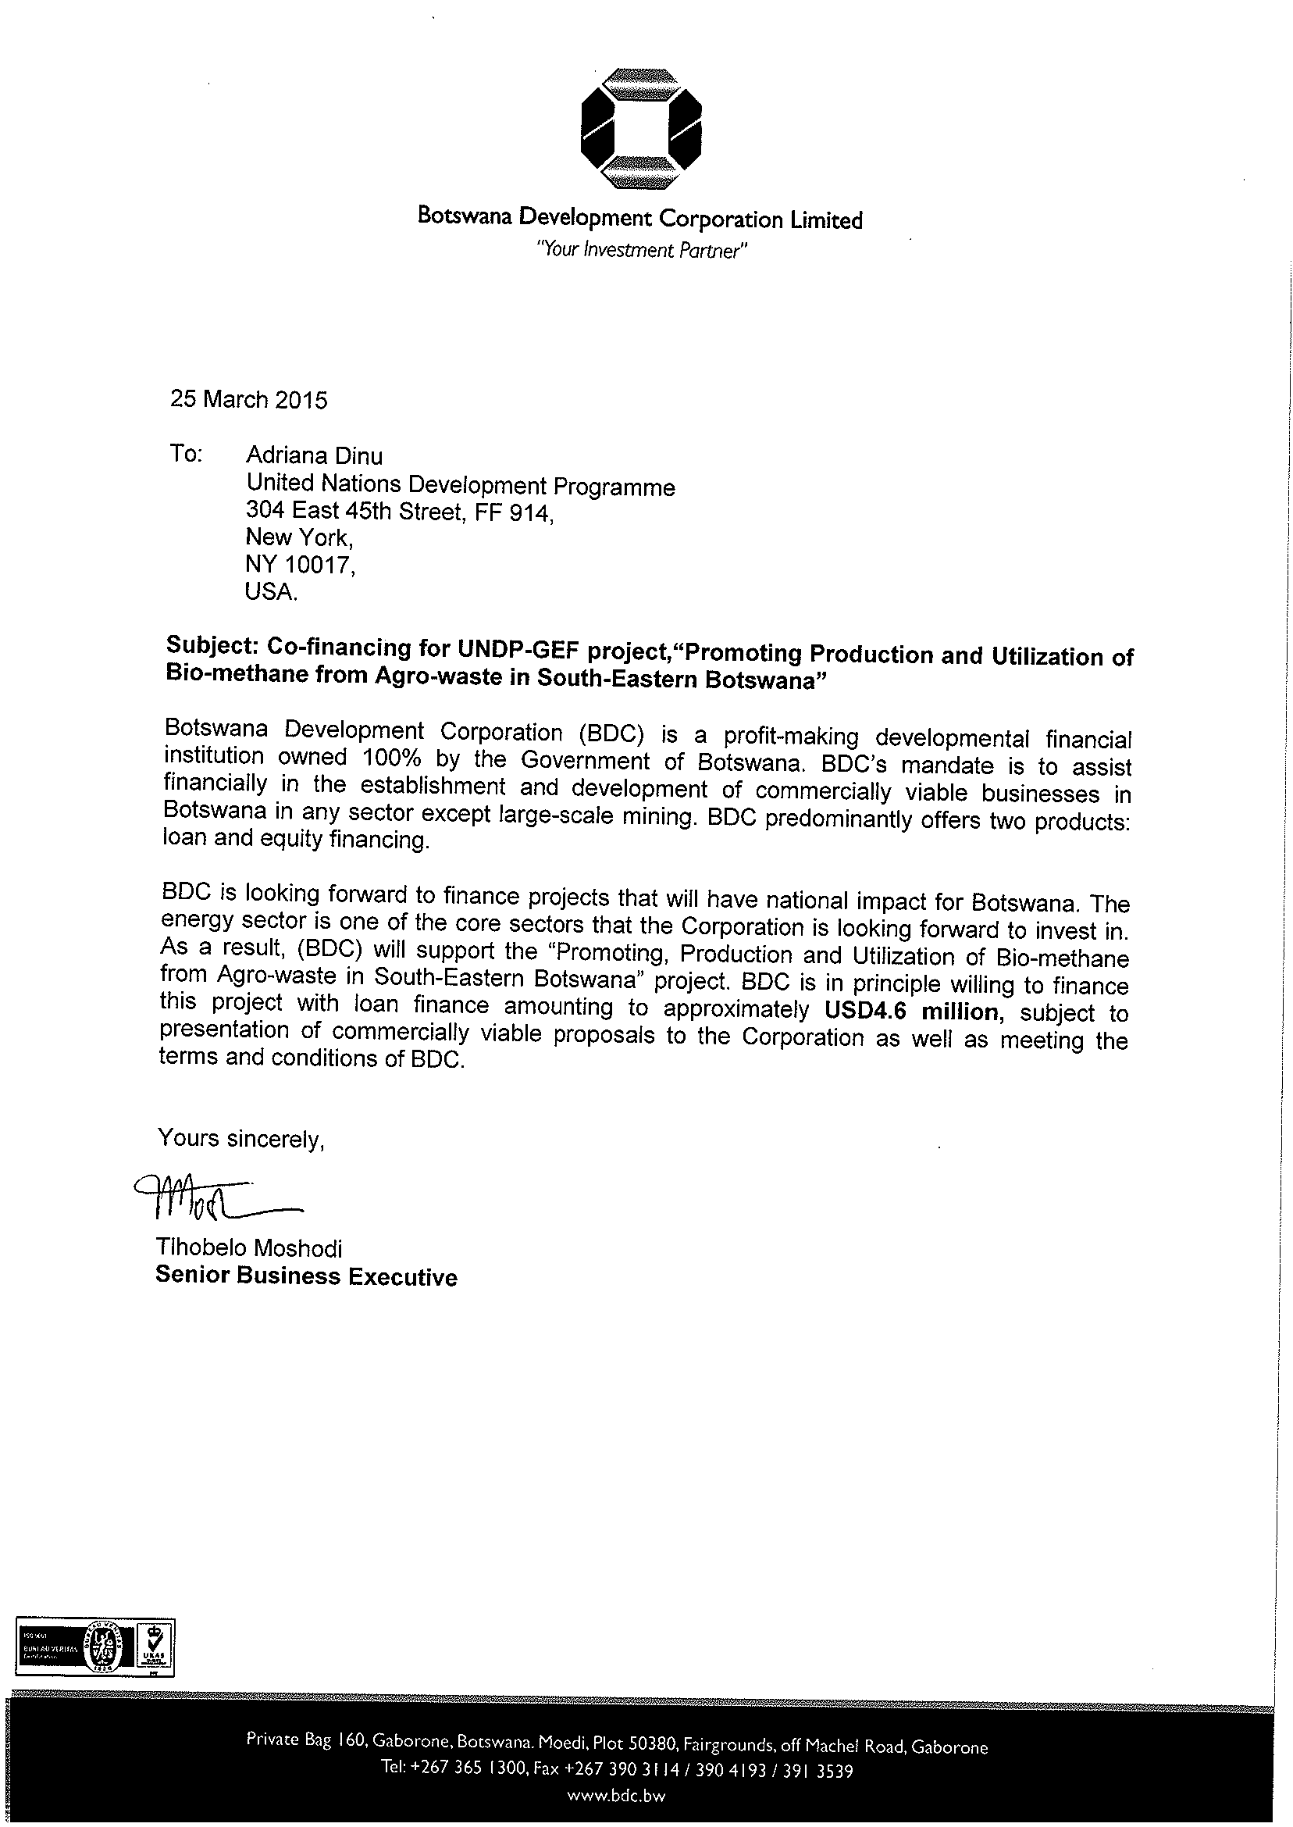

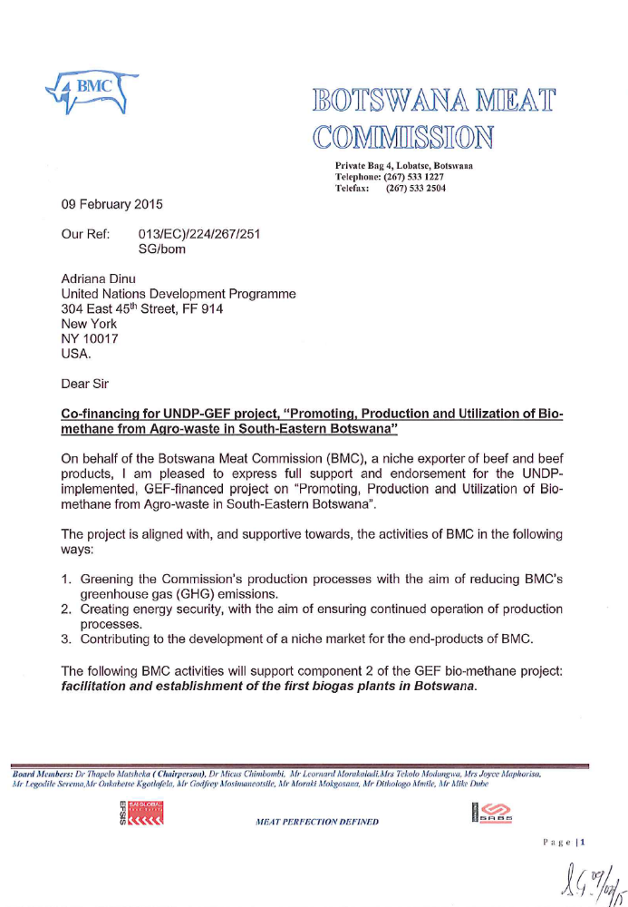

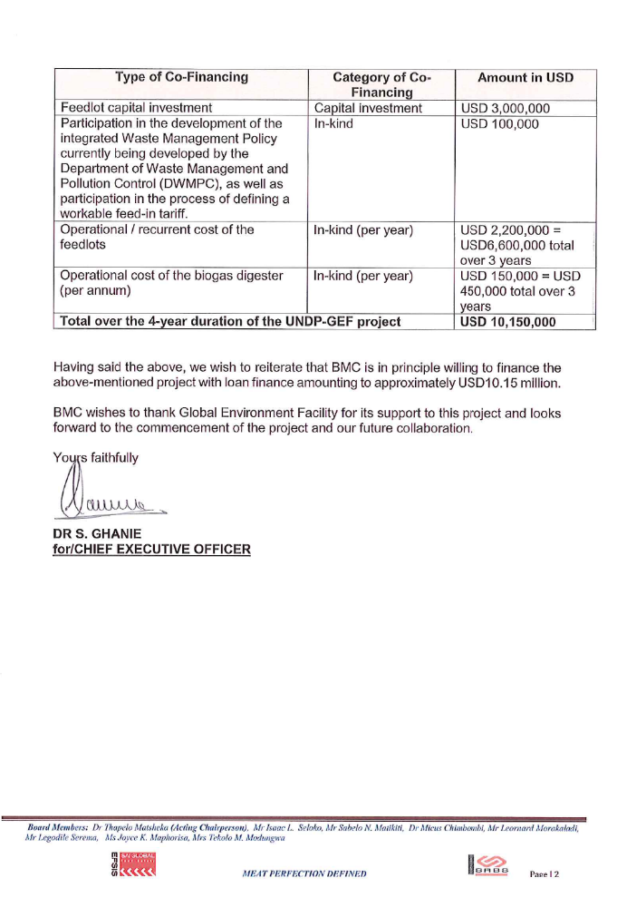

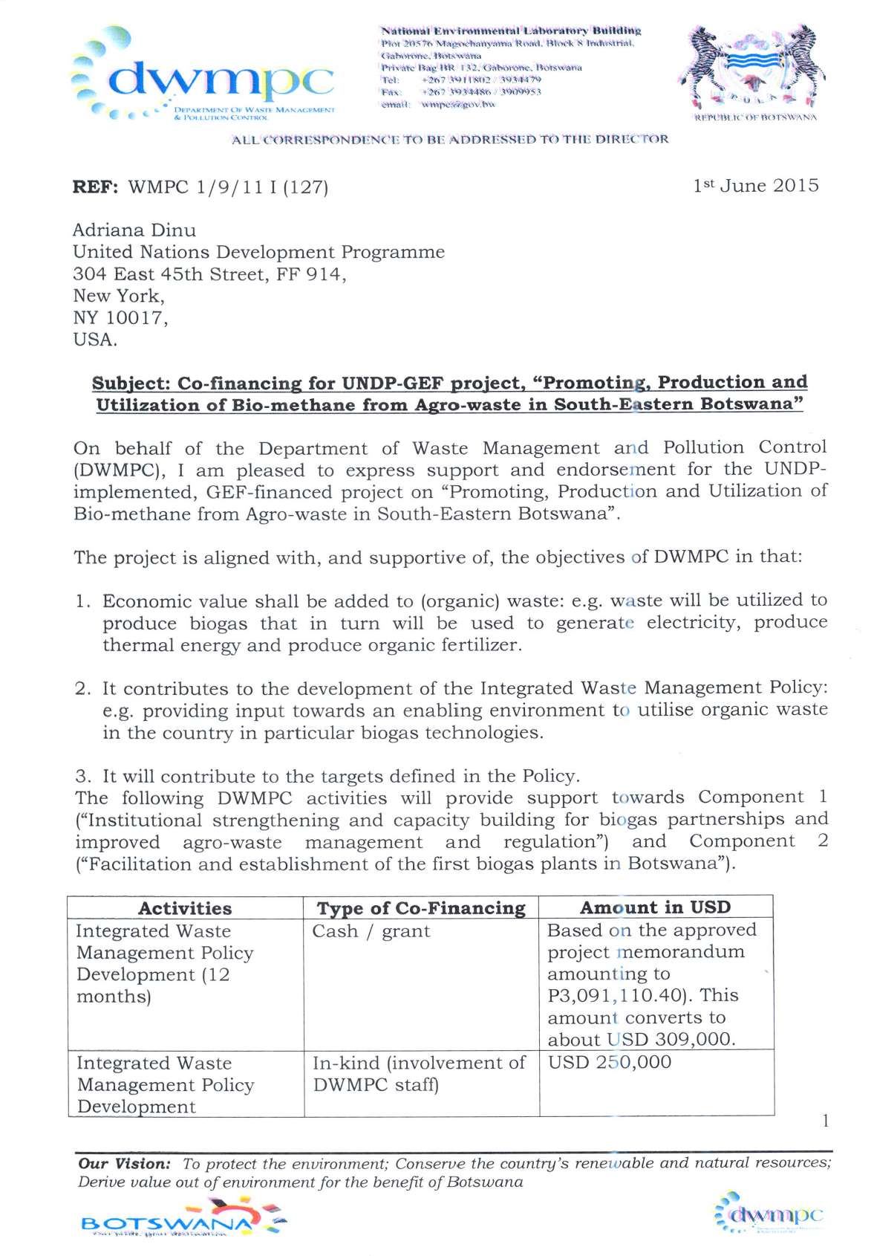

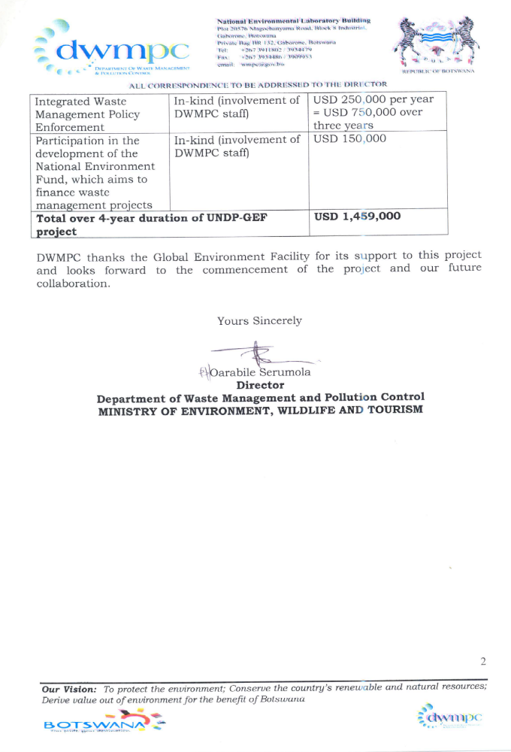

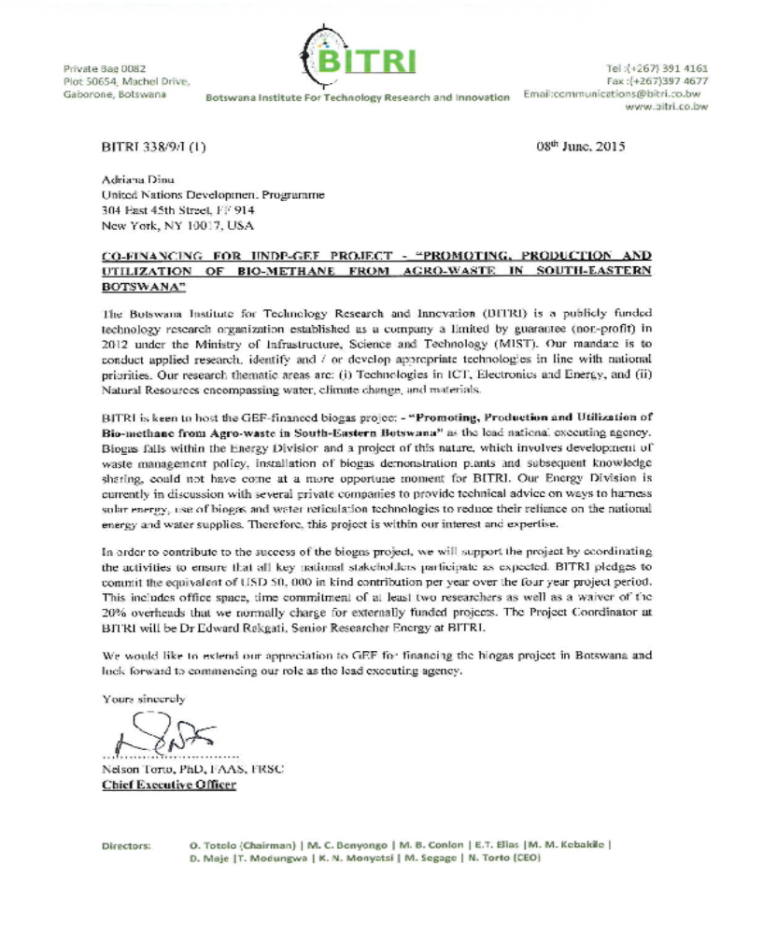

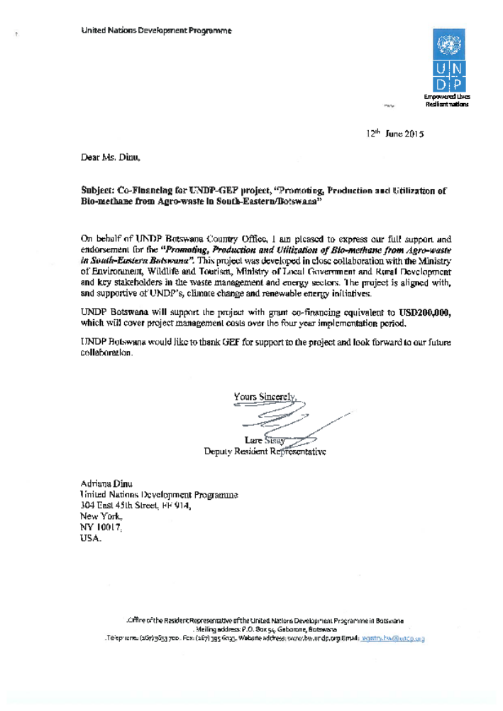

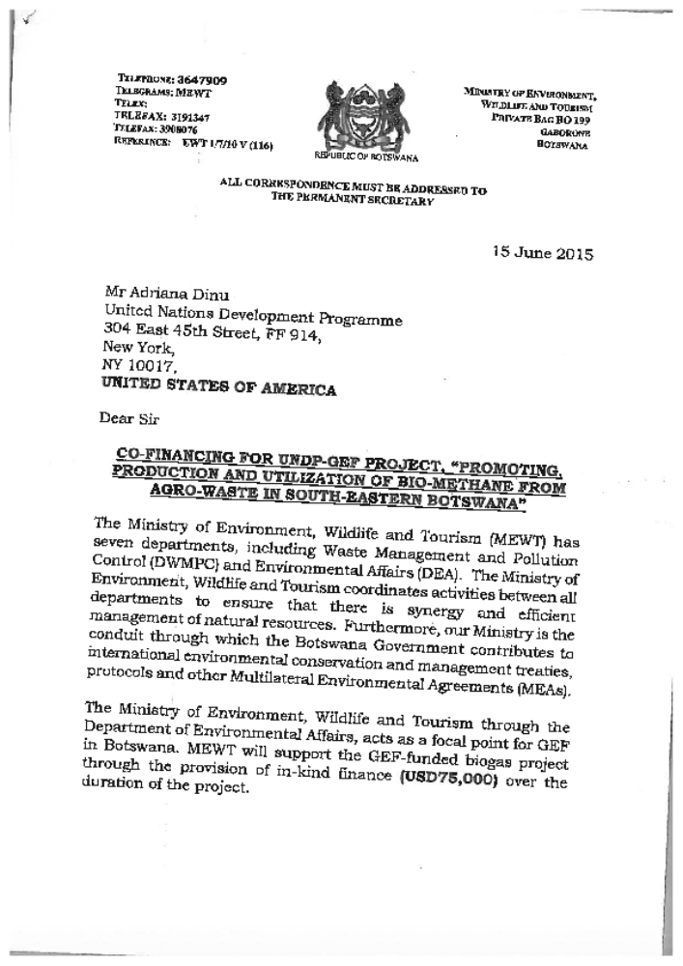

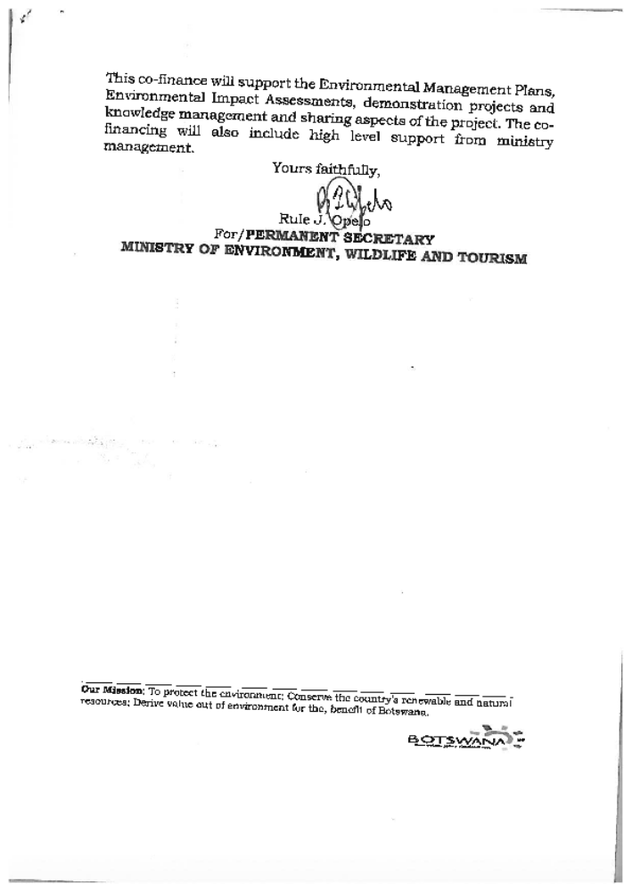

Organisational information

Name of the organisation | Operational Since | Main Activities | Number of Professional Staff (MSc and above) | Estimated Annual Budget | Financing towards GEF-supported activities
- Botswana Institute for Technology Research and Innovation | 2014 | Technology Research in Technologies (ICT & Energy) and Natural Resources and Materials (Nanomaterials, Building Materials and Climate Change) | 61 Researchers (30 PhDs) | Estimated annual budget for 2015/16:  USD 6.1 million (Recurrent), USD 7.2 million (R&D) | BITRI: USD 200,000 in-kind for office space, staff salaries and a waiver for 20% overhead costs.
- Botswana Meat Commission | 1965 | Cattle abattoir and cutting plant; Canning facility | 20 | USD 103 million | USD 3 million in cash for investment in biogas technology, USD 7.15 million in-kind for recurrent costs, operational costs and participation in policy formulation.
- Department of Environmental Affairs (DEA) | First established as National Conservation Strategy in 1992 | Policy development and enforcement of the Environmental Assessment Act | 8 | USD 3 million | In-kind contribution (staff time regarding EIAs of biogas projects).
- Department of Waste Management and Pollution Control (DWMPC) | 2005 | Development of policy and standards. Licensing, inspections and environmental audits. Prevention and monitoring of pollution to the environment. | 10 | USD 2.23 million | USD 1.5 million in-kind for development of integrated waste management policy and enforcement.
- Ministry of Environmental Affairs, Wildlife and Tourism | Ministry established in 2002 (National Conservation Strategy, then renamed Department of Environmental Affairs) | Refer to DWMPC and DEA | Refer to DWMPC and DEA | Refer to DWMPC and DEA | USD 75,000 in-kind for waste management policy development, knowledge management and sharing, and high-level support from ministry management (additional contribution through DEA and DWMPC).
- Botswana Development Corporation | 1970 | Developmental financial institution providing funding to commercially viable projects | 10 | Cannot be revealed | USD 4.6 million for commercial loans
- Energy Affairs Division | 1995 | National Energy Policy and Renewable Energy Policy Development | 8 | USD 2 million | Staff time regarding development of a bioenergy strategy.
- Ministry of Local Government & Rural Development: Department of Primary Healthcare Services | 2009 | Coordinate implementation of environmental health programmes for councils. | 2 (the relevant division only has 3 staff) | USD 2.3 million | Staff time to support councils to participate in the project.

UNDP Direct Project Services Costs



Letter of Agreement

A STANDARD LETTER OF AGREEMENT BETWEEN UNDP AND THE GOVERNMENT OF BOTSWANA FOR THE PROVISION OF SUPPORT SERVICES

1. Reference is made to consultations between officials of the Government of Botswana (hereinafter referred to as “the Government”) and officials of UNDP with respect to the provision of support services by the UNDP country office for nationally managed programmes and projects. UNDP and the Government hereby agree that the UNDP country office may provide such support services at the request of the Government through its institution designated in the relevant programme support document or project document, as described below.

2. The UNDP country office may provide support services for assistance with reporting requirements and direct payment. In providing such support services, the UNDP country office shall ensure that the capacity of the Government-designated institution is strengthened to enable it to carry out such activities directly. The costs incurred by the UNDP country office in providing such support services shall be recovered from the administrative budget of the office.

3. The UNDP country office may provide, at the request of the designated institution, the following support services for the activities of the programme/project:
(a) Identification and/or recruitment of project and programme personnel;
(b) Identification and facilitation of training activities;
(c) Procurement of goods and services;

4. The procurement of goods and services and the recruitment of project and programme personnel by the UNDP country office shall be in accordance with the UNDP regulations, rules, policies and procedures. Support services described in paragraph 3 above shall be detailed in an annex to the programme support document or project document, in the form provided in the Attachment hereto. If the requirements for support services by the country office change during the life of a programme or project, the annex to the programme support document or project document is revised with the mutual agreement of the UNDP resident representative and the designated institution.

5. The relevant provisions of the Convention on the Privileges and Immunities of the Specialised Agencies, to which the Government of Botswana became a signatory on 5 April 1983 including the provisions on liability and privileges and immunities, shall apply to the provision of such support services. The Government shall retain overall responsibility for the nationally managed programme or project through its designated institution. The responsibility of the UNDP country office for the provision of the support services described herein shall be limited to the provision of such support services detailed in the annex to the programme support document or project document.

6. Any claim or dispute arising under or in connection with the provision of support services by the UNDP country office in accordance with this letter shall be handled pursuant to the relevant provisions of the SBAA.

7. The manner and method of cost-recovery by the UNDP country office in providing the support services described in paragraph 3 above shall be as specified in Annex 1 attached.

8. The UNDP country office shall submit progress reports on the support services provided and shall report on the costs reimbursed in providing such services, as may be required.

9. Any modification of the present arrangements shall be effected by mutual written agreement of the parties hereto.

10. If you are in agreement with the provisions set forth above, please sign and return to this office two signed copies of this letter. Upon your signature, this letter shall constitute an agreement between your Government and UNDP on the terms and conditions for the provision of support services by the UNDP country office for nationally managed programmes and projects.

Yours sincerely,

_____________________
For the Government
Mr. J R Opelo
Deputy Permanent Secretary, Ministry of Environment, Wildlife and Tourism
Botswana

_______________________
Signed on behalf of UNDP
MR. Lare Sisay
Deputy Resident Representative

Attachment 1

DESCRIPTION OF UNDP COUNTRY OFFICE SUPPORT SERVICES
- In accordance with the provisions of the letter of agreement and the project document, the UNDP country office shall provide support services for the project “Promoting Production and Utilisation of Bio-Methane from Waste in South-Eastern Botswana” as described below.
- Support services to be provided:
Support services | Schedule for the provision of the support services | Cost to UNDP of providing such support services (where appropriate) |  |  | Amount and method of reimbursement of UNDP (where appropriate)
Support services | Schedule for the provision of the support services | Unit | Sub-total (US$) | For 4 years
Payment process  (Including setting up vendors) | Throughout project implementation when applicable | 30 per year @ 51.64 | 1,549 | *4 Years = 6,196 | UNDP will directly charge the project upon receipt of request of services from the Implementing Partner (IP)
Recruitment of Project Staff (Including staff benefits/payroll management) | Throughout project implementation when applicable | 1 per year @ 1162 | 1,162 | * 4 Years =  4,648
Procurement of Consultants | Throughout project implementation when applicable | 5 per year @ 217.25 | 1,086 | * 4 Years =  4,344
Travel Facilitation (Including authorisations & settlements) | Throughout project implementation when applicable | 6 per year @ 60 | 360 | * 4 Years =  1,440
Procurement Simple (low value) | Throughout project implementation when applicable | 10 per year @ 196.44 | 1,964 | * 4 Years =  7,856
Procurement Complex | Throughout project implementation when applicable | 2 per year @ 499.55 | 999 | * 4 Years = 3,996
Total |  |  |  | 28,480

- For procurement services, the Implementing Partner and UNDP will agree on the needed services in advance on a quarterly basis.
- UNDP service fees will be according to UN Universal Price List (UPL).

Letter of Endorsement

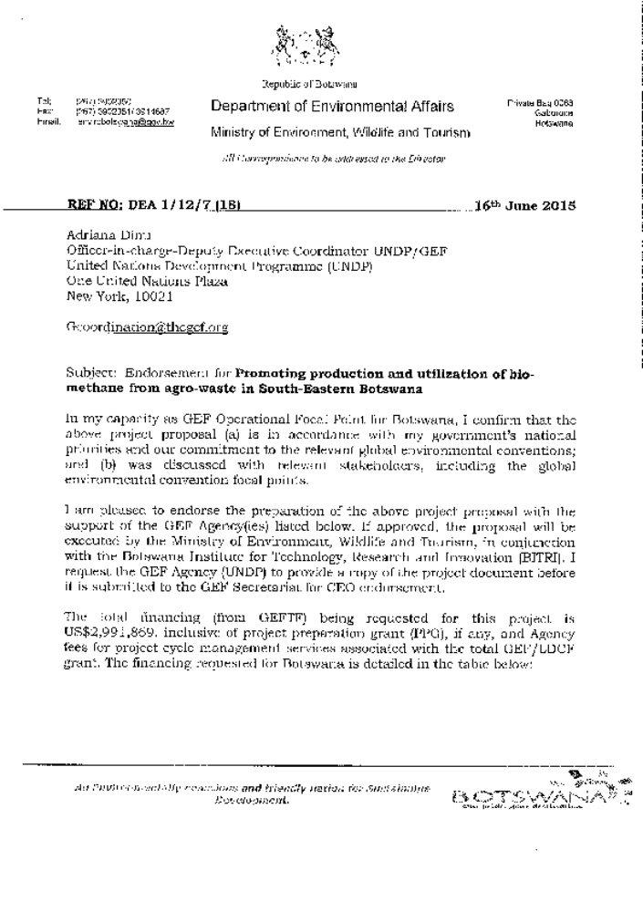

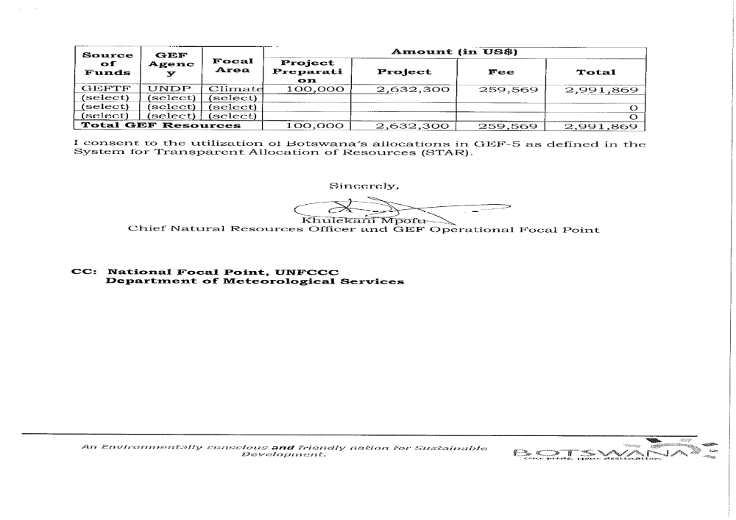

TORs for project staff/key consultants

Project Steering Committee (PSC)

Duties and responsibilities:
The Project Steering Committee (PSC) is the principal body supervising the project implementation in accordance with UNDP Direct Implementation Modality (DIM) rules and regulations and referring to the specific objectives and the outcomes of the project with their agreed performance indicators.

The main functions of the PSC are:

- General monitoring of the project’s progress in meeting its objectives and outcomes and ensuring that they continue to be in line with national development objectives;
- Facilitating the co-operation between the different Government entities whose inputs are required for successful implementation of the project, ensuring access to the required information and resolving eventual conflict situations arising during the project implementation when trying to meet its outcomes and stated targets;
- Supporting the elaboration, processing and adoption of the required institutional, legal and regulatory changes to support the project objectives and overcoming of related barriers;
- Facilitating and supporting other measures to minimise the identified risks to project success, remove bottlenecks and resolve eventual conflicts;
- Approval of the annual work plans and progress reports, the first plan being prepared at the outset of project implementation;
- Approval of the project management arrangements; and
- Approval of any amendments to be made in the project strategy that may arise due to changing circumstances, after careful analysis and discussion of the ways to solve problems.

PSC Structure and Reimbursement of Costs
The PSC will be chaired by MEWT. The PSC will include representatives from the key Ministries and Agencies involved in the project and representatives of the project’s other co-financing partners.

The costs of the PSC’s work shall be considered as the Government’s or other project partners’ voluntary in-kind contribution to the project and shall not be paid separately by the project. Members of the PSC are also not eligible to receive any monetary compensation from their work as experts or advisers to the project.

Meetings
It is suggested that the PSC will meet at least once a year, including the annual Tripartite Review (TPR) meeting. A tentative schedule of the PSC meetings will be agreed as a part of the annual work plans, and all representatives of the PSC should be notified again in writing 14 days prior to the agreed date of the meeting. The meeting will be organised provided that MEWT BITRI, UNDP and at least two-thirds of the other members of the PSC can confirm their attendance. The project manager shall distribute all materials associated with the meeting agenda at least 5 working days prior to the meeting.

UNDP Focal Point (Department of Environmental Affairs)
As a representative of the Government (MEWT), the UNDP Focal Point has the responsibility of liaising with UNDP and assisting UNDP’s direct implementation of the project. His/her main duties and responsibilities include:

- Coordinate with the work of the Project Manager through meetings at regular intervals to receive project progress reports and provide guidance on policy issues;
- Taking the lead in developing linkages with the relevant authorities at national, provincial and governmental level and supporting the project in resolving any institutional- or policy-related conflicts that may emerge during its implementation.

Project Manager (full time position)

Duties and responsibilities:
- Operational project management in accordance with the Project Document and the UNDP guidelines and procedures for directly-implemented (DIM) projects, including:
- General coordination, management and supervision of project implementation;
- Managing the procurement and the project budget under the supervision of UNDP to assure timely involvement of local and international experts, organization of training and public outreach, purchase of required equipment etc. in accordance with UNDP rules and procedures;
- Submission of annual Project Implementation Reviews and other required progress reports (such QPRs) to the PSC and UNDP in accordance with the “Monitoring and Evaluation” section of the Project Document;
- Ensuring effective dissemination of, and access to information on project activities and results (including a regularly updated project website);
- Supervising and coordinating the contracts of the experts working for the project;
- As applicable, communicating with the project’s international partners and attracting additional financing in order to fulfill the project objectives; and
- Ensuring otherwise successful completion of the project in accordance with the stated outcomes and performance indicators summarized in the project’s log frame matrix and within the planned schedule and budget.

Expected Qualifications:
- Advanced university degree and at least 7 years of professional experience in the specific areas the project is dealing with, including solid knowledge of renewable energy (including, specifically, biogas), state-of-the-art approaches, and best practices in catalyzing the renewable-energy market (by applying different policy measures and financing mechanisms such as investments, feed-in tariffs and climate finance);
- Experience in managing projects of similar complexity and nature, including demonstrated capacity to actively explore new, innovative implementation and financing mechanisms to achieve the project objective;
- Demonstrated experience and success in the engagement of, and working with, the private sector and NGOs, creating partnerships and leveraging financing for activities of common interest; experience with supporting multi-stakeholder platforms;
- Good analytical and problem-solving skills and the related ability to adaptively manage with prompt action on the conclusions and recommendations coming out of the project’s regular monitoring and self-assessment activities, as well as from periodic external evaluations;
- Ability and demonstrated success to work in a team, to organize it effectively, and to motivate its members and other project counterparts to work effectively towards the project’s objective and expected outcomes;
- Good communication skills and competence in handling the project’s external relations at all levels;
- Fluent/good knowledge of Setswana and English;
- Experience in developing countries, preferably in southern Africa;
- Familiarity and prior experience with UNDP and GEF requirements and procedures are considered an asset.
- Experience in mainstreaming gender in energy programmes will be an added advantage.

Project Engineer (full-time position)

Duties and responsibilities:
- The project engineer will contribute to and supervise the technical aspects of the project, including:
- Helping to select and interface with technical consultants on the project;
- Lending support to DWMPC, DEA, BDC, Barclays Bank Botswana, BMC, councils and other stakeholders in their work with consultants;
- Supervising the work of (technical) consultants and ensuring they meet the required ToRs for their work;
- Providing advice and support to project participants on their implementation of project components to achieve outcomes;
- Local capacity building – preparation of training materials for and organising/providing the actual training on the different technical aspects of the project, including biogas system design, selection and installation, product maintenance during operation, product performance monitoring and testing, etc.
- Co-operation with local universities, professional and vocational schools and initiating and developing activities of common interest, such as new courses and curricula for biogas systems designers and installers and opportunities for practical training of the students.
- Supporting and contributing to the implementation of other technical aspects of the project, as requested by the project manager.

Expected Qualifications:
- Advanced university degree and at least 2 years of professional experience or graduate university degree with 4 years in renewable energy and/or mechanical engineering, including biogas work;
- Familiarity with the characteristics of designing and operating biogas technologies, i.e. small-, medium- and large-scale. Familiarity with applications of biogas, including grid-connected and off-grid applications.
- Demonstrated experience and success in the engagement of, and working in, a multi-stakeholder setting, including the private sector;
- Good analytical and problem-solving skills and the related ability to adaptively manage with prompt action on the conclusions and recommendations coming out of the project’s regular monitoring and self-assessment activities, as well as from periodical external evaluations;
- Ability and demonstrated success to work in a team, to organize it effectively, and to motivate its members and other project counterparts to work effectively towards the project’s objective and expected outcomes;
- Good communication skills and competence in handling project’s external relations at all levels;
- Fluent/good knowledge of the Setswana and English languages;
- Experience in developing countries, preferably in southern Africa.

Project Assistant (full-time position)

Duties and responsibilities:
- Supporting the project manager in the implementation of the project, including:
- Responsibility for logistics and administrative support of project implementation, including administrative management of the project budget, required procurement support, etc.

- Maintaining up-to-date business and financial documentation, in accordance with UNDP and other project reporting requirements;
- Organising meetings, business correspondence and other communications with the project partners;
- Supporting the project outreach and PR activities in general, including keeping the project website up to date;
- Managing the project’s files and supporting the project manager in preparing the required financial and other reports required for monitoring and supervision of the project’s progress;
- Supporting the project manager in managing contracts, in organising correspondence and in ensuring effective implementation of the project otherwise.

Expected Qualifications:
- Fluent/good knowledge of Setswana and English;
- Demonstrated experience and success of work in a similar position;
- Good administration and interpersonal skills;
- Ability to work effectively under pressure;
- Good computer skills;
- Understanding of UNDP and/or GEF work practices would be an added advantage.

Key (inter)national experts (all on part-time consultancy contracts)

Biogas expert
Responsible for developing relevant capacity on biogas among stakeholders through workshops and tailor-made training programmes; providing training-of-trainers sessions to develop capacity on construction and operation of biogas; conducting feasibility studies for the small-, medium- and large-scale biogas components; supporting the programme management staff, where applicable, on biogas-related issues. Proven experience with small-, medium- and large-scale biogas applications. Knowledge of sector development, training, technical backstopping and ability to prepare detailed business proposals for the development of medium- and large-scale biogas digesters with upgrade facilities.

Waste management expert
Provide technical support towards the development of the Integrated Waste Management Policy; develop knowledge and capacity among stakeholders on the latest waste-management application and technologies. Proven experience in waste management, with a preference for the utilisation of organic waste streams for biogas applications.

Multi-Stakeholder & Public-Private Partnership Expert
Responsible for developing knowledge and capacity on the relevance and functioning of multi-stakeholder platforms; acting as a coach for the project’s management staff on coordination of multi-stakeholder platforms at the national and district level; and providing guidance on the establishment of sector coordination. Develop knowledge and capacity on public-private partnerships and act as a coach to support PPPs on waste management and biogas. Proven experience with MSPs and PPPs, and ability to mobilise investment for the development of waste-management and biogas projects.

Standards expert
Develop capacity among stakeholders on technical standards regarding waste management and construction of biogas; safety regulations; identify effective incentives and introduce effective enforcement methods that are agreed upon by all sector stakeholders. Act as coach. Proven experience in the implementation of waste-management policies.

GHG calculations

Direct GHG Emissions Reductions:
Biogas generated by the small-scale biogas digesters will be predominantly used for direct heating. There is no detailed information yet on the type and quantity of fuel that will be replaced by the use of biogas, as the baseline for every installation will be subtly different, depending upon the baseline fuels that are displaced and the applications for which the biogas is used. This information will be collected and stored during project implementation, and the relevant emission reduction calculations will be reported in annual PIRs and the Mid-Term and Final Tracking Tools. The three medium-scale biogas digesters will each generate 1 MW of electricity. The heat produced by the Combined Heat and Power Unit by each medium-scale digester will be partly used for heating the biogas digester and the remaining heat will be used to pre-heat industrial boilers or other similar applications. The electricity produced by these biogas digesters will mainly replace electricity that was previously provided through the grid.

For the purpose of the GHG calculations, the total energy value for biogas is considered to be 6 kWh per cubic meter. The calculation is presented in four steps:

- Calculation of an emission factor for electricity displaced by project electricity or equivalent
- Calculation of the energy generated by the project, according to GEF Guidelines
- Calculation of GHG emissions avoided
- Calculation of leakage of biogas

At each step, the most conservative assumptions are used.

Step 1:
According to the draft Botswana National Energy Policy, the overall goal is to provide affordable, reliable and adequate supply of energy for sustainable development, as well as to improve access to and efficient use of energy resources. There is no specific mention in the draft policy of specific targets for GHG reduction although there are favourable conditions for the application of biogas:

- Botswana Power Corporation (BPC) will be responsible for base load requirements to meet the national power demand.
- Facilitation of the participation of Independent Power Producers to meet national power demand peaks and for regional exports.
- Electricity must be generated in a manner that facilitates cost-recovery, efficiency and provides for future investment with tariffs that are export-competitive.
- Facilitation of the development and use of all available resources, especially renewable resources.
- Promotion of the development and use of cleaner technologies.
- Attract the private sector to participate in electricity generation.
- Advocacy for opening up the electricity market to international bidders.
- Adoption of the renewable energy feed-in tariff (REFIT) policy.

According to the National Development Plan (NDP 10), the use of renewable energy at present is minimal in Botswana but the Government aims to increase the share of renewable energy usage to 25% by 2030.

Source | Fraction of Generation | Emission Factor (kg CO₂/kWh) | Weighted emission factor
Diesel/Coal | 0.75 | 0.82 | 0.615
Renewables | 0.25 | 0 | 0
Botswana Emission Factor 2030 (kgCO₂/kWh) |  |  | 0.615

According to UNFCCC Guidelines, emission factors for off-grid diesel generation range from 0.82 kg CO₂/kWh to 2.4 kg CO₂/kWh, depending on the size of the diesel generator and operating conditions. In order to maintain conservativeness in the GHG emission reduction calculations, the lower emission factor (0.82 kg CO₂/kWh) has been used in the calculation of the weighted emission factor.

If it is assumed that Botswana progresses linearly from the present to its future emission factor, then the average emission factor over the project period (up to 2020) is 0.615 kg CO₂/kWh.

Step 2:
For the 1,000 small-scale biogas digesters: using a 15-year lifespan for biogas and a capacity factor of 360 days a year, the direct output of the small-scale biogas digesters is equivalent to 63,202 MWh/year (948,030 MWh over 15 years/1,000 digesters). For the medium-scale biogas digesters: using a 20-year lifespan for biogas technology in accordance with GEF guidelines, and a capacity factor of 360 days a year, the 3 MW installed as a direct result of the project will produce 25,920 MWh/year (i.e. 518,400 MWh over 20 years).

Estimated Electricity Production equivalent (Small-Scale Biogas only)
Category | [m³/ day] |  |  | Number of  digesters | Electricity
Category | min | max | Ave | Number of  digesters | [m³/year] | kWh/m³ | total annual MWh | Share
Small | 4.6 | 5.6 | 5.1 | 600 | 1,101,600 | 6 | 6,610 | 10%
Small | 23 | 28 | 25.5 | 200 | 1,836,000 | 6 | 11,016 | 17%
Small | 75 | 90 | 82.5 | 150 | 4,455,000 | 6 | 26,730 | 42%
Small | 159 | 190 | 174.5 | 50 | 3,141,000 | 6 | 18,846 | 30%
Total |  |  |  | 1,000 | 10,533,600 |  | 63,202
 |  |  |  | Average MWh/year/digester |  |  | 63.2

Step 3:
Multiplying the average grid emission factor (0.615 kgCO₂/kWh) by the calculated energy generated from biogas power as a result of the project, the avoided greenhouse gas emissions are 901,836 tCO₂e.

Avoided Direct Emissions
Type | Power equivalent |  |  | Emission Factor |  | Avoided Emissions
 | Unit | period | Value | Unit | Value | tCO₂e
Small-Scale | MWh | 15 year | 948,000 | tCO₂e/MWh | 0.615 | 583,020
Medium-Scale | MWh | 20 year | 518,400 | tCO₂e/MWh | 0.615 | 318,816
Total |  |  | 1,466,400 |  |  | 901,836

Conservativeness of the approach:
The approach above is conservative as:

- The actual baseline for small-scale biogas digesters that will be used by small-scale agro-businesses and schools, which will principally be coal for cooking and space heating, is likely to be considerably ‘dirtier’ (i.e. more GHG-intensive) than the grid emission factor used here. Data for calculating an accurate baseline will be collected during the process of installing the small-scale digesters: all households and businesses installing such digesters will be required to complete a form detailing their current sources and uses of energy.
- The approach assumes that all medium-scale biogas plants displace grid electricity, which has a lower emission factor than coal or diesel.
- The calculation estimates only the emission reductions associated with fuel displacement and does not take into account avoided baseline atmospheric methane emissions arising from anaerobic disposal of agro-waste. This baseline will vary considerably on a digester-by-digester basis: some digesters will displace an anaerobic disposal baseline, others an aerobic baseline. As with the baseline fuel data, estimates of the methane venting baseline will be made during the process of installing the digesters.

Indirect GHG Emissions Reductions

Top-down analysis:
The targeted potential for renewable energy in Botswana is 25% of generation capacity by 2030, generating some 1.97 TWh/year. Using the calculated average grid emission factor of 0.615 kgCO₂/kWh and taking into account planned dynamic developments in the power generation system, the emissions reductions can be estimated in the ten-year post-project period as per the GEF methodology, assuming:

- 7.5% of the 25% renewable electricity generation capacity target is provided by biogas/bio-methane.
- 40% of this biogas/bio-methane is attributable to the GEF-financed project (i.e. a Level 2 causality factor: “The GEF contribution is modest and substantial indirect emission reductions can be attributed to the baseline”).
- Augmenting the 7.5% of biogas/bio-methane electricity generation is an accompanying 41.4 Mm³/year (equivalent to 248,400 MWh/year) of small-scale biogas digesters/bio-methane thermal generation (displacing, as a highly conservative assumption, a baseline with an equivalent emission factor to that of the electricity grid) – see table below:

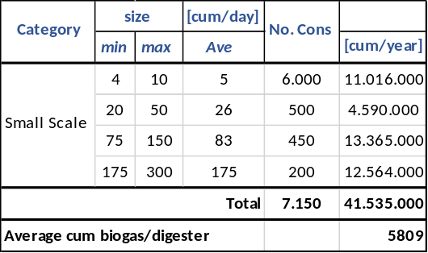

then the top-down indirect emission reductions over the 10-year post-project influence period are estimated as:

- 363,465 tCO₂ associated with clean electricity generation
- 611,064 tCO₂ associated with clean thermal energy generation
For a total of 974,529 tCO₂.

Bottom up analysis:
The GEF guidelines provide a formula for bottom-up emissions assessment as:

CO_{2 indirect BU} = CO_{2 direct} * RF

where RF is the Replication Factor. The GEF guidelines estimate a default RF of 2 for biogas projects. For the project at hand, a default replication factor of 2 is estimated – noting, however:

- The GEF guidelines for renewable energy are based on 2008 figures, when biogas technology was far less competitive with alternatives. Today, biogas technology is developing rapidly, with increasing uptake in Africa.
- Power shortages in Botswana provide an additional incentive to seek alternative power sources.

A Replication Factor of 2 is used but is, for these reasons, considered conservative. With a replication factor of 2, the bottom-up indirect emissions are 1,803,672 tCO₂ over the 10-year post-project period.

Step 4:
Research on the leakage of bio-methane highlights the following issues: the IPCC (2006) estimates that 5-15% of the potential methane production can be emitted as ‘leakage’. The CDM (2012) then further estimates ‘leakage’ from the digestate after it has been removed from the digester and distinguishes between liquid and solid digestate. Liebetrau (2011) measures leakage from 10 anaerobic digesters in Germany; he finds CH₄ leakage from the digesters themselves, 0.4-2.4% CH₄ leakage during gas utilisation, and 0.2-11% of the total CH₄ produced during storage of the digestate.

A further consideration is the project baseline. Given that the baseline for most (but potentially not all) of the agro-waste that will be used as feedstock in the biodigesters would be anaerobic decomposition (i.e. with associated production of methane), leakage from the biodigesters would not necessarily add to atmospheric methane emissions (since such emissions would anyway occur, even in the absence of the digesters).

At this stage, it is difficult to precisely estimate methane emissions due to leakage over and beyond baseline CH₄ emissions. Instead, a simple but defensible approach of discounting the calculated emission reduction benefits of the project by 12% has been adopted. During project implementation, precise measurements will be made of (a) baseline emissions and (b) project leakage emissions, and accurate GHG emission reductions will be calculated.

Net Emission Reductions with Leakage Discount (tCO₂e)
Category | Emission Reductions | Average  Leakage | Net Emission Reductions | Cost  (GEF US$/ tCO₂e)
Direct | 901,836 | 12% | 793,616 | 3.32
Direct post-project | - | - | - | -
Indirect bottom-up | 1,803,672 | 12% | 1,587,231 | 1.66
Indirect top-down | 974,529 | 12% | 857,586 | 3.07

For UNDP-supported, GEF-funded projects as this includes GEF-specific requirements
1 USD = P9.7 (BWP also known in financial markets simply as P).
The 2015/16 Budget in Brief, Ministry of Finance and Development Planning.
Ibid.
Information obtained from the ‘Botswana Draft Energy Policy as done by Task Force 2’, document of December 2009.
Draft Energy Policy, February 2015.
BPC Annual Report, 2013.
2013 TARIFF RATES.pdf - Botswana Power Corporation
BPC Annual Report 2013.
This includes a 1 MW solar PV project.
This is illustrated by the recent request for bids for the construction of a 100MW solar PV park: http://af.reuters.com/article/investingNews/idAFKBN0OP0OA20150609
Draft Energy Policy, February 2015.
Second National Communication to the UNFCCC, December 2011.
Ibid.
Ibid.
The different sources of waste in red-meat abattoirs can be categorised as: lairagus/animal pens; bleeding/stunning; carcass processing /cleaning; offal processing; and by-products processing.
This Policy Brief was prepared with assistance from UNDP in support of the Ministries of Environment, Wildlife and Tourism, Finance and Development Planning, and Foreign Affairs and International Cooperation in preparation for the United Nations Conference on Sustainable Development in June 2012 and for subsequent use within the country to advance sustainable development.
Published monthly by the Bank of Botswana (see www.bob.bw)
Retrospective EIA of the Lobatse Abattoir – Botswana, Ecosurv, Client: Botswana Meat Corporation, 2009.
Botswana’s Strategy for Waste Management, 1998
Based on data from the Department of Animal Production, Ministry of Agriculture.
J.C. Moreki and S.C. Chiripasi (2011), ‘Poultry waste management in Botswana: a review’, Online Journal of Animal and Feed Research, Volume 1, Issue 6: 285-292.
The Gamodubu landfill is a model landfill and a similar approach can be found at the other landfills managed by councils in South Eastern Botswana.
Botswana Biomass Energy Strategy (2009).
Pre-feasibility studies at three potential sites for the construction of a biogas plant to inform the preparation of the UNDP/GEF project document – Promoting Production and Utilisation of Bio-Methane from Agro-Waste in South Eastern Botswana, Environplan (2014).
Nozipho Wright for UNDP, October 2014.
The Department of Waste Management and Pollution Control (DWMPC) is currently in the process of reviewing the Waste Management Policy.
http://www.mewt.gov.bw/DWMPC/index.php
Waste Management Act, 1999.
District Councils (Gaborone City Council, South-East District Council, Lobatse Town Council, Southern District Council, Jwaneng Town Council, Kweneng District Council, Kgatleng District Council).
http://www.mewt.gov.bw/DWMPC/article.php?id_mnu=107
http://www1.eis.gov.bw/EIS/Policies/Environmental%20Policies/Environmental%20Assessment%20Act.pdf
The Intended Nationally Determined Contribution (INDC) for Botswana states that “Botswana is developing a Climate Change Policy and Institutional Framework which will be supported by a Strategy and Action Plan to operationalize the Policy. The Policy will be approved by Parliament in 2016.” The country intends to achieve an overall emissions reduction of 15% by 2030, taking 2010 as the base year. The reductions will be realised from the energy sector. The country will also continuously implement mitigation measures for the livestock sector to reduce CH₄ emissions mainly from enteric fermentation, though these initiatives are not estimated in the 15%. Initiatives for emission reductions will be developed from the long-term low-carbon strategy. The REFIT is actually in the Energy Draft Bill that will be discussed in Parliament during the December 2015 sitting. If it passes, then it is highly likely to happen during the lifetime of the project. The project will take note of the required transitional arrangements regarding institutional, legal and administrative issues which might cause delays in implementation, but it is important to note that there is political willingness associated with the Energy Bill (and hence the REFIT).
http://www.bpc.bw/Pages/home.aspx
PMIS 1235.
Such PPAs have not hitherto been negotiated in Botswana but changing Government policy, BPC’s growing power shortages and the recent legal mandate of Local Authorities to enter into PPPs all indicate the high potential of such arrangements.
Absa Bank Limited (Absa Bank) is a wholly-owned subsidiary of the Barclays Africa Group. Absa Bank exists in South Africa and Namibia only.
Taken from discussions with OFMB’s Sales and Marketing Manager in February 2015.
The Tuli Block is a narrow fringe of land at Botswana's eastern border, wedged between Zimbabwe in the north and east and South Africa in the south.
The functioning of a biogas digester can be affected by over-reliance on chicken manure because of: excessive concentration of nitrogen in the substrate; too much mineral matter; antibiotics and steroids being a serious threat to many cultures of methane fermentation bacteria; and excessive concentration of sulphur compounds (from proteins).
Ibid.
Botswana Biomass Energy Study (2009).
N. Ditlhale and M. Wright (2013), ‘The importance of gender in energy decision-making: the case of rural Botswana’, Journal of Energy in Southern Africa, 14:2.
http://www.energia.org/fileadmin/files/media/reports/Botswana_gender_audit_report.pdf
UNDP (2004), Gender and Energy for Sustainable Development – A Toolkit & Resource Guide.
Botswana Biomass Energy Strategy, 2007.
UNDP (2007), Gender Mainstreaming Training Manual.
A department of the Ministry of Environment, Wildlife and Tourism.
Botswana’s Policy for Wastewater and Sanitation Management, August 2001.
At the time of the PGG, no working biogas digesters were identified that could be visited.
"Waste carrier" means a person registered and licensed to transport waste. Waste Management Act 1998
BPC 2012 rates.
PPP, BOCCIM Business Conference, Public Private Partnership, October 14-17, 2012
These include quantity, quality and ownership of waste streams, transport and handling, technology selection, utilisation of biogas, capacity to operate and manage, bankable business plan, financing, monitoring, policy and legal issues, need for performance-based incentives, etc.
A meat (beef) processing company that has been in operation since 1982, located in Tlokweng, South East District.
http://www.genderlinks.org.za/article/botswana-women-farmers-lead-the-way-2011-09-30
Inception Report and Pre-Feasibility Studies at 3 Potential Sites for Construction of a Biogas Plant in South Eastern Botswana, submitted by Enviroplan (Pvt) Ltd to UNDP Botswana.
This is the average standard rate that BPC charges for a kWh. The actual rate that can be paid by BPC is negotiable but is not at this stage of the project.
Palm R. (2010), The Economic Potential For Production Of Upgraded Biogas Used As Vehicle Fuel In Sweden, Chalmers University of Technology, Goteborg, Sweden.
The rate of BWP 3/kWh was taken from an interview with BPC.
Ranging from 4-300 m³ and operated by small-scale (agro-business), livestock producers, households, schools and other institutions.
Ranging from 300-5,000 m³ and operated by medium-size agro-industry.
Over 5,000 m³ and typically centralised co-digestion of multiple waste streams and multiple ownership.
Stakeholders will meet periodically to exchange information and experiences; topic experts will be invited to prepare tailor-made training; lessons-learned and best practices are documented and disseminated at district, national and international level.
Livestock Unit.
This could, for example, include topping-up of the price per kWh produced through biogas and supplied to the national grid, and tax incentives for private-sector companies to invest in green waste-management technology (in particular biogas).
Like awarding well performing projects or initiatives with performance certificates and additional attention in the media.
Estimated cost between 1.5-3.5 million USD depending on the design, size and customer requirements.
Approximately at 1 BWP/kWh at 2014 prices.
Extrapolation of BPC price development for power per kWh.
This could be, for example, the University of Botswana or BRIDEC.
Reference is made to the budget for detail on cost for capacity development.
The BWG is a multi-stakeholder platform whereby participants set the agenda and determine how promotion is undertaken in the context of this project. Participants will, in turn, be responsible for implementation.
For example, an abattoir with a daily turnover of 20–100 animals.
Piggeries, cattle post, feedlots, etc.
For example, the waste streams in Jwaneng Town Council are sludge from the stabilisation pond, abattoir waste, food waste from mine camps (2,000 inhabitants in one camp alone), food waste from households, garden waste and waste from surrounding villages, municipal solid waste, food waste from Debswana canteens, etc.
The engagement of IPPs is currently not common practice. However, there are some recent developments that indicate that Botswana is now opening up opportunities for IPPs to enter the power sector. (i) The Electricity Supply Act Cap 73:01 allows an IPP to feed power into the national grid; (ii) the Government is about to award an IPP tender for the development of a (2 X 150 MW) 300 MW coal-fired power plant; (iii) A call for expressions of interest to install a 100 MW solar power station was advertised by the Ministry of Minerals, Energy and Water Resources in 2015. Bids from independent power producers are currently being evaluated. The latest feedback from the Department of Energy (as of early December 2015) states that the Energy Policy is now with the Attorney General’s Chambers and is being prepared for submission to the December 2015 Parliament sitting. The Policy has already been approved by the Cabinet. The Department of Energy has started awareness creation on the policy to Councils, to secure their buy-in. As soon as the Policy receives Parliamentary approval, implementation will start immediately. In fact, implementation of the Policy has already started as some activities, such as the development of the renewable energy strategy and the establishment of the regulator, are being undertaken. The Government has approved, in principle, the setting up of the office of the Botswana Energy and Regulatory Authority, whose main pillar will be economic regulation.
It is not foreseen that the project will support the development of quality standards or a certification process for bio-fertilizer.
Pre-treated steel panels with a ceramic-like coating can be used to prevent erosion; another option is to apply a special coating on concrete to prevent corrosion. In addition, the project will ensure that stakeholders are aware of corrosion-related issues and will ensure that high-quality and durable biogas technology is selected.
Alterra Wageningen UR & Nutrient Management Institute NMI (2014), Bio-slurry as Fertilizer, http://www.academia.edu/18055905/Bioslurry_as_a_fertilizer.
Appropriate management of biogas digestate will have benefits including: lower gaseous emission; less diffuse pollution from surface run off and leaching; reduced odours, improved veterinary safety, plant pathogen reduction and the reduction of weed seeds. Source: IEA Bioenergy (2010), Utilisation of Digestate from Biogas Plants as Biofertiliser.
The terms feasibility and market study are used interchangeably. Both refer to a study to determine a detailed overview of the potential for small-scale biogas and the roles and responsibilities of stakeholders and the programme modalities.
At least one company is identified to take on responsibility to operate the digester through a tender process.
A utility-based bio-methane installation requires a daily feedstock of at least 300 tonnes, and a 15,000 m³ biogas installation is required for processing this daily feedstock. In addition, a similar investment is required for upgrading biogas to bio-methane and the facilities for compressing and bottling bio-methane. To ensure guaranteed operation 24/7 throughout the year, a reliable and constant input of feedstock is required. There is no single agro-waste industry among councils that has access to this size of waste stream and therefore input will be sourced from multiple agro-industries.
During the project period, 1,000 small-scale biogas digesters will be constructed as well as 3 medium-scale biogas digesters. In at least 2 District Councils, municipality waste will be collected and organic waste will be separated and used as feedstock for medium-scale biogas digesters. These District Council digesters will be implemented as Public-Private Partnerships (PPPs), with one or more district-based agro-industrial firms providing co-investment In return, the District Council will share revenues gained from biogas and slurry production with the firm(s).
Teodorita Al Seadi, et al (2008), Biogas Handbook, University of Southern Denmark. Esbjerg.
Ibid.
Ibid.
BOTA Standard, Demonstrate Knowledge of Occupational Health and Safety Requirements, Level 2.
Workers Compensation Act, No. 23 of 1998.
Current prices for organic fertilizer produced by OFMB are BWP 104 for 20kg for carbonised lawn dressing, BWP 700 for a tonne of un-carbonised lawn dressing, and BWP 104 for crumbled or pelletised 50kg bags.
BPC tariff rates (12% VAT inclusive) effective 1st April 2014.
SE4All Rapid Assessment and Gap Analysis – Botswana (2014).
Support includes: training of masons, promotion, quality control, monitoring, user training, financing.
This Policy Brief was prepared with assistance from UNDP in support of the Ministries of Environment, Wildlife and Tourism, Finance and Development Planning, and Foreign Affairs and International Cooperation in preparation for the United Nations Conference on Sustainable Development in June 2012 and subsequent use within the country to advance sustainable development.
Local abattoirs, BMC Francistown, BMC Maun, organic waste from villages and towns, cattle farms, etc.
http://unhabitat.org/publications-listing/challenges-of-municipal-finance-in-africa-with-special-reference-to-gaborone-city-botswana/
Potential users of the small-scale and medium-scale biogas digesters – piggeries, cattle farms, animal feedlots, households, Councils, etc. – are expected to invest in the installation of the technology themselves. As the identities of the digester users will not be known until the end of Year 1 of project implementation, co-finance letters cannot be provided at this stage and, as a conservative measure, the expected co-finance is not included in the project budget. Nonetheless, it is fully expected to materialise, is likely to be approximately $12 million in total, and will be reported in PIRs accordingly. The indicators for Component 2 (‘Number of biogas digesters constructed and in use’; ‘Total capacity (in m³) of installed biogas digesters constructed and energy generated’) and Component 3 (‘Total investment in biogas technology’, with a target of ‘At least three financial institutions have incorporated the financing of biogas technology in their national portfolios’) are specifically designed to capture the digester take-up and investment. The Botswana Meat Cooperation (BMC) has already set aside funds for the investment in a medium-scale biogas digester and its commitment is supported by a letter of co-finance. Barclays Bank of Botswana and the Botswana Development Cooperation (BDC) have indicated that they will offer loans for bankable business proposals relating to the construction of small-scale and medium-scale biogas digesters. BDC will provide loans or equity to private companies of up to $4.6m, at 11.7% per annum, with a bankable business plan as the main requirement. Barclays will provide loans to private companies of up to $2m, at 9% per annum, again with a bankable business plan as the main requirement. Furthermore, Insight Consulting, a locally-based business accelerator, has committed to connecting a private Botswanan company with European or American financiers for biogas plant construction and will help to arrange a loan with an interest rate of between 5-10% per annum. All three institutions have long-standing track records in Botswana.
Summary table should include all financing of all kinds: GEF financing, cofinancing, cash, in-kind, etc...
http://www.energia.org/
The exact amount of GHG reduced emissions is presented under the section on GHG calculations.
The Environmental Assessment Act of 2011.
http://www.extension.org/: http://www.renewableenergymagazine.com/article/60-percent-of-biogas-plants-have-safety
Where applicable, transport from feedlot to biogas digester (cow dung); kitchen and food waste from schools, institutions, households to the biogas digester.
To avoid emissions of biogas into the atmosphere due to technical issues, a backup flaring system will be installed for medium-scale biogas digesters to burn off access and unused biogas. Users of small-scale biogas digesters will be trained to burn biogas in case of access biogas by reading a simple pressure meter.
Prohibited grounds of discrimination include race, ethnicity, gender, age, language, disability, sexual orientation, religion, political or other opinion, national or social or geographical origin, property, birth or other status including as an indigenous person or as a member of a minority. References to “women and men” or similar is understood to include women and men, boys and girls, and other groups discriminated against based on their gender identities, such as transgender people and transsexuals.
In regards to CO_{2,} ‘significant emissions’ corresponds generally to more than 25,000 tons per year (from both direct and indirect sources). [The Guidance Note on Climate Change Mitigation and Adaptation provides additional information on GHG emissions.]
Forced evictions include acts and/or omissions involving the coerced or involuntary displacement of individuals, groups, or communities from homes and/or lands and common property resources that were occupied or depended upon, thus eliminating the ability of an individual, group, or community to reside or work in a particular dwelling, residence, or location without the provision of, and access to, appropriate forms of legal or other protections.
University of Southern Denmark (2008), Biogas Handbook.
October 2014.
UNFCCC, Appendix B of the simplified modalities and procedures for small scale (up to 15 MW) CDM project activities.
A small-scale digester should operate year-round and only a limited number of days are needed for repairs and cleaning per year.
On average, 5 days a year are required for maintenance of the plant.
http://www.reegle.info/policy-and-regulatory-overviews/bw (demand 902 MW by 2020, of which 25% is from renewables).
GEF (2008), Manual for Calculating GHG Benefits of Projects: Energy Efficiency and Renewable Energy Projects.
http://johnpaulprofessional.com/2015/09/24/methane-emission-leakage-from-co-digestion-on-dairy-farms/

